Appendix II
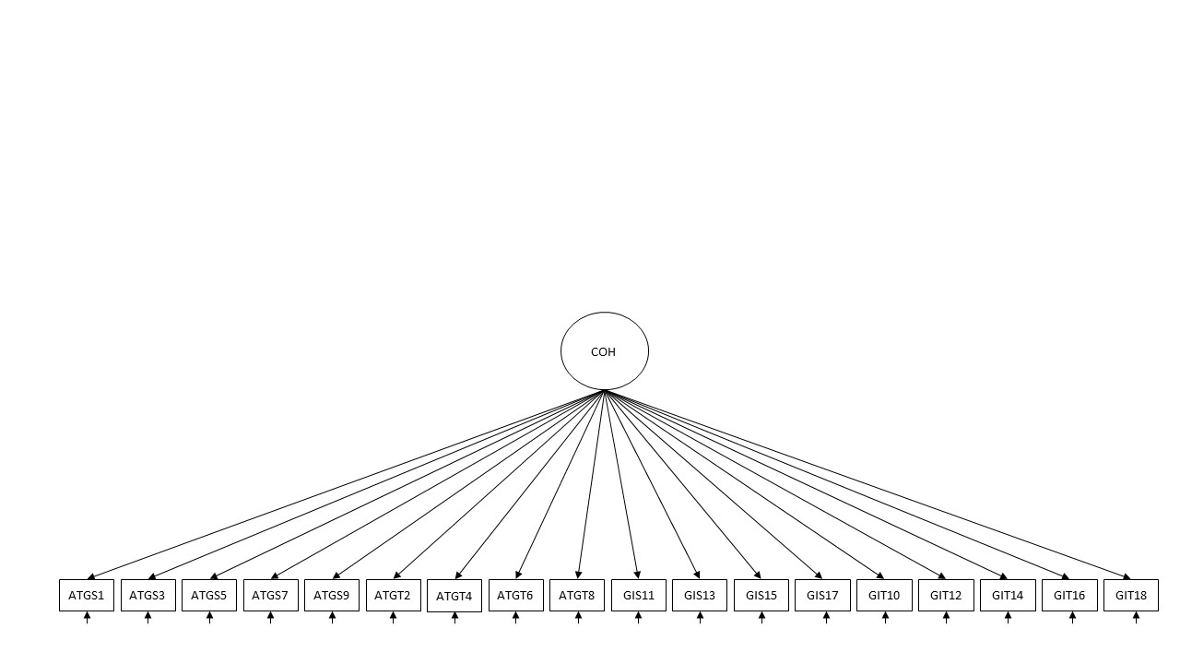
Figure a1. M1 One-factor ICM-CFA GEQ
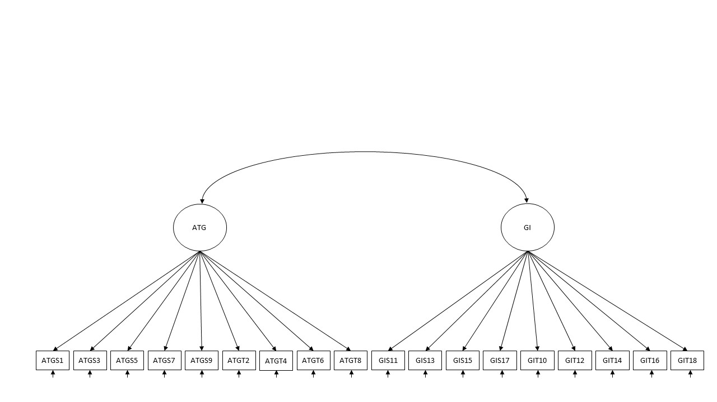
Figure a2. M2a Two-factor ICM-CFA (ATG/GI) GEQ
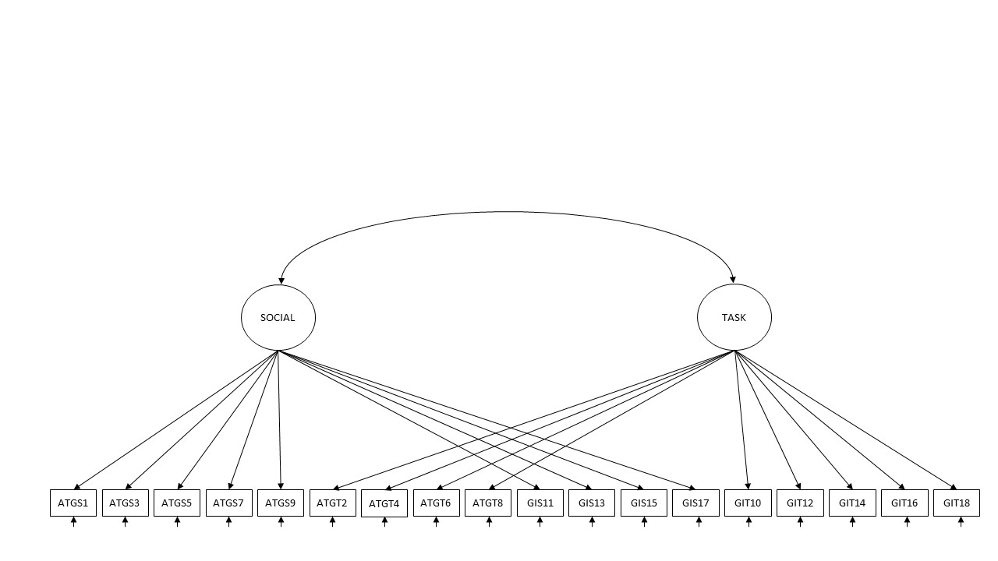
Figure a3. M3a Two-factor ICM-CFA (Task/Social) GEQ
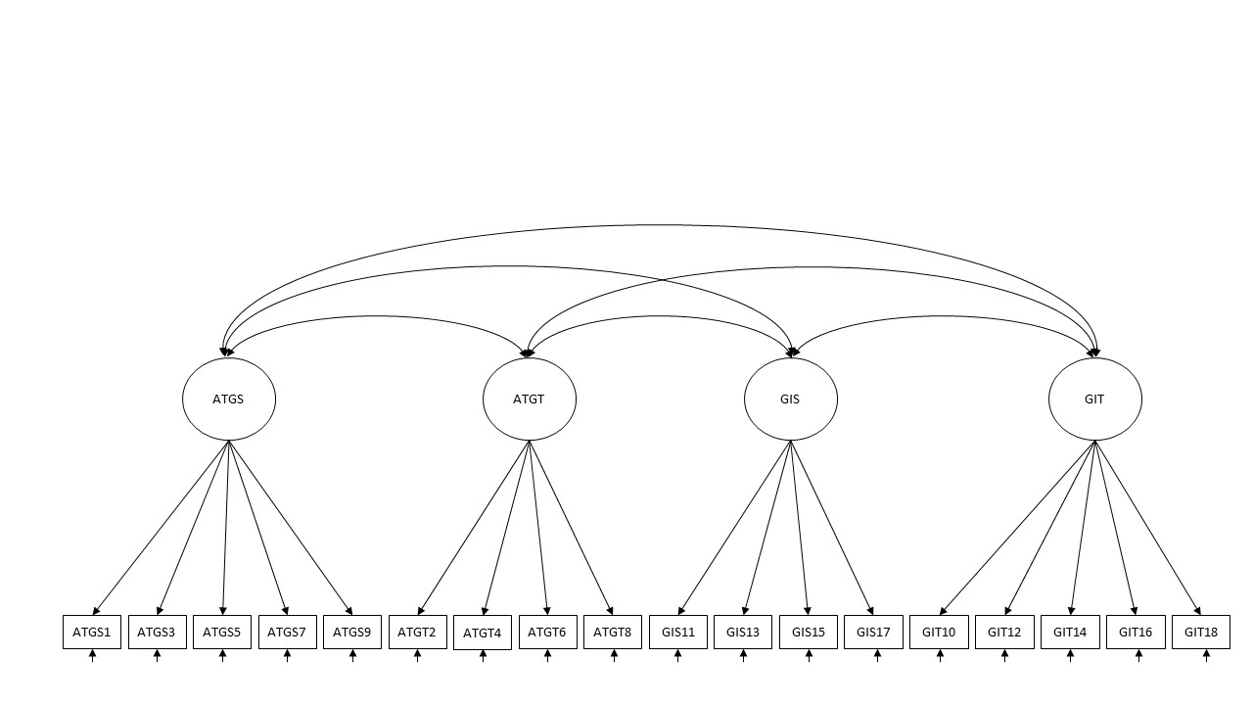
Figure a4. M4a Four-factor ICM-CFA GEQ
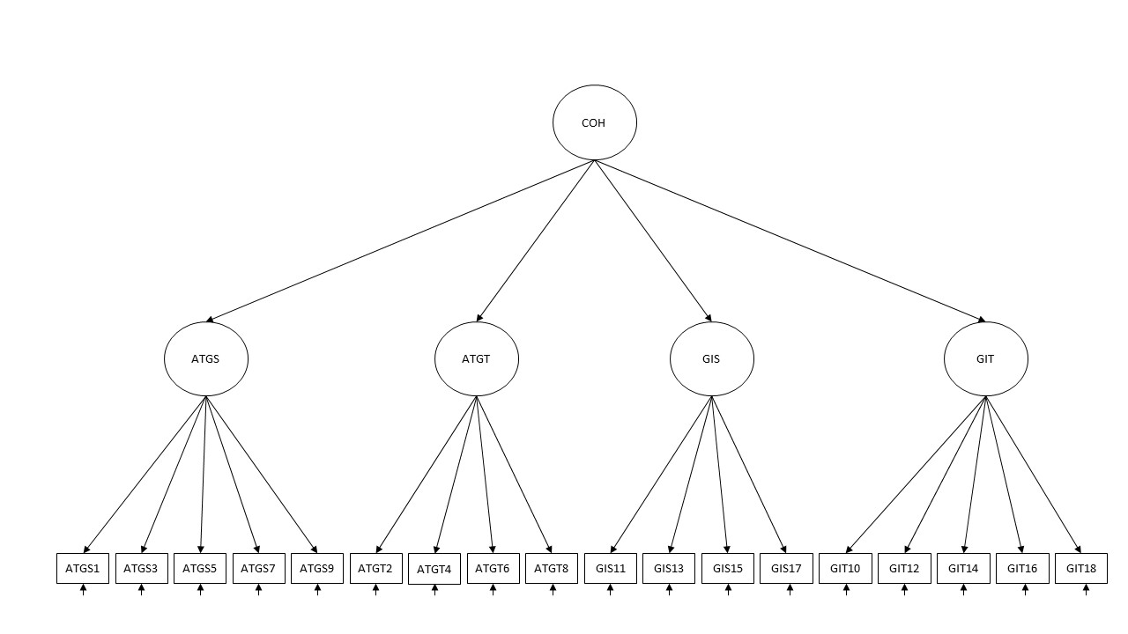
Figure a5. M5a Hierarchical CFA (Cohesion) GEQ
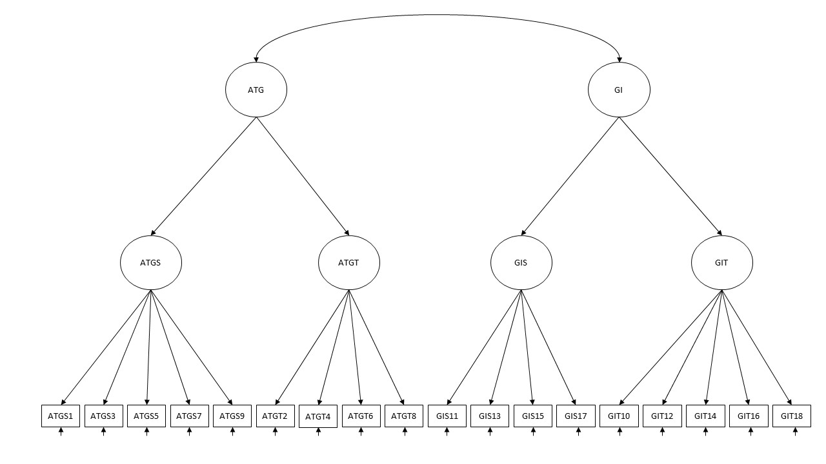
Figure a6. M6a Hierarchical CFA (ATG/GI) GEQ
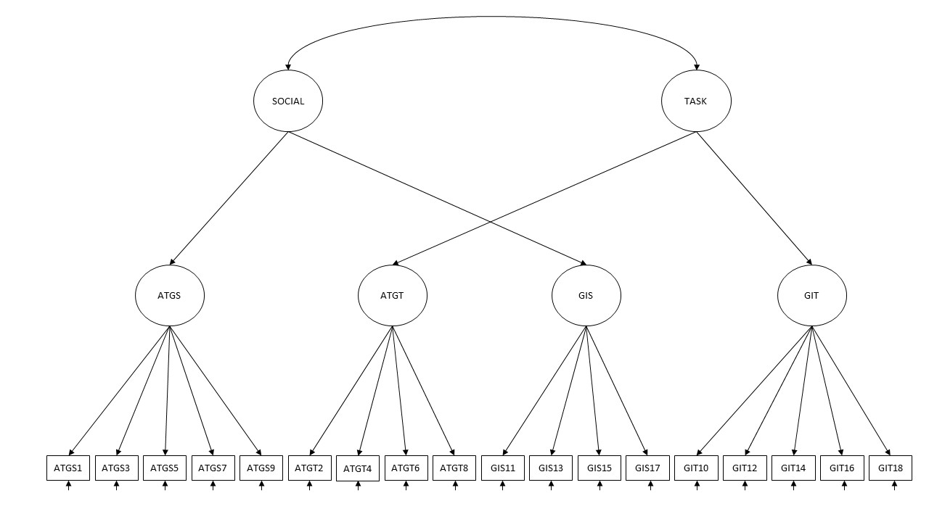
Figure a7. M7a Hierarchical CFA (Task/Social) GEQ
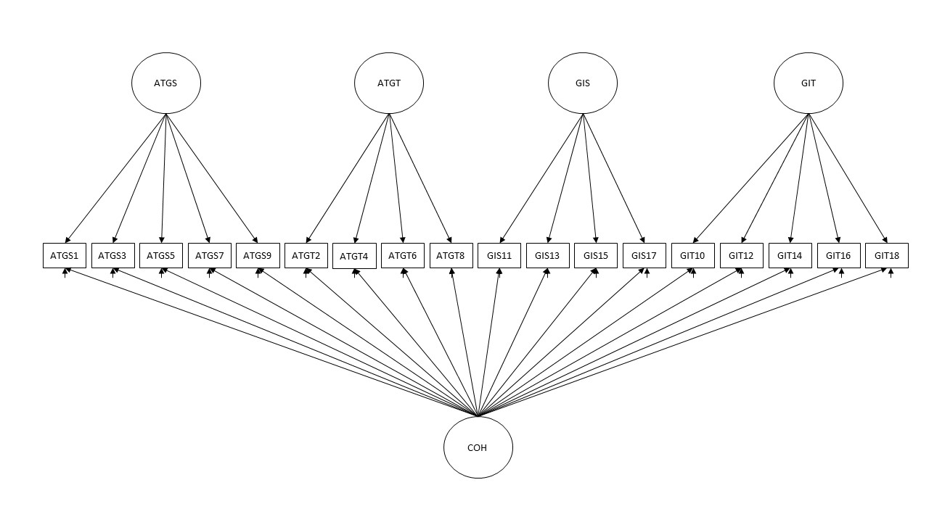
Figure a8. M8a Bifactor CFA GEQ
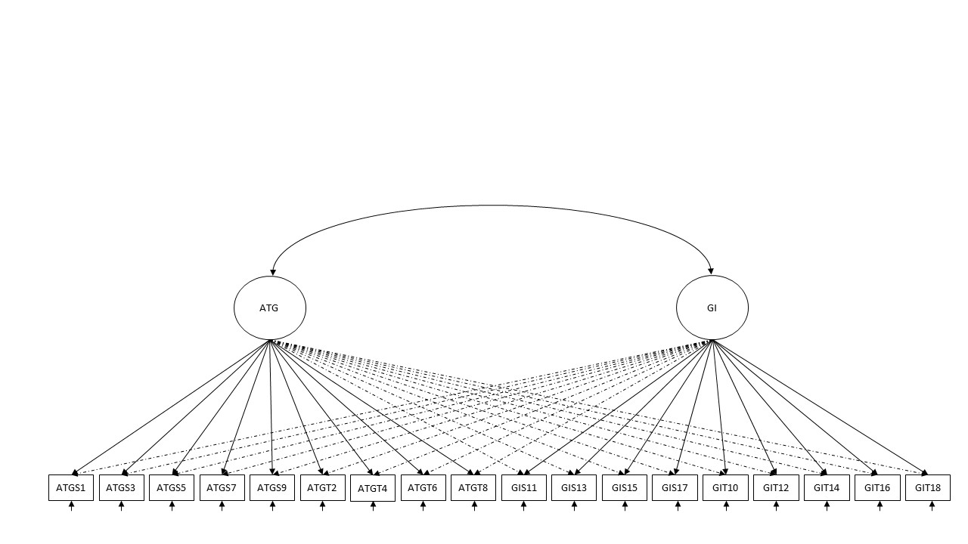
Figure a9. M2b Two-factor ESEM (ATG/GI) GEQ
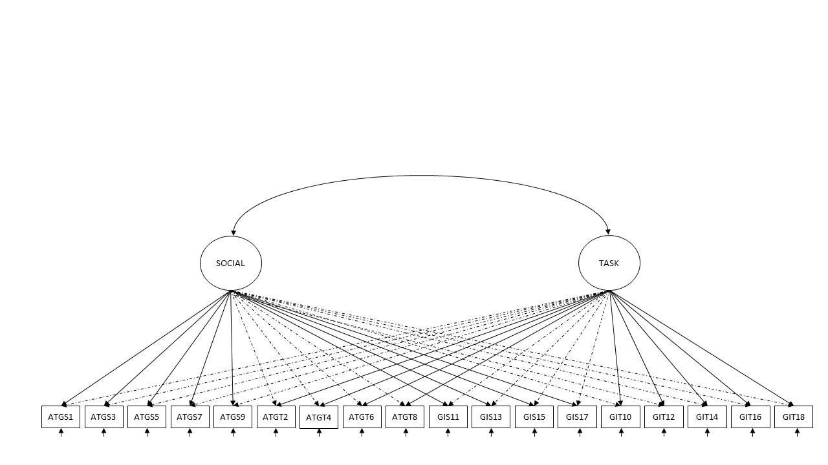
Figure a10. M3b Two-factor ESEM (Task/Social) GEQ
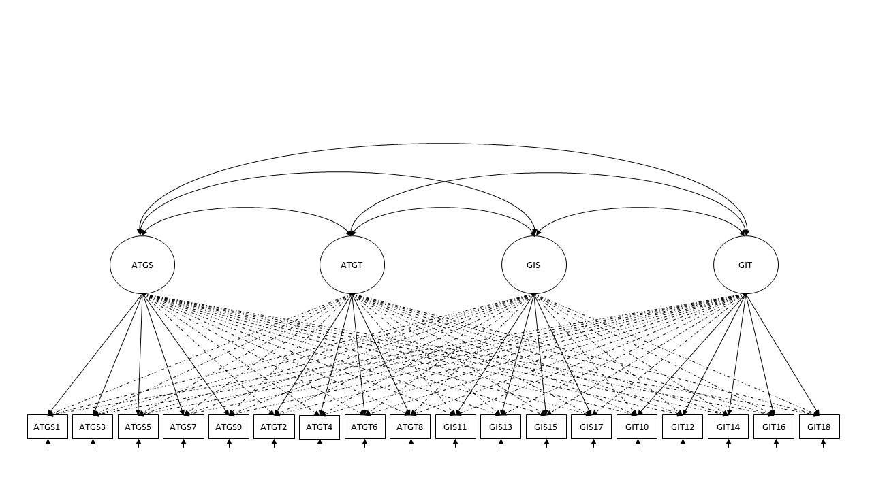
Figure a11. M4b Four-factor ESEM GEQ
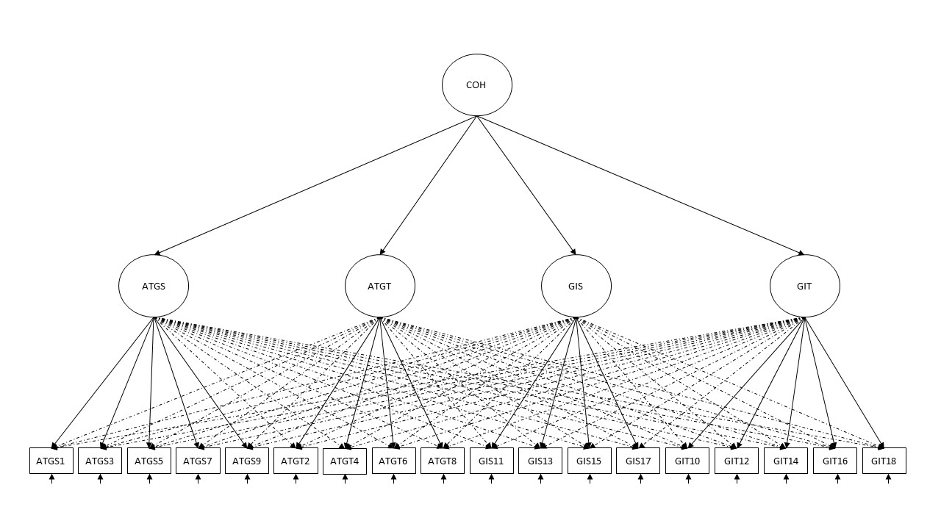
Figure a12. M5b Hierachical ESEM (Cohesion) GEQ
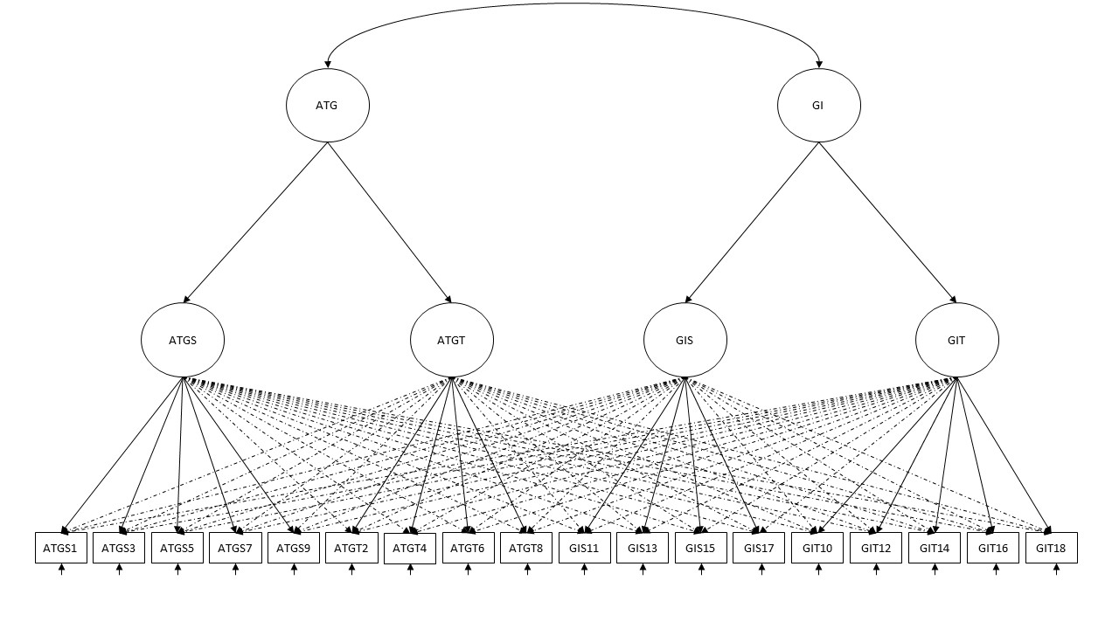
Figure a13. M6b Hierachical ESEM (ATG/GI) GEQ
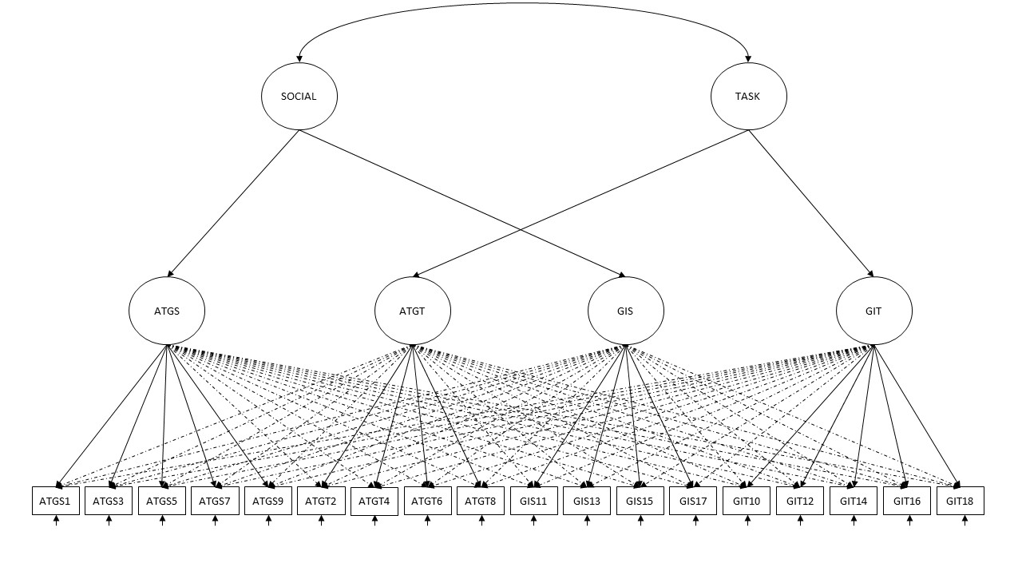
Figure a14. M7b Hierachical ESEM (Task/Social) GEQ
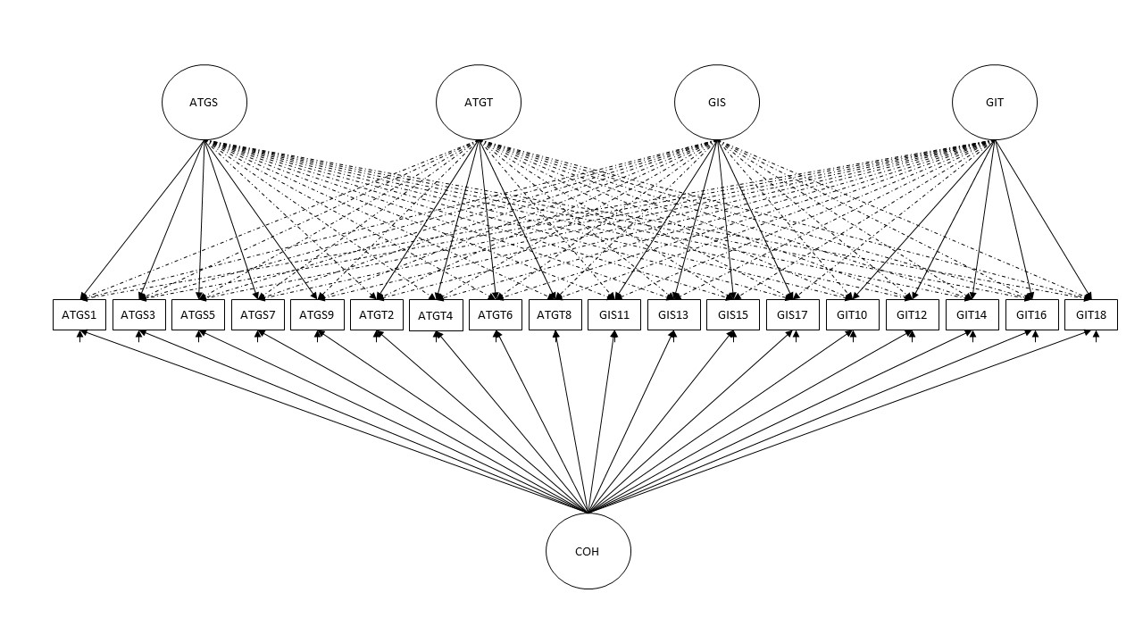
Figure a15. M8b Bifactor ESEM GEQ
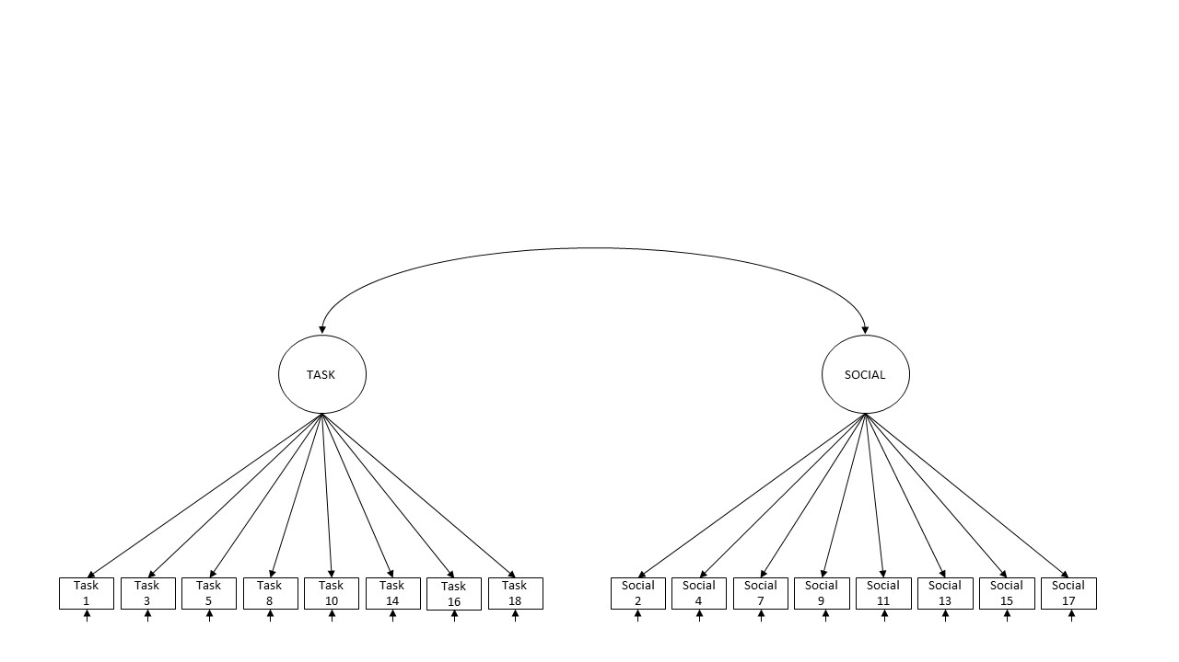
Figure a16. ICM CFA (Task/Social) YSEQ
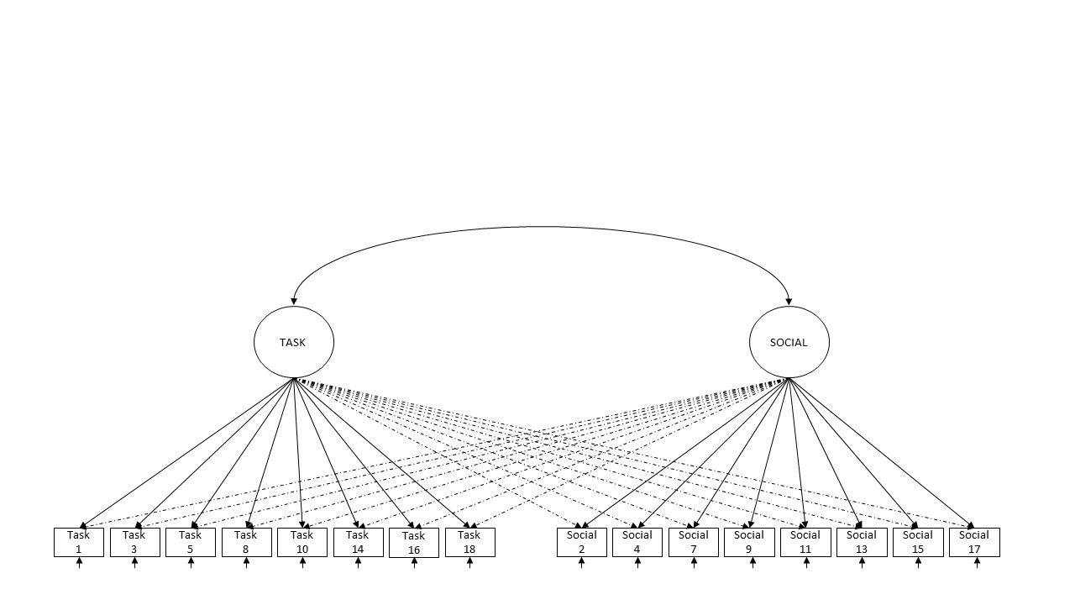
Figure a17. ESEM (Task/Social) YSEQ

