Supporting Information

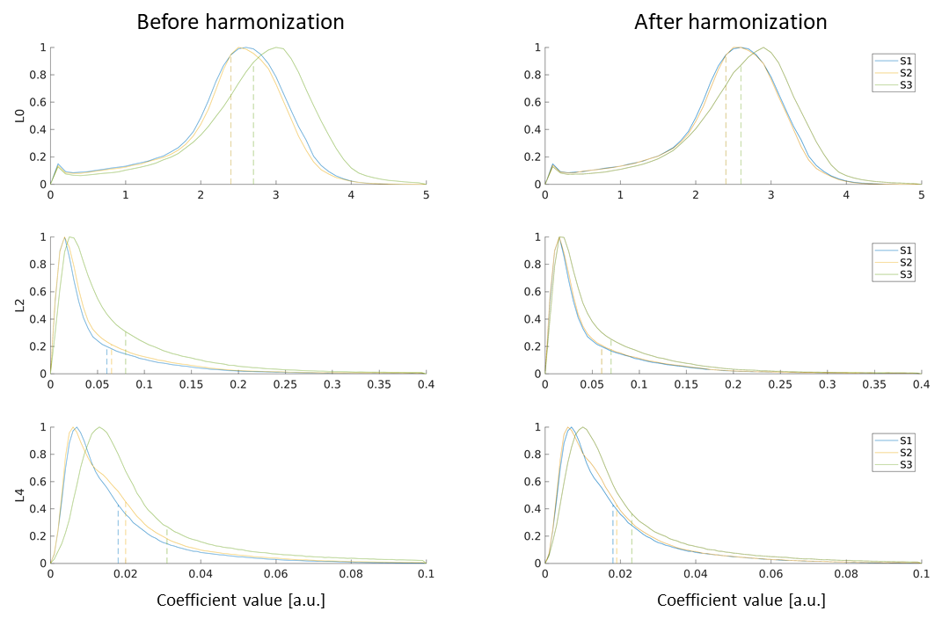
Supporting Figure S1: average whole brain distribution of RISH features of order 0 (L0), 2 (L2) and 4 (L4) corresponding to data at b = 1000s/mm² across sites before and after harmonization. The dashed lines show the average value of each distribution. RISH harmonization results in appreciably more similar cross-site distributions and closer average values.

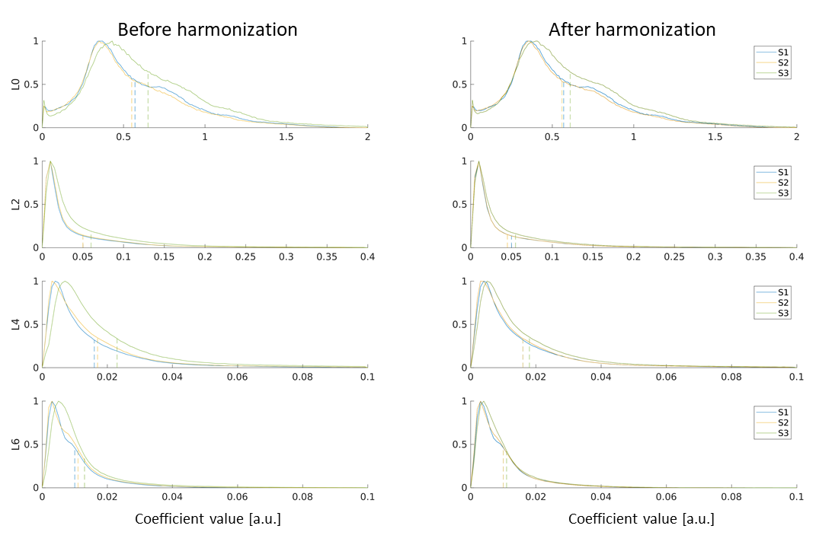
Supporting Figure S2: average whole brain distribution of RISH features of order 0 (L0), 2 (L2), 4 (L4) and 6 (L6) corresponding to data at b = 2500s/mm² across sites before and after harmonization. The dashed lines show the average value of each distribution. RISH harmonization results in appreciably more similar cross-site distributions and closer average values.

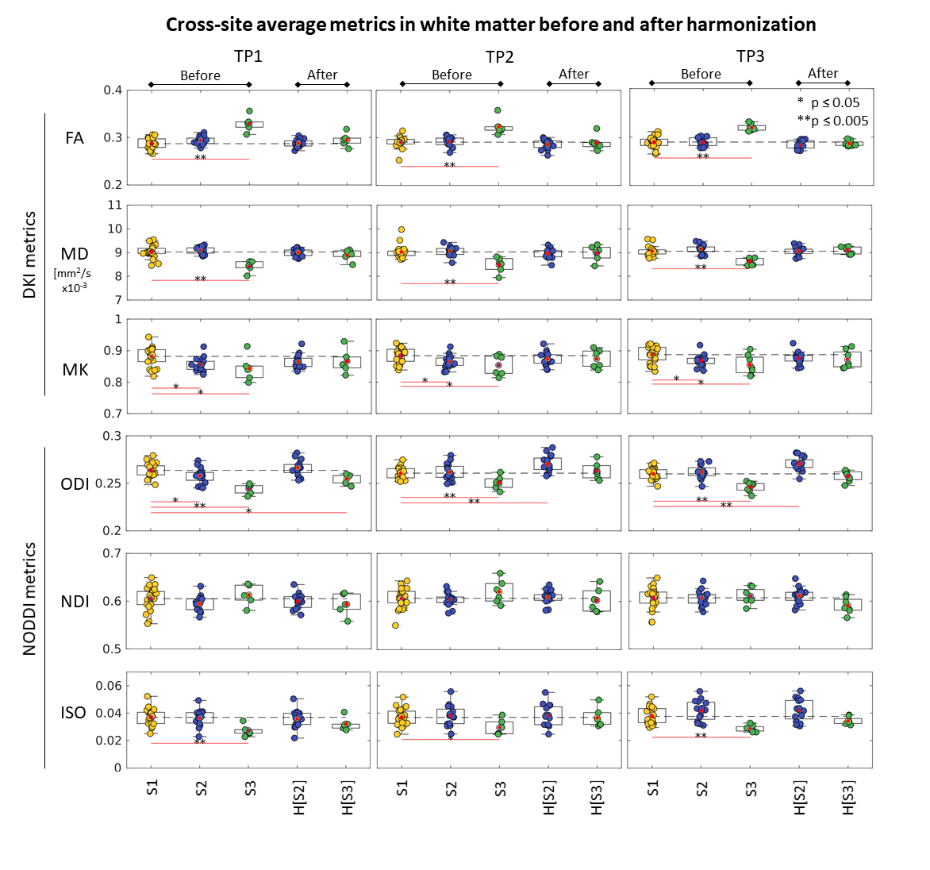
Supporting Figure 3: The boxplots of fractional anisotropy (FA), mean diffusivity (MD), mean kurtosis (MK), orientation dispersion index (ODI) and neurite density index (NDI) in a white matter mask (FA > 0.2) for S1, S2 and S3 at TP1, TP2 and TP3 before and after harmonization (H[S2] and H[S3]). The black dashed line indicates the average value of S1 for reference. Yellow, blue and green dots represent the average value of the considered diffusion metrics for S1, S2 and S3, respectively. The red dots indicate the average value of each site. The asterisks indicate significant differences between sites: * = p ≤ 0.05; ** = p ≤ 0.005. After harmonization, most significant cross-site differences are effectively removed, except for residual differences for ODI of S2 at TP2 and TP3.
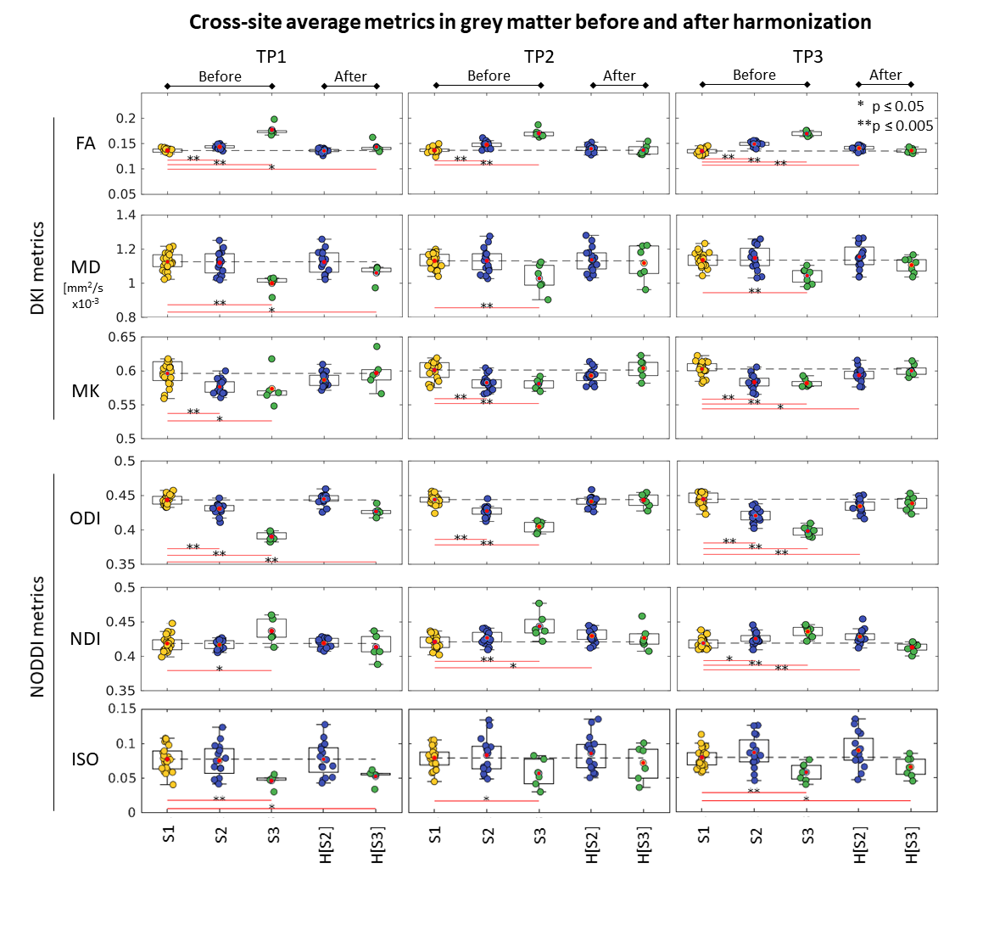
Supporting Figure 4: The boxplots of fractional anisotropy (FA), mean diffusivity (MD), mean kurtosis (MK), orientation dispersion index (ODI) and neurite density index (NDI) in a grey matter mask (FA < 0.2, MD < 2x10⁻³mm²/s) for S1, S2 and S3 at TP1, TP2 and TP3 before and after harmonization (H[S2] and H[S3]). The black dashed line indicates the average value of S1 for reference. Yellow, blue and green dots represent the average value of the considered diffusion metrics for S1, S2 and S3, respectively. The red dots indicate the average value of each site. The asterisks indicate significant differences between sites: * = p ≤ 0.05; ** = p ≤ 0.005. After harmonization, most significant cross-site differences are effectively removed, except for residual differences for ODI of S2 at TP3, and NDI of S2 at TP2 and TP3.

