Supplementary Materials
Physical activity attenuates but does not eliminate coronary heart disease risk amongst adults with risk factors: EPIC-CVD case-cohort study

Melony C Fortuin-de Smidt¹, Maquins Odhiambo Sewe¹, Camille Lassale^{2,3}, Elisabete Weiderpass⁴, Jonas Andersson⁵, José María Huerta^{6,7}, Ulf Ekelund^{8,9}, Krasimira Aleksandrova^{10,11}, Tammy YN Tong¹², Christina C Dahm¹³, Anne Tjønneland^{14,15}, Cecilie Kyrø¹⁴, Karen Steindorf¹⁶, Matthias B Schulze^{17,18}, Verena Katzke¹⁹, Carlotta Sacerdote²⁰, Claudia Agnoli²¹, Giovanna Masala²², Rosario Tumino²³, Salvatore Panico²⁴, Jolanda MA Boer²⁵, N Charlotte Onland-Moret²⁶, GC Wanda Wendel-Vos²⁵, Yvonne T van der Schouw²⁶, Kristin Benjaminsen Borch²⁷, Antonio Agudo^{28,29}, Dafina Petrova^{30,31,32}, María-Dolores Chirlaque^{33,34}, Moreno-Iribas Conchi^{35,36}, Pilar Amiano^{7,37,38}, Olle Melander^{39,40}, Alicia K Heath⁴¹, Dagfinn Aune^{41,42,43,44}, Nita G Forouhi⁴⁵, Claudia Langenberg^{45,46}, Soren Brage⁴⁵, Elio Riboli⁴¹, Nicholas J Wareham⁴⁵, John Danesh^{47,48,49,50,51}, Adam S Butterworth^{47,48,49,50}, Patrik Wennberg¹

Affiliations
¹Department of Public Health and Clinical Medicine, Umeå University, Umeå, Sweden
²Cardiovascular epidemiology and genetics, Hospital del Mar Research Institute (IMIM), Barcelona, Spain
³CIBER of Pathophysiology of Obesity and Nutrition (CIBEROBN), Instituto de Salud Carlos III, 28029 Madrid, Spain
⁴International Agency for Research on Cancer, Lyon, France
⁵Department of Public Health and Clinical Medicine, Skellefteå Research Unit, Umeå University, Sweden
⁶Department of Epidemiology, Murcia Regional Health Council, IMIB-Arrixaca, Murcia, Spain
⁷CIBER Epidemiología y Salud Pública (CIBERESP), Instituto de Salud Carlos III, 28029 Madrid, Spain
⁸Department of Sports Medicine, Norwegian School of Sport Science, Oslo, Norway
⁹Department of Chronic Diseases and Ageing, Norwegian Institute of Public Health, Oslo, Norway
¹⁰Department Epidemiological Methods and Etiological Research, Leibniz Institute for Prevention Research and Epidemiology - BIPS, Bremen, Germany
¹¹Faculty of Human and Health Sciences, University of Bremen, Bremen, Germany
¹²Cancer Epidemiology Unit, Nuffield Department of Population Health, University of Oxford, Oxford, United Kingdom
¹³Department of Public Health, Aarhus University, Denmark
¹⁴Danish Cancer Society Research Center, Copenhagen, Denmark
¹⁵Department of Public Health, University of Copenhagen, Copenhagen, Denmark
¹⁶Division of Physical Activity, Prevention and Cancer, German Cancer Research Center (DKFZ), Heidelberg, Germany
¹⁷Department of Molecular Epidemiology, German Institute of Human Nutrition Potsdam-Rehbruecke, Nuthetal, Germany
¹⁸Institute of Nutritional Science, University of Potsdam, Potsdam, Germany
¹⁹Division of Cancer Epidemiology, German Cancer Research Center (DKFZ), Heidelberg, Germany
²⁰Unit of Cancer Epidemiology, Città della Salute e della Scienza University-Hospital, Turiny, Italy
²¹Epidemiology and Prevention Unit, Fondazione IRCCS Istituto Nazionale dei Tumori di Milano, Italy
²²Institute for Cancer Research, Prevention and Clinical Network (ISPRO), Florence Italy
²³Hyblean Association for Epidemiological Research, AIRE-ONLUS, Ragusa, Italy
²⁴Dipartimento di medicina clinica e chirurgia, Federico II University, Naples, Italy
²⁵National Institute for Public Health and the Environment (RIVM), Bilthoven, The Netherlands
²⁶Julius Center for Health Sciences and Primary Care, University Medical Center Utrecht, Utrecht University, Utrecht, The Netherlands
²⁷Department of Community Medicine, UiT, The Arctic University of Norway, Tromsø, Norway
²⁸Unit of Nutrition and Cancer, Catalan Institute of Oncology - ICO, L'Hospitalet de Llobregat, Spain
²⁹Nutrition and Cancer Group; Epidemiology, Public Health, Cancer Prevention and Palliative Care Program; Bellvitge Biomedical Research Institute - IDIBELL, L'Hospitalet de Llobregat, Spain
³⁰Escuela Andaluza de Salud Pública (EASP), 18011 Granada, Spain
³¹Instituto de Investigación Biosanitaria ibs.GRANADA, 18012 Granada, Spain
³²Centro de Investigación Biomédica en Red de Epidemiología y Salud Pública (CIBERESP), 28029 Madrid, Spain
³³Department of Epidemiology, Regional Health Council, IMIB-Arrixaca, Murcia University, Murcia, Spain
³⁴CIBER in Epidemiology and Public Health (CIBERESP), Madrid, Spain
³⁵Navarra Public Health Institute, IdiSNA, Pamplona, Spain
³⁶Red de Investigación en Servicios de Salud en Enfermedades Crónicas (REDISSEC), Pamplona, Spain
³⁷Ministry of Health of the Basque Government, Sub Directorate for Public Health and Addictions of Gipuzkoa, San Sebastian, Spain
³⁸Biodonostia Health Research Institute, Epidemiology of Chronic and Communicable Diseases Group, San Sebastián, Spain
³⁹Department of Clinical Sciences Malmö, Lund University, Malmö, Sweden
⁴⁰Department of Emergency and Internal Medicine, Skåne University Hospital, Malmö, Sweden
⁴¹Department of Epidemiology and Biostatistics, School of Public Health, Imperial College London, London, United Kingdom
⁴²Department of Nutrition, Bjørknes University College, Oslo, Norway
⁴³Department of Endocrinology, Morbid Obesity and Preventive Medicine, Oslo University Hospital, Oslo, Norway
⁴⁴Unit of Cardiovascular and Nutritional Epidemiology, Institute of Environmental Medicine, Karolinska Institutet, Stockholm, Sweden
⁴⁵MRC Epidemiology Unit, University of Cambridge School of Clinical Medicine, Cambridge, United Kingdom
⁴⁶Computational Medicine, Berlin Institute of Health, Charité-University Medicine Berlin, Berlin, Germany
⁴⁷British Heart Foundation Cardiovascular Epidemiology Unit, Department of Public Health and Primary Care, University of Cambridge, Cambridge, United Kingdom
⁴⁸National Institute for Health Research Blood and Transplant Research Unit in Donor Health and Genomics, University of Cambridge, Cambridge, United Kingdom
⁴⁹British Heart Foundation Centre of Research Excellence, University of Cambridge, Cambridge, United Kingdom
⁵⁰Health Data Research UK Cambridge, Wellcome Genome Campus and University of Cambridge, Cambridge, United Kingdom
⁵¹Department of Human Genetics, Wellcome Sanger Institute, Hinxton, United Kingdom

Tables
Supplementary Table S1. Comparison of participants included in the complete case analysis and those excluded due to missing values in the sub-cohort and amongst those with CHD events outside the sub-cohort
Supplemental Table S2 Characteristics of CHD cases outside the sub-cohort (N=8,393) stratified by physical activity and sex
Supplementary Table S3. Sensitivity analysis: Hazard ratio for coronary heart disease (CHD) across physical activity levels amongst participants, excluding those with a BMI <18.5kg/m², with CHD risk factors defined by body mass index (BMI), total cholesterol, hypertension (clinically and/or history), history of diabetes and smoking status and with those without the specific risk factor and inactive as the reference group (Ref).

Figures
Supplementary Figure S1. Sensitivity analysis: Estimates of coronary heart disease (CHD) across physical activity levels amongst participants with CHD risk factors defined by body mass index (BMI), non-HDL cholesterol, history of diabetes, hypertension (clinically and/or history) and smoking status and with those without the risk factor and inactive as the reference group (REF). The model for each risk factor was adjusted for age at baseline, alcohol consumption, educational level, fruit intake, vegetable intake, the other risk factors and stratified by sex and centre.
Supplementary Figure S2. Sensitivity analysis: Estimates of coronary heart disease (CHD) across physical activity levels amongst men with CHD risk factors defined by body mass index (BMI), total cholesterol, history of diabetes, hypertension (clinically and/or history) and smoking status and with those without the risk factor and inactive as the reference group (REF). The model for each risk factor was adjusted for age at baseline, alcohol consumption, educational level, fruit intake, vegetable intake, the other risk factors, and stratified by centre.
Supplementary Figure S3. Sensitivity analysis: Estimates of coronary heart disease (CHD) across physical activity levels amongst women with CHD risk factors defined by body mass index (BMI), total cholesterol, history of diabetes, hypertension (clinically and/or history) and smoking status and with those without the risk factor and inactive as the reference group (REF). The model for each risk factor was adjusted for age at baseline, alcohol consumption, educational level, fruit intake, vegetable intake, the other risk factors and stratified by centre.

Supplemental Table S1. Comparison of included and excluded participants from the case-cohort study by location in or outside the sub-cohort
 | Included | Excludedª | P value^{b}
Sub-cohort n (%) | 14,663(89.6) | 1,701(10.4)
Age (years)^{c} | 52.1±9.1 | 54.5±9.0 | <0.001
Follow-up (years)^{d} | 12.8(3.5) | 13.1(3.8) | <0.001
Sex n (%) |  |  | <0.001
Men (n=6,163) | 5,436(37.1) | 727(42.7)
Women (n=10,201) | 9,227(62.9) | 974(57.3)
Educational level n (%) |  |  | <0.001
No schooling (n=1,290) | 1,248(8.5) | 42(3.0)
Primary (n=5,373) | 4,848(33.1) | 525(37.6)
Secondary (n=2,452) | 2,265(15.4) | 187(13.4)
Vocational/University(n=6,945) | 6,302(43.0) | 643(46.0)
Cambridge physical activity index n (%) |  |  | <0.001
Inactive (n=3,743) | 3,362(22.9) | 381(26.8)
Moderately inactive (n=5,485) | 4,987(34.0) | 498(35.1)
Moderately active (n=36,46) | 3,342(22.8) | 304(21.4)
Active (n=3,209) | 2,972(20.3) | 237(16.7)
Alcohol consumption n (%) |  |  | <0.001
None (n=2,713) | 2,438(16.6) | 275(16.6)
1 to ≤5 g/day (n=4,917) | 4,394(30.0) | 523(31.5)
>5 to ≤10 g/day (n=2,341) | 2,055(14.0) | 286(17.2)
>10 to ≤40 g/day (n=4,956) | 4,480(30.6) | 476(28.7)
>40 g/day (n=1,396) | 1,296(8.8) | 100(6.0)
Fruit (g/day)^{d} | 196.7(217.3) | 175.0(185.9) | <0.001
Vegetables (g/day)^{d} | 157.0(140.6) | 154.7(137.3) | 0.084
Body mass index category n (%) |  |  | 0.011
<25 kg/m² (n=7,153) | 6,405(43.7) | 748(46.9)
25-29.9 kg/m² (n=6,410) | 5,791(39.5) | 619(38.8)
≥30 kg/m² (n=2,695) | 2,467(16.8) | 228(14.3)
Total cholesterol category n (%) |  |  | 0.249
<5.2 mmol/l (n=4,314) | 4,086(27.9) | 228(25.3)
5.2-6.1 mmol/l (n=5,640) | 5,303(36.2) | 337(37.4)
≥6.2 mmol/l (n=5,610) | 5,274(36.0) | 336(37.3)
Hypertension n (%) |  |  | <0.001
No (n=10,406) | 9,505(64.8) | 901(59.0)
Yes (n=5,783) | 5,158(35.2) | 625(41.0)
History of diabetes n (%) |  |  | <0.001
No (n=15,505) | 14,264(97.3) | 1,241(94.4)
Yes (n=472) | 399(2.7) | 73(5.6)
Smoking status n (%) |  |  | <0.001
Never (n=7,610) | 6,948(47.4) | 662(42.3)
Former(n=4,419) | 3,938(26.9) | 481(30.7)
Current (n=4,200) | 3,777(25.8) | 423(27.0)
CHD cases outside sub-cohort
n (%) | 8,393(64.7) | 4,576(35.3)
Age (years)^{c} | 58.5±8.2 | 60.4±9.8 | <0.001
Follow-up (years)^{d} | 6.9(5.5) | 7.6(5.8) | <0.001
Sex n (%) |  |  | <0.001
Men (n=7,577) | 5,087(60.6) | 2,490(54.4)
Women (n=5,392) | 3,306(39.4) | 2,086(45.6)
Educational level n (%) |  |  | <0.001
No schooling (n=464) | 410(4.9) | 54(1.62)
Primary (n=4,920) | 3,551(42.3) | 1,369(39.6)
Secondary (n=1,344) | 948(11.3) | 396(11.5)
Vocational/University (n=5,122) | 3,484(41.5) | 1,638(47.4)
Cambridge physical activity index n (%) |  |  | <0.001
Inactive (n=3,906) | 2,392(28.5) | 1,514(37.4)
Moderately inactive (n=3,863) | 2,648(31.6) | 1,215(30.0)
Moderately active (n=2,436) | 1,716(20.4) | 720(17.8)
Active (n=2,239) | 1,637(19.5) | 602(14.9)
Alcohol consumption n (%) |  |  | <0.001
None (n=2,293) | 1,466(17.5) | 827(18.6)
1 to ≤5 g/day (n=4,098) | 2,407(28.7) | 1,691(38.0)
>5 to ≤10 g/day (n=1,811) | 1,111(13.2) | 700(15.8)
>10 to ≤40 g/day (n=3,516) | 2,525(30.1) | 991(22.3)
>40 g/day (n=1,111) | 884(10.5) | 227(5.1)
Fruit (g/day)^{d} | 172.5(195.9) | 171.2(184.8) | 0.271
Vegetables (g/day)^{d} | 151.8(132.5) | 165.1(163.8) | <0.001
Body mass index category n (%) |  |  | <0.001
<25 kg/m² (n=4,282) | 2,592(30.9) | 1,690(38.4)
25-29.9 kg/m² (n=5,979) | 4,042(48.2) | 1,937(44.0)
≥30 kg/m² (n=2,535) | 1,759(21.0) | 776(17.6)
Total cholesterol category n (%) |  |  | 0.945
<5.2 mmol/l (n=1,485) | 1,283(15.3) | 202(15.6)
5.2-6.1 mmol/l (n=3,081) | 2,670(31.8) | 411(31.8)
≥6.2 mmol/l (n=5,119) | 4,440(52.9) | 679(52.6)
Hypertension n (%) |  |  | <0.001
No (n=5,191) | 3,269(38.9) | 1,922(46.9)
Yes (n=7,302) | 5,124(61.1) | 2,178(53.1)
History of diabetes n (%) |  |  | 0.744
No (n=11,523) | 7,800(92.9) | 3,723(92.8)
Yes (n=883) | 593(7.1) | 290(7.2)
Smoking status n (%) |  |  | <0.001
Never (n=4,080) | 2,552(30.4) | 1,528(34.9)
Former (n=4,313) | 2,751(32.8) | 1,562(35.7)
Current (n=4,381) | 3,090(36.8) | 1,291(29.5)
ªExcluded due to missing data: Number and percentage of participants (n, %) in the sub-cohort (N=16,364) with missing data per variable: Age (0), sex (0), duration of follow-up (1, 0.01%), body mass index (106, 0.7%), total cholesterol (800, 4.9%), educational level (304, 1.9%), alcohol consumption (41, 0.3%), hypertension (175, 1.1%), history of diabetes (387, 2.4%), physical activity index (281, 1.7%), fruit intake (51, 0.3%), vegetable intake (51, 0.3%). Number and percentage of participants (n) with CHD events outside the sub-cohort (N=12,969) with missing data per variable: Age (0), sex (0), duration of follow-up (0), body mass index (137, 1.3%), total cholesterol (3,284, 25.3%), educational level (1,119, 8.6%), alcohol consumption (140, 1.1%), hypertension (476, 3.7%), history of diabetes (5632, 4.3%), physical activity index (525, 4.1%), fruit intake (470, 3.6%), vegetable intake (470, 3.6%).
^{b}P-values are derived from unpaired t-tests or Mann-Whitney tests for normal and non-normal distributed continuous variables, respectively, or derived from Chi² tests for categorical variables.
^{c}Values for normally distributed variables are expressed as mean ±standard deviation.
^{d}Values from non-normally distributed variables are expressed as median (interquartile range).

Supplemental Table S2 Characteristics of CHD cases outside the sub-cohort (N=8,393) stratified by physical activity and sex
 | Physical activity
 | Inactive | Moderately inactive | Moderately active | Active | P valueª
Men (n=5,087)
n (%) | 1,312(25.8) | 1,541(30.3) | 1,127(22.2) | 1,107(21.8)
Age (years)^{b} | 61.1±8.7 | 57.9±7.8 | 56.2±7.5 | 55.3±7.2 | <0.001
Educational level n (%) |  |  |  |  | 0.012
No schooling (n=234) | 56(4.3) | 84(5.5) | 58(5.1) | 36(3.3)
Primary (n=2,027) | 531(40.5) | 566(36.7) | 451(40.0) | 479(43.3)
Secondary (n=561) | 144(11.0) | 189(12.3) | 126(11.2) | 102(9.2)
Vocational/University (n=2,265) | 581(44.3) | 702(45.6) | 492(43.7) | 490(44.3)
Alcohol consumption n (%) |  |  |  |  | <0.001
None (n=554) | 213(16.2) | 139(9.0) | 101(9.0) | 101(9.1)
1 to ≤5 g/day (n=1,157) | 343(26.1) | 348(22.6) | 243(21.6) | 223(20.1)
>5 to ≤10 g/day (n=687) | 178(13.6) | 202(13.1) | 152(13.5) | 155(14.0)
>10 to ≤40 g/day (n=1,869) | 414(31.6) | 606(39.3) | 426(37.8) | 423(38.2)
>40 g/day (n=820) | 164(12.5) | 246(16.0) | 205(18.2) | 205(18.5)
Fruit (g/day)^{c} | 146.0(192.2) | 150.0(180.5) | 151.7(197.5) | 148.6(184.9) | 0.498
Vegetables (g/day)^{c} | 160.9(156.5) | 149.3(128.9) | 144.1(135.6) | 148.7(124.5) | 0.021
Body mass index n (%) |  |  |  |  | 0.332
<25 kg/m² (n=1,365) | 345(26.3) | 423(27.4) | 305(27.1) | 292(26.4)
25-29.9 kg/m² (n=2,701) | 672(51.2) | 823(53.4) | 605(53.7) | 601(54.3)
≥30 kg/m² (n=1,021) | 295(22.5) | 295(19.1) | 217(19.3) | 214(19.3)
Total cholesterol n (%) |  |  |  |  | 0.120
<5.2 mmol/l (n=887) | 222(16.9) | 286(18.6) | 174(15.4) | 205(18.5)
5.2-6.1 mmol/l (n=1,742) | 425(32.4) | 527(34.2) | 414(36.7) | 376(34.0)
≥6.0 mmol/l (n=2,458) | 665(50.7) | 728(47.2) | 539(47.8) | 526(47.5)
Hypertension^{d} n (%) |  |  |  |  | <0.001
No (n=2,064) | 463(35.3) | 619(40.2) | 478(42.4) | 504(45.5)
Yes (n=3,023) | 849(64.7) | 922(59.8) | 649(57.6) | 603(54.5)
History of diabetes n (%) |  |  |  |  | <0.001
No (n=4,731) | 1,186(90.4) | 1,436(93.2) | 1,068(94.8) | 1,041(94.0)
Yes (n=356) | 126(9.6) | 105(6.8) | 59(5.2) | 66(6.0)
Smoking status n (%) |  |  |  |  | 0.664
Never (n=1,071) | 271(20.7) | 323(21.0) | 245(21.7) | 232(21.0)
Former (n=1,927) | 518(39.5) | 594(38.5) | 414(36.7) | 401(36.2)
Current (n=2,089) | 523(39.9) | 624(40.5) | 468(41.5) | 474(42.8)
Women (n=3,306)
n (%) | 1,080(32.7) | 1,107(33.5) | 589(17.8) | 530(16.0)
Age (years)^{b} | 61.4±8.7 | 59.8±7.6 | 58.8±7.3 | 57.1±7.5 | <0.001
Educational level n (%) |  |  |  |  | <0.001
No schooling (n=176) | 97(9.0) | 59(5.3) | 13(2.2) | 7(1.3)
Primary (n=1,524) | 587(54.4) | 481(43.5) | 261(44.3) | 195(36.8)
Secondary (n=387) | 107(9.9) | 135(12.2) | 67(11.4) | 78(14.7)
Vocational/University (n=1,219) | 289(26.8) | 432(39.0) | 248(42.1) | 250(47.2)
Alcohol consumption n (%) |  |  |  |  | <0.001
None (n=912) | 401(37.1) | 289(26.1) | 124(21.1) | 98(18.5)
1 to ≤5 g/day (n=1,250) | 402(37.2) | 402(36.3) | 227(38.5) | 219(41.3)
>5 to ≤10 g/day (n=424) | 118(10.9) | 148(13.4) | 88(14.9) | 70(13.2)
>10 to ≤40 g/day (n=656) | 140(13.0) | 243(22.0) | 142(24.1) | 131(24.7)
>40 g/day (n=64) | 19(1.8) | 25(2.3) | 8(1.4) | 12(2.3)
Fruit (g/day)^{c} | 209.5(213.3) | 210.0(183.2) | 214.3(195.4) | 225.8(189.9) | 0.687
Vegetables (g/day)^{c} | 173.5(159.3) | 154.9(121.1) | 145.8(107.1) | 148.6(88.6) | <0.001
Body mass index n (%) |  |  |  |  | <0.001
<25 kg/m² (n=1227) | 318(29.4) | 428(38.7) | 249(42.3) | 232(43.8)
25-29.9 kg/m² (n=1,341) | 450(41.7) | 434(39.2) | 244(41.4) | 213(40.2)
≥30 kg/m² (n=738) | 312(28.9) | 245(22.1) | 96(16.3) | 85(16.0)
Total cholesterol n (%) |  |  |  |  | 0.371
<5.2 mmol/l (n=396) | 123(11.4) | 148(13.4) | 67(11.4) | 58(10.9)
5.2-6.1 mmol/l (n=928) | 293(27.1) | 327(29.5) | 159(27.0) | 149(28.1)
≥6.0 mmol/l (n=1,982) | 664(61.5) | 632(57.1) | 363(61.6) | 323(60.9)
Hypertension^{d} n (%) |  |  |  |  | <0.001
No (n=1,205) | 341(31.6) | 414(37.4) | 236(40.1) | 214(40.4)
Yes (n=2,101) | 739(68.4) | 693(62.6) | 353(59.9) | 316(59.6)
History of diabetes n (%) |  |  |  |  | 0.001
No (n=3,069) | 980(90.7) | 1026(92.7) | 555(94.2) | 508(95.8)
Yes (n=237) | 100(9.3) | 81(7.3) | 34(5.8) | 22(4.2)
Smoking status n (%) |  |  |  |  | <0.001
Never (n=1,481) | 508(47.0) | 538(48.6) | 244(41.4) | 191(36.0)
Former (n=824) | 260(24.1) | 261(23.6) | 148(25.1) | 155(29.2)
Current (n=1,001) | 312(28.9) | 308(27.8) | 197(33.4) | 184(34.7)
ªP values are derived from a Kruskal Wallis or ANOVA test for continuous variables or from a Chi² test for categorical variables;
^{b}Values for normally distributed variables are expressed as mean ±standard deviation;
^{c}Values from non-normally distributed variables are expressed as median (interquartile range);
^{d}Hypertension definition is based on medical history and/or clinical measurements.

Supplementary Table S3. Sensitivity analysis: Hazard ratio for coronary heart disease across physical activity levels amongst participants, excluding those with a BMI <18.5kg/m², with CHD risk factors defined by body mass index (BMI), total cholesterol, hypertension (clinically and/or history), history of diabetes and smoking status and with those without the specific risk factor and inactive as the reference group (REF).
Risk factor category | Physical activity level | HRª (95% Cl) | N participants | N cases
BMI kg/m²
18.5-24.9 | Inactive | 1.0 (REF) | 1,762 | 675
 | Moderately inactive | 0.91 (0.82-1.01) | 3,010 | 875
 | Moderately active | 0.84 (0.73-0.95) | 2,107 | 574
 | Active | 0.84 (0.74 -0.95) | 1,917 | 545
25-29.9 | Inactive | 1.30 (1.18-1.43) | 2,477 | 1,202
 | Moderately inactive | 1.19 (1.03 -1.37) | 3,257 | 1,345
 | Moderately active | 1.09 (0.92-1.28) | 2,138 | 903
 | Active | 1.09 (0.93-1.27) | 1,961 | 861
≥30 | Inactive | 1.48 (1.32 -1.65) | 1,461 | 646
 | Moderately inactive | 1.35 (1.16 -1.57) | 1,305 | 579
 | Moderately active | 1.24 (1.04 -1.46) | 764 | 330
 | Active | 1.24 (1.05-1.46) | 696 | 317
Total cholesterol mmol/l
<5.2 | Inactive | 1.0 (REF) | 1,215 | 362
 | Moderately inactive | 0.91 (0.82-1.01) | 1,790 | 452
 | Moderately active | 0.84 (0.73-0.95) | 1,184 | 258
 | Active | 0.84 (0.74 -0.95) | 1,112 | 273
5.2-6.1 | Inactive | 1.26 (1.10-1.44) | 1,912 | 754
 | Moderately inactive | 1.15 (0.97 -1.36) | 2,617 | 907
 | Moderately active | 1.05 (0.87-1.27) | 1,799 | 599
 | Active | 1.06 (0.88 -1.26) | 1,572 | 560
≥6.2 | Inactive | 1.81 (1.56-2.11) | 2,573 | 1,407
 | Moderately inactive | 1.66 (1.38-1.99) | 3,165 | 1,440
 | Moderately active | 1.51 (1.24-1.85) | 2,026 | 950
 | Active | 1.52 (1.25-1.85) | 1,890 | 890
Hypertension
No | Inactive | 1.0 (REF) | 2,864 | 856
 | Moderately inactive | 0.91 (0.82-1.01) | 4,197 | 1,088
 | Moderately active | 0.84 (0.73-0.95) | 2,947 | 751
 | Active | 0.84 (0.74 -0.95) | 2,614 | 747
Yes | Inactive | 1.80 (1.65-1.96) | 2,836 | 1,667
 | Moderately inactive | 1.65 (1.44-1.89) | 3,375 | 1,711
 | Moderately active | 1.51 (1.29-1.76) | 2,062 | 1,056
 | Active | 1.51 (1.30-1.75) | 1,960 | 976
History of diabetes
No | Inactive | 1.0 (REF) | 5,342 | 2,279
 | Moderately inactive | 0.91 (0.82-1.01) | 7,260 | 2,601
 | Moderately active | 0.84 (0.73-0.95) | 4,833 | 1,703
 | Active | 0.84 (0.74 -0.95) | 4,430 | 1,631
Yes | Inactive | 2.41 (1.62-3.59) | 358 | 244
 | Moderately inactive | 2.20 (1.46-3.33) | 312 | 198
 | Moderately active | 2.01 (1.32-3.06) | 176 | 104
 | Active | 2.02 (1.33-3.06) | 144 | 92
Smoking status
Never | Inactive | 1.0 (REF) | 2,560 | 833
 | Moderately inactive | 0.91 (0.82-1.01) | 3,240 | 898
 | Moderately active | 0.84 (0.73-0.95) | 1,950 | 509
 | Active | 0.84 (0.74 -0.95) | 1,669 | 443
Former | Inactive | 1.34 (1.19 -1.50) | 1,455 | 810
 | Moderately inactive | 1.22 (1.05-1.43) | 2,179 | 912
 | Moderately active | 1.12 (0.94-1.33) | 1,528 | 585
 | Active | 1.12 (0.95-1.33) | 1,491 | 587
Current | Inactive | 2.54 (2.23-2.88) | 1,685 | 880
 | Moderately inactive | 2.32 (1.97-2.74) | 2,153 | 989
 | Moderately active | 2.12 (1.77-2.54) | 1,531 | 713
 | Active | 2.13 (1.78-2.53) | 1,414 | 693
ªHazard Ratio (HR) and 95% Confidence Intervals (CI) estimated from Prentice-weighted Cox proportional hazard models. The model for each risk factor was adjusted for age at baseline, alcohol consumption, educational level, fruit intake, vegetable intake, and all the other risk factors, stratified by sex and center. HRs were first estimated per center and then combined by multivariate random-effect meta-analysis. Analysis included 22,855 participants, including 8,852 incident CHD cases.
Supplementary Figure S1. Sensitivity analysis: Combined estimates of coronary heart disease (CHD) across physical activity levels amongst participants with CHD risk factors defined by body mass index (BMI), non-HDL cholesterol, history of diabetes, hypertension (clinically and/or history) and smoking status and with those without the risk factor and inactive as the reference group (REF). The model for each risk factor was adjusted for age at baseline, alcohol consumption, educational level, fruit intake, vegetable intake, the other risk factors and stratified by sex and centre. N=23,051, including 8,389 CHD cases

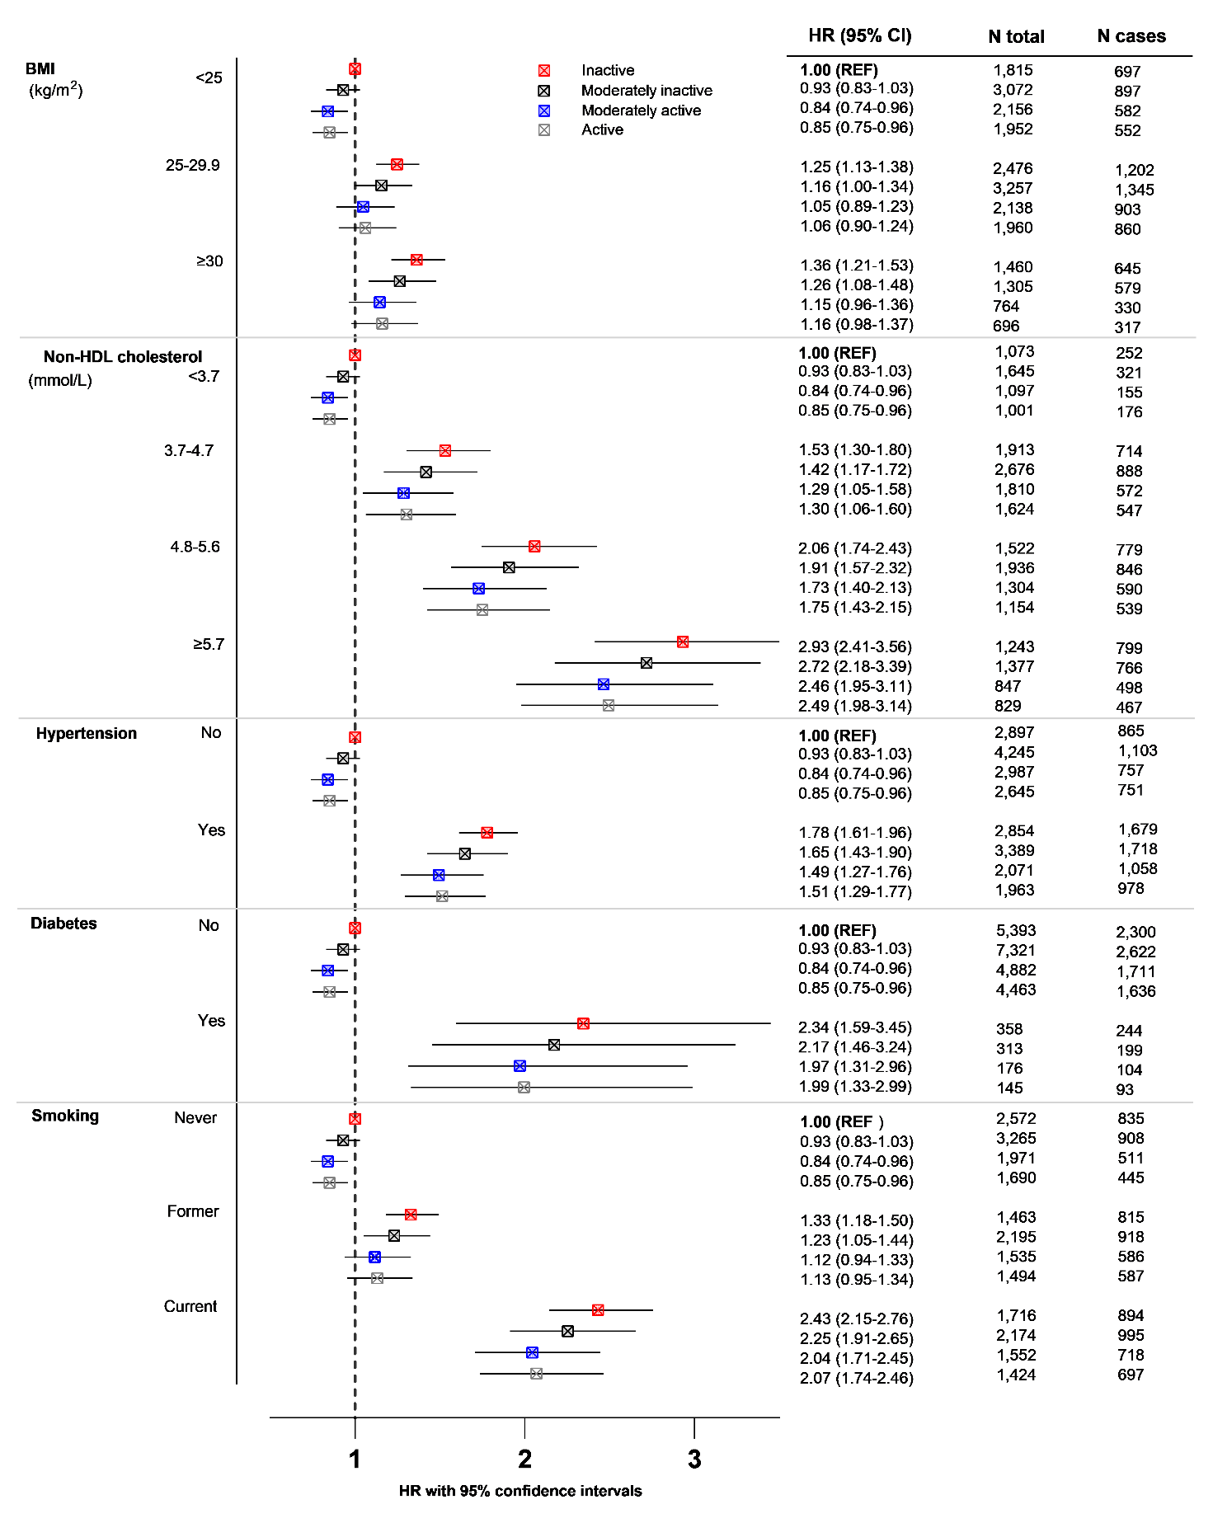

Supplementary Figure S2. Sensitivity analysis: Combined estimates of coronary heart disease (CHD) across physical activity levels amongst men with CHD risk factors defined by body mass index (BMI), total cholesterol, history of diabetes, hypertension (clinically and/or history) and smoking status and with those without the risk factor and inactive as the reference group (REF). The model for each risk factor was adjusted for age at baseline, alcohol consumption, educational level, fruit intake, vegetable intake, the other risk factors, and stratified by centre. n=10,523 participants, including 5,408 CHD cases

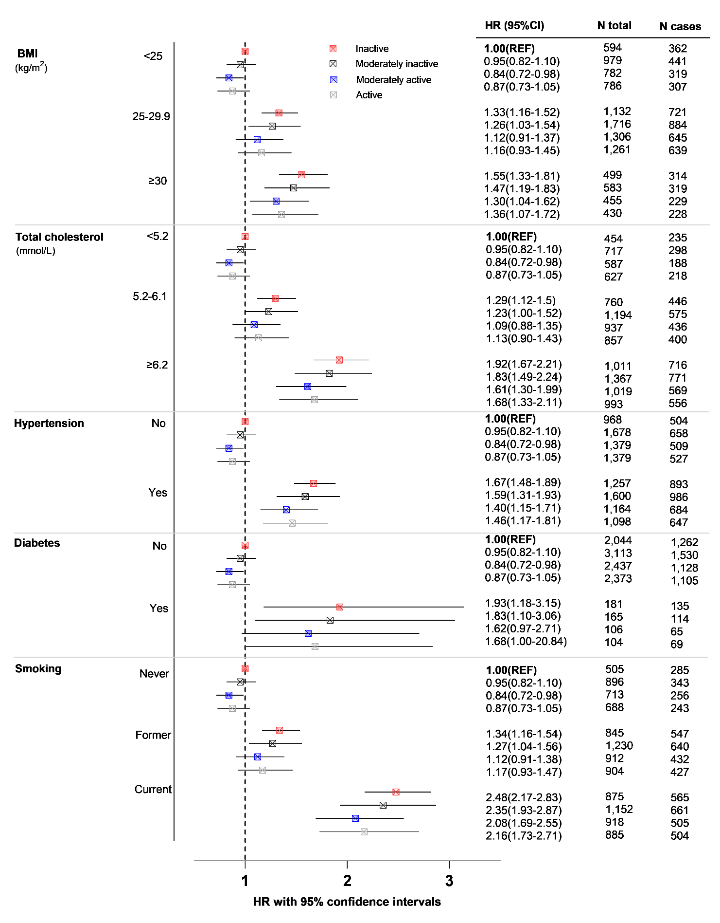
Supplementary Figure S3. Sensitivity analysis: Combined estimates of coronary heart disease (CHD) across physical activity levels amongst women with CHD risk factors defined by body mass index (BMI), total cholesterol, history of diabetes, hypertension (clinically and/or history) and smoking status and with those without the risk factor and inactive as the reference group (REF). The model for each risk factor was adjusted for age at baseline, alcohol consumption, educational level, fruit intake, vegetable intake, the other risk factors and stratified by centre. n=12,533 participants, including 3,306 CHD cases

