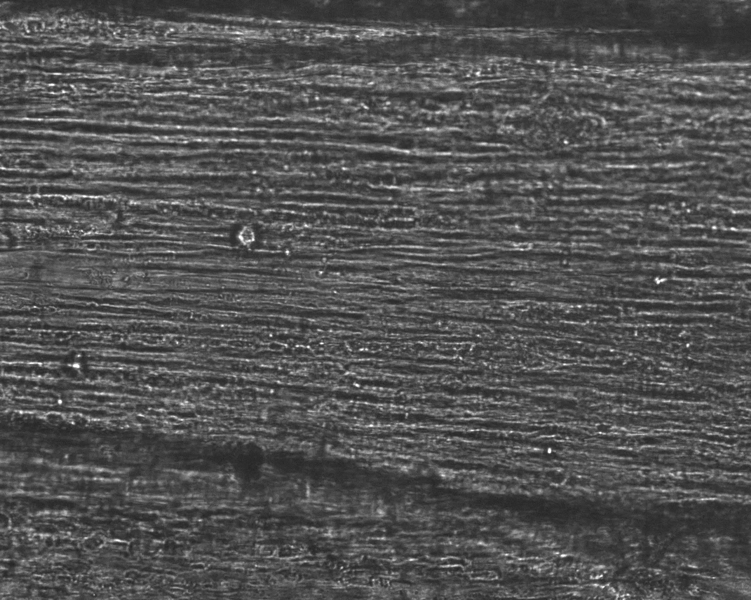
Supplementary File 1. Video of C₂C₁₂ bioengineered SkM spontaneously twitching at day 14

