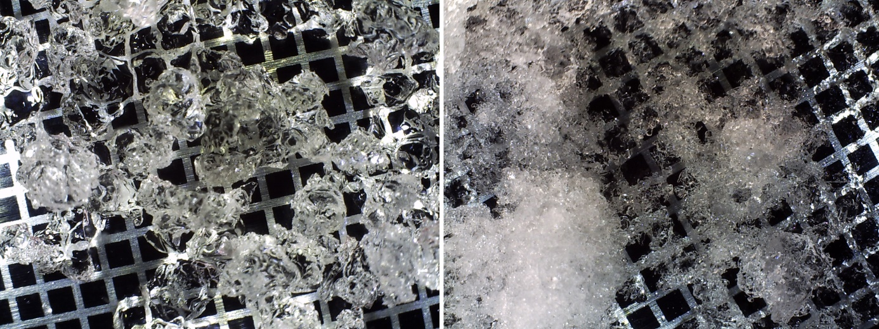
Fig. A1: left) April 8, 2018. right) March 28, 2018
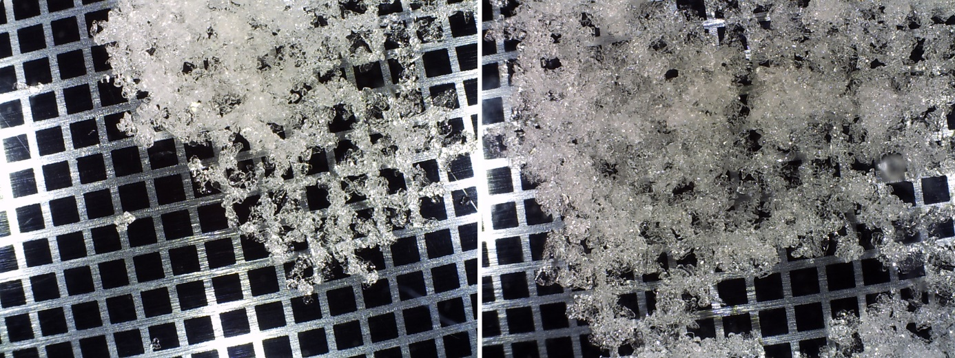
Fig. A2: left) March 4, 2018. right) March 3, 2018.
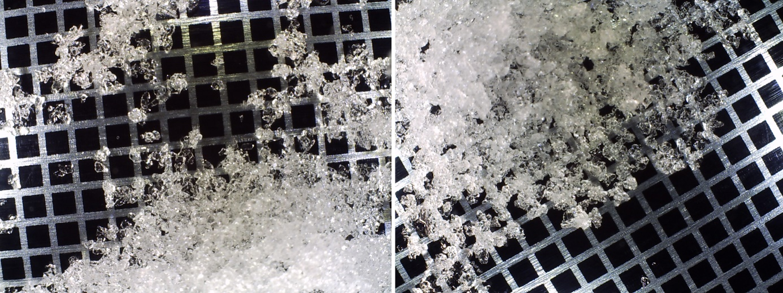
Fig. A3: left) Feb. 22, 2018. right) Feb. 21, 2018.
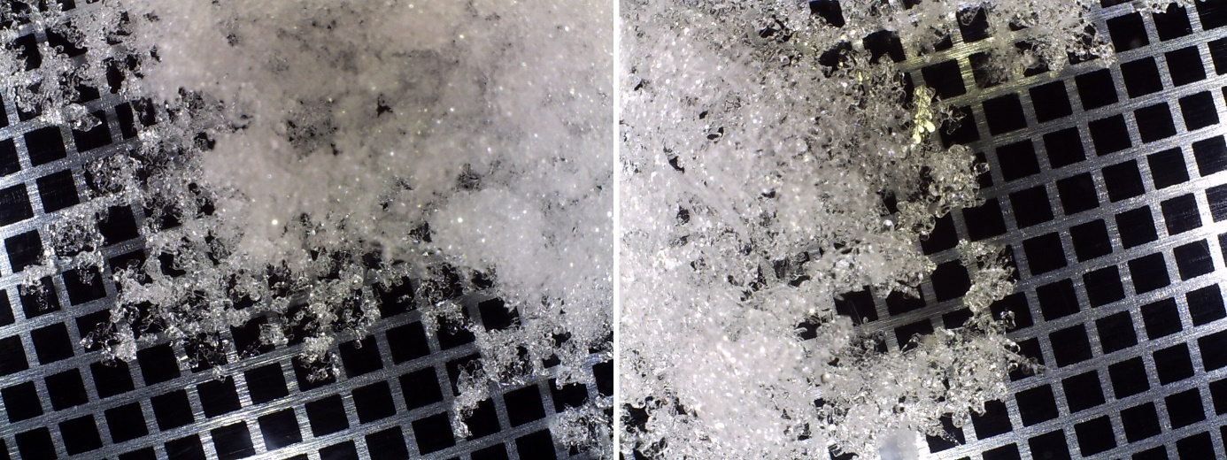
Fig. A4: left) Feb. 13, 2018. right) Feb. 8, 2018.
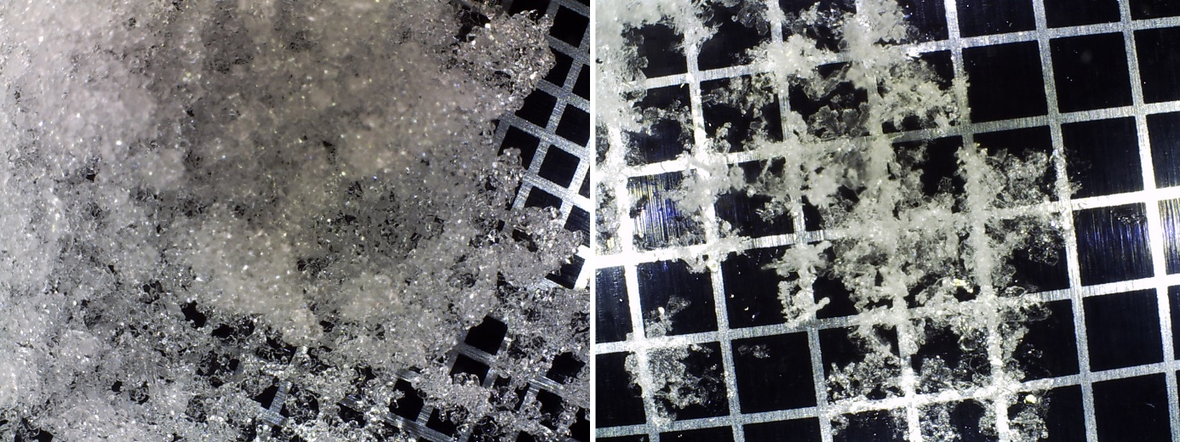
Fig. A5: left) Feb. 7, 2018. right) Feb. 1, 2018. Note that a 2-mm grid board was used.
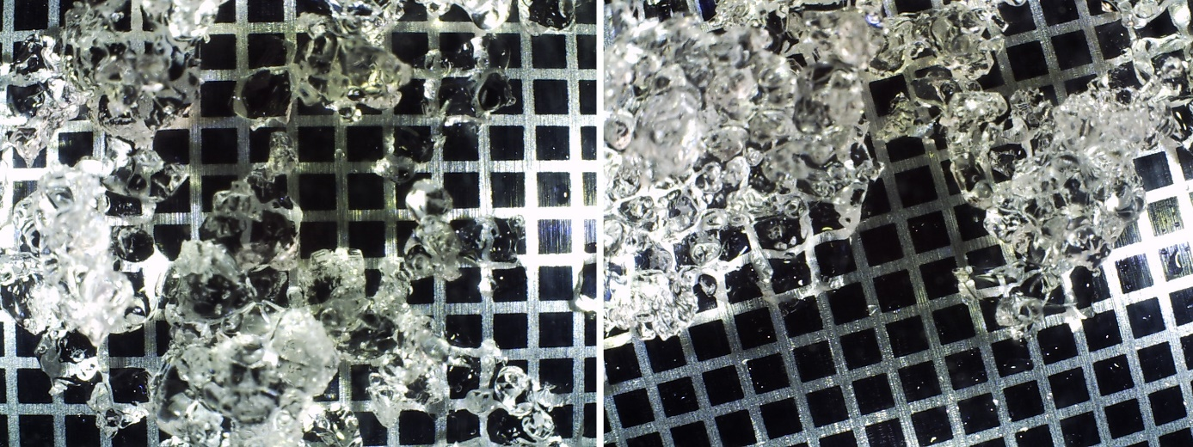
Fig. A6: left) March 31, 2017. right) March 30, 2017.
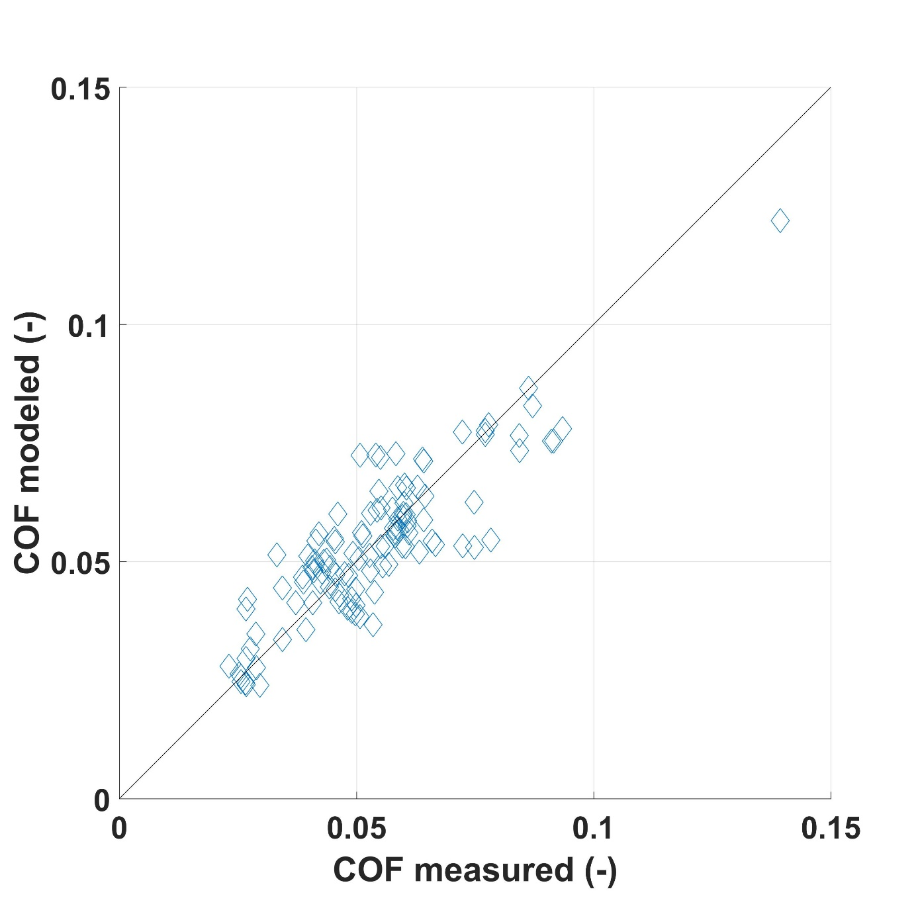
Fig. A7: Comparison of all measured and modeled COF values for ski.
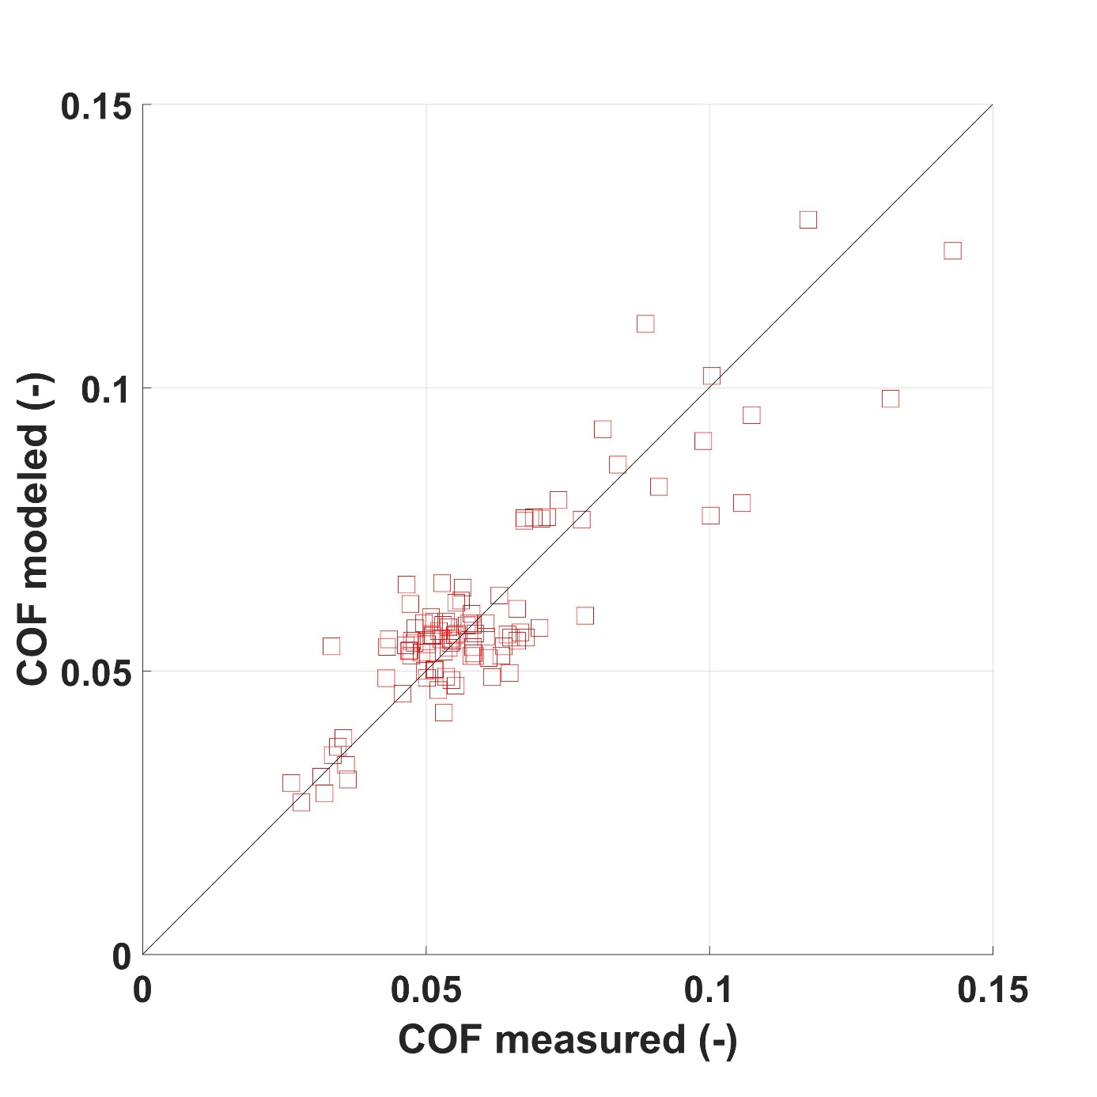
Fig. A8: Comparison of all measured and modeled COF values for snowboard.
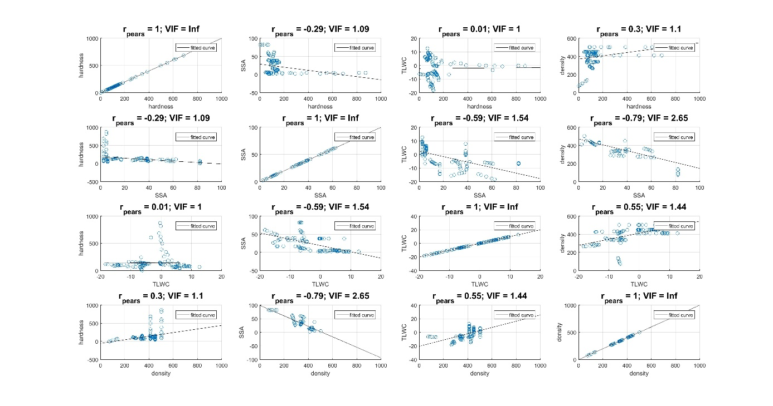
Fig. A9: Scatter plots, pearson correlation coefficient (r_{pearson}) and the variance inflation factor (VIF) to identify strong correlations between snow parameters and to quantify the severity of multicollinearity of the multivariate COF models for the group of skiers.
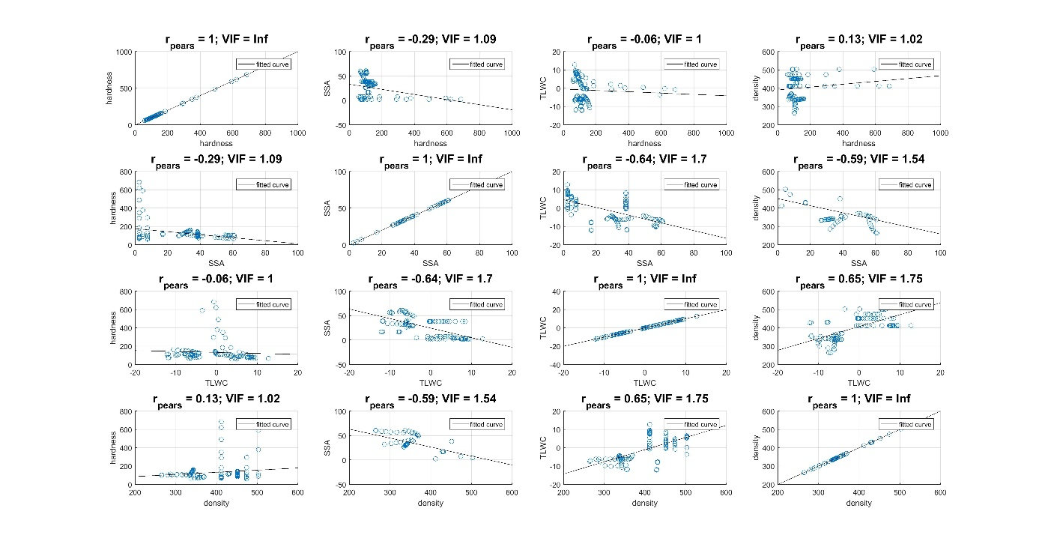
Fig. A10: Scatter plots, pearson correlation coefficient (r_{pearson}) and the variance inflation factor (VIF) to identify strong correlations between snow parameters and to quantify the severity of multicollinearity of the multivariate COF models for the group of snowboarders.
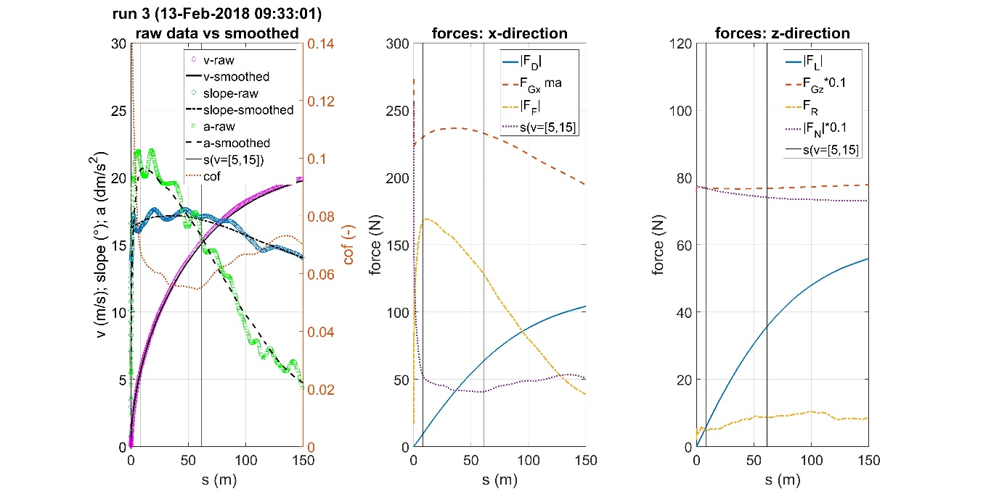
Fig. A11: Example of kinematic data of one run on Feb. 13, 2018. left) Comparison of raw and smoothed data. middle) Force components in x-direction acting on the athlete. right) Force components in z-direction acting on the athlete.
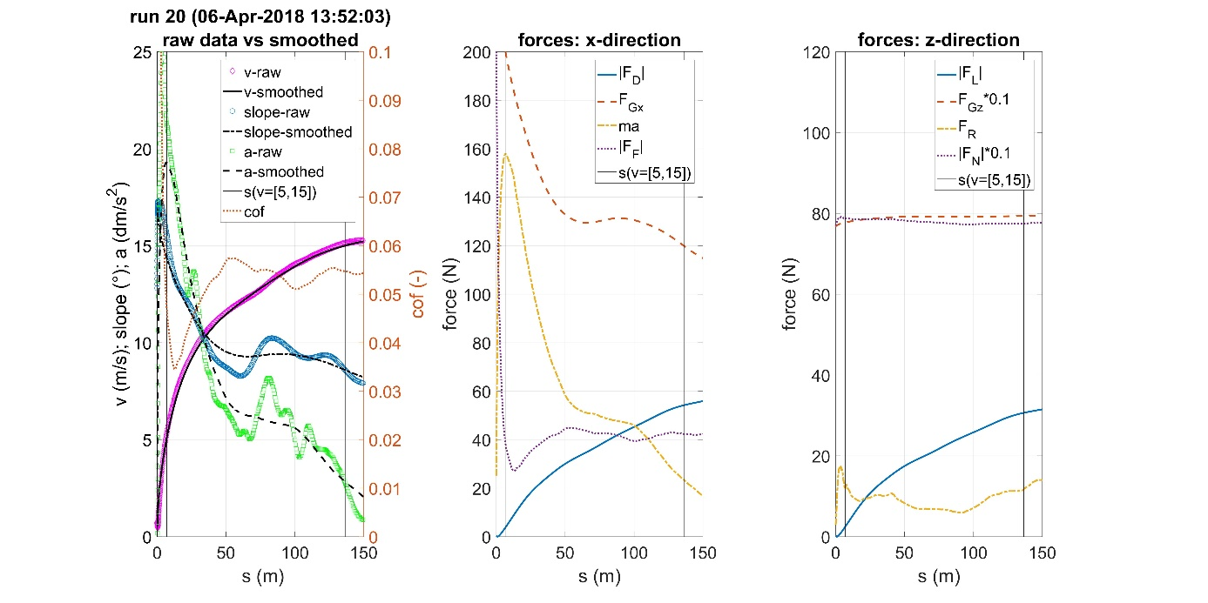
Fig. A12: Example of kinematic data of one run on April 6, 2018. left) Comparison of raw and smoothed data. middle) Force components in x-direction acting on the athlete. right) Force components in z-direction acting on the athlete.

