Original article

Speed and surface steepness affect internal tibial loading during running

Hannah Rice^{a,*}, Markus Kurz^{b,c}, Patrick Mai ^{c,d}, Leon Robertz^{d}, Kevin Bill ^{d}, Timothy R. Derrick^{e}, Steffen Willwacher ^{c,d}

ª Department of Physical Performance, Norwegian School of Sport Sciences, Oslo 0806, Norway
^{b} Sports Tech Research Centre, Mid Sweden University, Östersund SE-831 25, Sweden
^{c} Department of Mechanical and Process Engineering, Offenburg University of Applied Sciences, Offenburg 77652, Germany
^{d} Institute of Biomechanics and Orthopaedics, German Sport University Cologne, Cologne 50933, Germany
^{e} Department of Kinesiology, Iowa State University, Ames, IA 50011, USA

*Corresponding author.
Email address: hannahr@nih.no (H. Rice).

Received 18 October 2022; revised 8 December 2022; accepted 13 February 2023

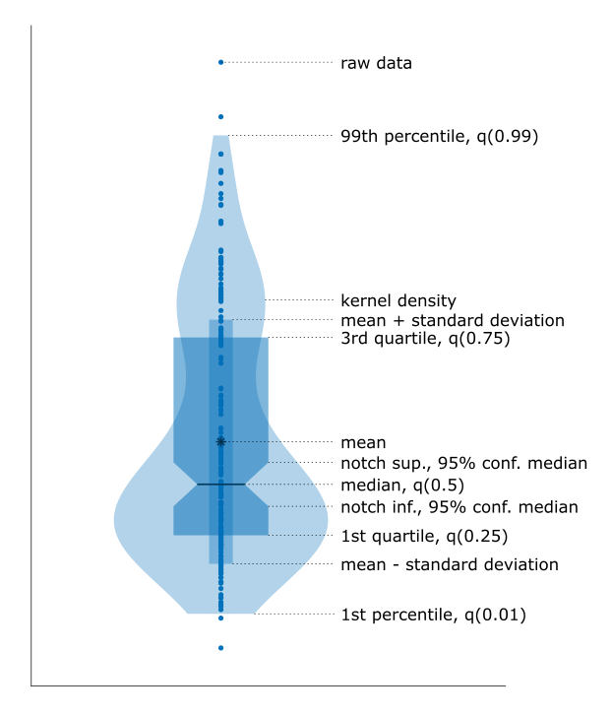

Figure key: Example plot explaining the information presented in Supplementary Figs. 2-5.

Supplementary Table 1: Resultant bending moment (Nm).

 |  | Surface gradient
 |  | Downhill |  |  |  | Level |  | Uphill
Running speed [m/s] |  | -15% | -10% | -5% |  | 0% |  | +5% | +10% | +15%
 | 2.5 m/s | 95.42 (20.76) | 101.78 (28.64) | 105.45 (26.69) |  | 121.78 (52.36) |  | 123.96 (53.02) | 130.24 (53.23) | 135.62  (56.64)
 | 3.0 m/s | 105.17 (19.78) | 110.78 (28.64 | 111.95 (27.41) |  | 130.38 (56.33) |  | 130.99 (56.99) | 138.09 (58.32) | 145.21  (60.96)
 | 3.5 m/s | 113.25 (21.20) | 118.39 (28.64) | 119.36 (29.90) |  | 139.46 (59.05) |  | 138.38 (59.69) | 147.72 (63.98) | 151.65  (63.14)

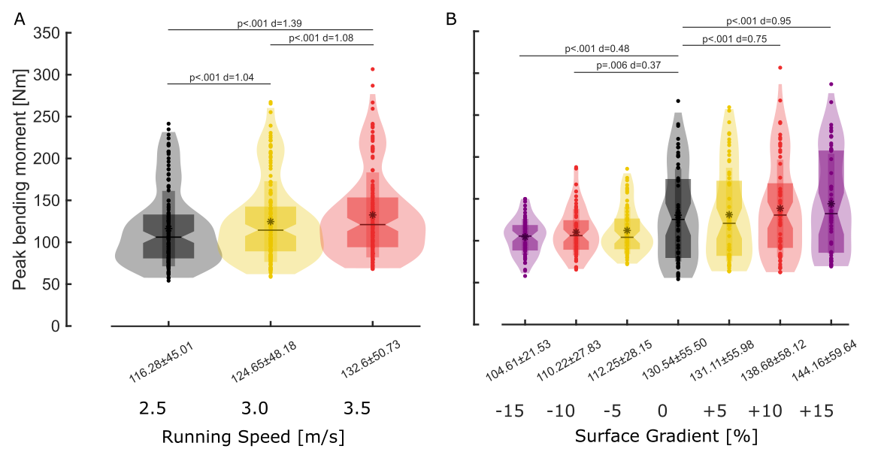

Supplementary Fig. 1: Main effect for speed (A, α_{corrected}=0.0167) and gradient (B, α_{corrected}=0.0083) on peak ML bending moment. All gradient comparisons were with level running (0%). The figure can be interpreted using the Figure Key.

Supplementary Table 2: Peak posterior tibial stress (MPa)

 |  | Surface gradient
 |  | Downhill |  |  |  | Level |  | Uphill
Running speed [m/s] |  | -15% | -10% | -5% |  | 0% |  | +5% | +10% | +15%
 | 2.5 m/s | 57.67 (11.93) | 61.53 (13.74) | 64.13 (14.95) |  | 72.53 (28.23) |  | 74.00 (28.52) | 77.67 (28.77) | 80.81 (30.64)
 | 3.0 m/s | 63.32 (11.38) | 66.86 (16.24) | 67.97 (15.52) |  | 77.82 (30.31) |  | 78.06 (30.75) | 82.17 (31.51) | 86.19 (33.16)
 | 3.5 m/s | 67.96 (11.94) | 71.35 (16.62) | 72.33 (17.00) |  | 82.69 (31.80) |  | 82.32 (32.17) | 87.58 (34.69) | 89.86 (34.40)

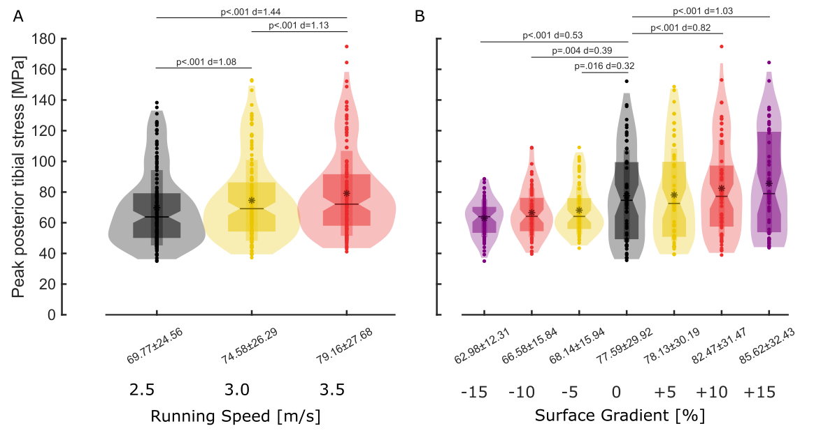
Supplementary Fig 2: Main effect for speed (A, α_{corrected}=0.0167) and gradient (B, α_{corrected}=0.0083) on peak posterior stress. All gradient comparisons were with level running (0%) The figure can be interpreted using the Figure Key.

Supplementary Table 3: Peak anterior tibial stress (MPa).

 |  | Surface gradient
 |  | Downhill |  |  |  | Level |  | Uphill
Running speed [m/s] |  | -15% | -10% | -5% |  | 0% |  | +5% | +10% | +15%
 | 2.5 m/s | 41.30 (9.93) | 43.73 (11.46) | 45.25 (12.83) |  | 53.76 (25.70) |  | 54.58 (26.12) | 57.42 (26.09) | 59.87 (27.69)
 | 3.0 m/s | 45.76 (9.60) | 48.04 (13.56) | 48.15 (12.97) |  | 57.70 (27.71) |  | 57.81 (27.92) | 61.06 (28.51) | 64.43 (29.64)
 | 3.5 m/s | 49.45 (10.39) | 51.49 (13.74) | 51.49 (14.00) |  | 61.96 (29.02) |  | 61.22 (29.24) | 65.56 (31.18) | 67.43 (30.60)

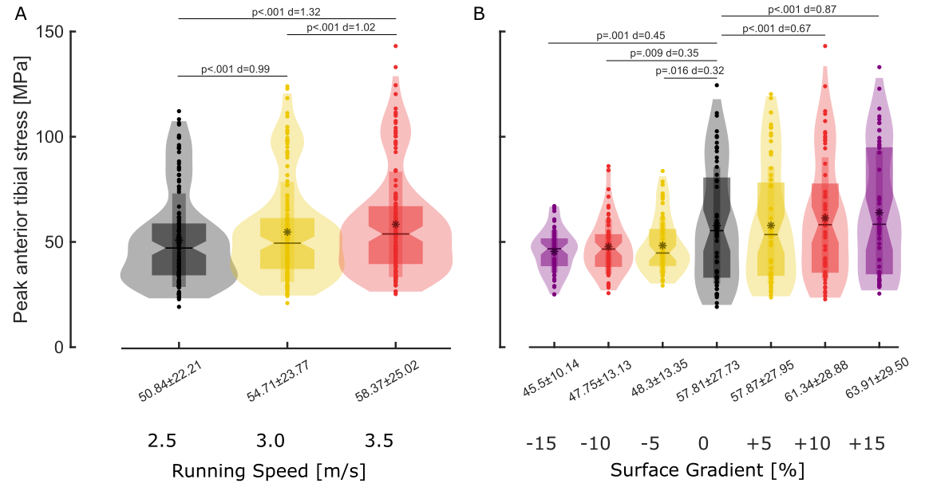

Supplementary Fig 3: Main effect for speed (A, α_{corrected}=0.0167) and gradient (B, α_{corrected}=0.0083) on peak anterior stress. All gradient comparisons were with level running (0%) The figure can be interpreted using the Figure Key.

Supplementary Fig 4: Time series displaying ML bending moments at the distal 1/3rd tibial centroid during the stance phase of running when running at different speeds (A) and gradients (B). Curves represent the mean of the runners (n = 20) with ten steps each with SD presented in A. Grey shaded regions indicate the time points during which there was a significant (p < 0.05) main effect for speed (A) and gradient (B). SD was not presented in B to maintain clarity of the figures.

Supplementary Table 4: Ground contact time (s).
 |  |  | Surface gradient
 |  |  |  | Downhill |  |  |  | Level |  | Uphill
Running speed [m/s] |  |  |  | -15% | -10% | -5% |  | 0% |  | +5% | +10% | +15%
 |  | 2.5 m/s |  | 0.27  (0.03) | 0.27  (0.03) | 0.27 (0.03) |  | 0.27  (0.02) |  | 0.28  (0.02) | 0.28  (0.02) | 0.27  (0.02)
 |  | 3.0 m/s |  | 0.25  (0.02) | 0.25  (0.02) | 0.25 (0.02) |  | 0.25  (0.02) |  | 0.25  (0.02) | 0.25  (0.02) | 0.25  (0.02)
 |  | 3.5 m/s |  | 0.23  (0.02) | 0.23  (0.02) | 0.23 (0.02) |  | 0.23  (0.02) |  | 0.23  (0.02) | 0.23  (0.02) | 0.23  (0.02)

Supplementary Table 5: Step frequency (Steps/min).

 |  | Surface gradient
 |  | Downhill |  |  |  | Level |  | Uphill
Running speed [m/s] |  | -15% | -10% | -5% |  | 0% |  | +5% | +10% | +15%
 | 2.5 m/s | 154.7  (7.5) | 154.3  (6.4) | 155.3 (6.1) |  | 157.3  (7.5) |  | 158.9 (6.6) | 158.8  (7.5) | 163.2  (8.2)
 | 3.0 m/s | 158.9  (9.8) | 158.6  (7.4) | 160.0 (7.0) |  | 161.4  (8.0) |  | 164.4 (8.1) | 165.8  (8.2) | 170.3  (10.0)
 | 3.5 m/s | 164.9  (10.5) | 163.9  (8.5) | 163.9  (7.9) |  | 166.6  (8.6) |  | 169.4 (8.1) | 172.3  (10.0) | 178.4  (11.9)

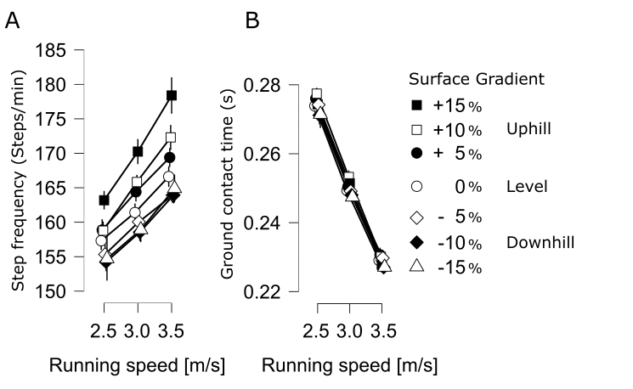
Supplementary Fig 5: Step frequency (A) and ground contact time (B) for each speed and gradient.

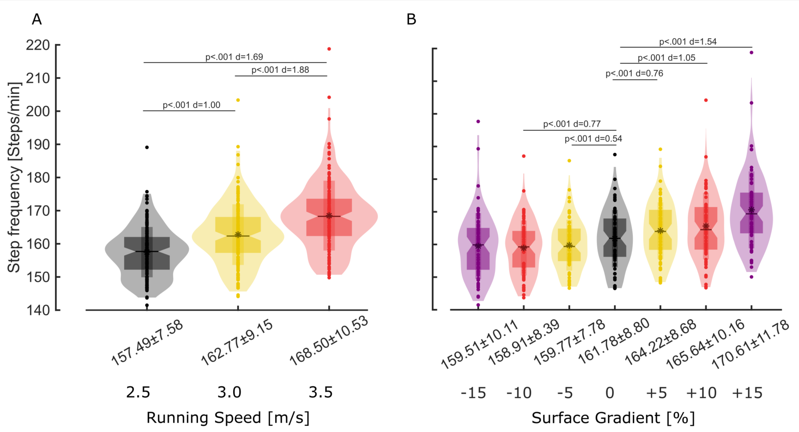Supplementary Fig 6: Main effect for speed (A, α_{corrected}=0.0167) and gradient (B, α_{corrected}=0.0083) on step frequency. All gradient comparisons were with level running (0%). The figure can be interpreted using the Figure Key.

