SUPPLEMENTAL MATERIAL LIST OF ITEMS
Supplemental Table 1: Assessment and harmonisation of covariates and adiposity measures across cohort
Supplemental Table 2: Assessment of blood biomarkers across cohort
Supplemental Table 3. Estimated regression coefficients a of isometric log ratio (ILR coordinates of daily time composition for SB, Sleep, Standing, LIPA and MVPA across all six outcomes
Supplemental Table 4. Estimated regression coefficientsª of isometric log ratio (ILR coordinates of daily time composition for SB, Sleep, Standing, LIPA and MVPA across all six outcomes with additional adjustments
Supplemental Table 5. Summary of reallocation plots and the modelled impact on each outcome
Supplemental Table 6. Summary of reallocation plots and the modelled impact on each outcome
Supplemental Table 7. Estimated regression coefficients a of isometric log ratio (ILR coordinates of daily time composition for SB, Sleep, Standing, LIPA and MVPA across all six outcomes stratified by females and males (maximal available sample)
Supplemental Table 8. Estimated regression coefficients a of isometric log ratio (ILR coordinates of daily time composition for SB, Sleep, Standing, LIPA and MVPA across all six outcomes stratified by low MVPA (<76.2min/day) and high MVPA (≥76.2min/day)
Supplemental Table 9. Estimated regression coefficients a of isometric log ratio (ILR coordinates of daily time composition for SB, Sleep, Standing, LIPA and MVPA across all six outcomes in those with >3 valid wear days (including 1+ weekend days)
Supplementary Table 10. Differences in outcomes and behaviours in complete cases (up to 12,193 depending on outcome) and those missing covariate data (n=3,047)
Supplemental Figure 1. Daily time spent in each behaviour by cohort presented as a) absolute time in hours and b) percent difference compared to overall mean of the sample (0%)
Supplemental Figure 2. Four-part isotemporal substitution model (n=15,204) for BMI outcome for a) sedentary behaviour; b) sleep; c) Light Intensity Physical Activity (LIPA); d) Moderate to Vigorous Intensity Physical Activity (MVPA)
Supplemental Figure 3. Substitution models (n=6,900) for males for BMI for a) sedentary behaviour; b) sleep; c) Standing; d) Light Intensity Physical Activity (LIPA); e) Moderate-to-Vigorous Intensity Physical Activity (MVPA).
Supplemental Figure 4. Substitution models (n=7,600) for those with low MVPA (<median: <76.2 min/day) for BMI for a) sedentary behaviour; b) sleep; c) Standing; d) Light Intensity Physical Activity (LIPA); e) Moderate-to-Vigorous Intensity Physical Activity (MVPA).
Supplemental Figure 5. Substitution models (n=7,600) for those with high MVPA (median: (≥76.2min/day) for BMI for a) sedentary behaviour; b) sleep; c) Standing; d) Light Intensity Physical Activity (LIPA); e) Moderate-to-Vigorous Intensity Physical Activity (MVPA).

Supplemental Text 1. Details of individual cohort funding

Supplemental Table 1. Overview of individual cohort details

Cohort | Sample description and age range | Sample size with valid accel data | Gender | Device | Leading institution, Country | Eligibility criteria | Ethics approval (committee name, reference number)
Australian Longitudinal Study on Women’s Health (ALSWH) | General population / 41-49 years | n=941 with accelerometer data | Females only | ActivPAL3 and ActivPAL4 micro | The University of Queensland and The University of Sydney, Australia | Women aged 40-45, not pregnant, not currently undergoing treatment for breast or reproductive cancer | Metro South Health and Health Services Human Research Ethics Committee (reference number: HREC/2019/ QMS/52052)
1970 British Cohort Study (BCS70) | General population /  46 years | n=5229 with accelerometer data | Females & males | ActivPAL3 micro | University College London, United Kingdom | Born within 1 week in April 1970 in England, Scotland or Wales | NRES Committee South East Coast - Brighton and Sussex (Ref 15/LO/1446)
Danish PHysical ACTivity cohort with Objective measurements cohort (DPhacto) | Workers in cleaning, manufacturing, and transportation companies /  18-65 years | n=771 with accelerometer data | Females & males | Actigraph GT3X | National Research Centre for the Working Environment, Denmark | Workers from manual-based jobs in manufacturing, transportation and cleaning sectors | Danish data protection agency and local Ethics Committee (H-2-2012-011).
Finnish Retirement and Aging Study (FIREA | General Population, public sector employees / 59-65 years | n=253 with accelerometer data | Females & males | ActivPAL3 | University of Turku, Finland | Public sector employees whose statutory retirement date was between 2014 and 2019 | Ethics Committee of Hospital District of Southwest Finland.
Nijmegen Exercise Study (NES) | Participants in Nijmegen 4-day Marches or Seven Hills Run, and their friends & family members /  23-87+ years | n=537 with accelerometer data | Females & males |  | Radboud University Medical Centre, Netherlands | Individuals participating in Dutch sport events (i.e. International Nijmegen Four Days Marches and the Seven Hills Run) and their family and friends. | The Local Ethics Committee on Research Involving Human Subjects (CMO) of the region Arnhem and Nijmegen, the Netherlands (NL36743.091.11)
The Maastricht Study (TMS) | General Population (Oversampling of those with T2 Diabetes) /  39-79 years | n=7515 with accelerometer data | Females& males | ActivPAL3 | Maastricht University Medical Center+ and Maastricht University, Netherlands | Individuals aged 40-75 years old, oversampling of those with Type 2 Diabetes | Institutional medical ethical committee (NL31329.068.10) and the Minister of Health, Welfare and Sports of the Netherlands (Permit 131088-105234-PG).

Supplemental Table 2. Assessment and harmonisation of covariates and adiposity measures across cohort

 | Harmonised construct | Australian Longitudinal Study on Women’s Health (n=950) | 1970 British Cohort Study (n=5263) | Danish PHysical ACTivity cohort with Objective measurements cohort (n=780) | Finnish Retirement and Aging Study (n=253) | Nijmegen Exercise Study (n=537) | The Maastricht Study (n=7515)
MAIN ANALYSES COVARIATES
Age | Continuous (years) | Question: “What is your age in years?” | All participants assigned age 46 (birth cohort study; year of birth: 1970; year of accelerometer assessment: 2016) | Determined using workers’ unique civil registration number based on time between date of birth and date of measurement visit | Derived based on time between date of birth and date of measurement visit | Derived based on time between date of birth and date of measurement visit | Derived based on time between date of birth and date of measurement visit
Sex | 1: Male  2: Female | 2: Female | 1: Male  2: Female | 1: Male  2: Female | 1: Male  2: Female | 1: Male  2: Female | 1: Male  2: Female
Smoking | 0: Non-smoker  1: Smoker | Question: "How often do you currently smoke?"  Responses & coding:  0: Not at all  1: Daily; At least weekly (but not daily); Less often than weekly | Question: “Which of the statements on this card applies to you?”  Responses & coding:  0: I've never smoked cigarettes; I used to smoke but don't at all  1: I now smoke occasionally but not daily; I smoke cigarettes every day | Question: “Do you smoke?”  Responses & coding:  0: Never smoked; Formerly smoked  1: Daily smoking; Occasionally smoking | Question: “Do you currently smoke or have you smoked regularly, i.e. daily or almost daily?”  Responses & coding:  0: No I have never smoked; Yes, previously  1: Yes, currently | Question: “Do you smoke?”  Responses & coding:  0: No, but I smoked in the past; No, I have never smoked  1: Yes | Question: “Do you smoke?”  Responses & coding:  0: No I have never smoked; No, I stopped smoking more than 6 months ago; No, I stopped less than 6 months ago  1: Yes
Alcohol consumption | 1: Lowest tertile  2: Middle tertile  3: Highest tertile  (cohort-specific tertiles) | Question: “How often do you normally drink alcohol?”  Responses & coding:  1: Less than once a week  2: 1-4 days/week  3: 5+ days/week | Units consumed in last 7 days (continuous)  Derived variable from interview questions on type, size and number of alcoholic drinks | Question: “Do you drink alcohol? How many units did you drink last week?”  (continuous) | Total intake in grams/week (continuous)  Derived from questionnaire items on amount of beer, wine and spirits | Question: “How many glasses did you consumed on average per week in the past year?”  (continuous) | Total intake in grams/day (continuous)  Derived from Food Frequency Questionnaire with a 1-year reference period
Self-rated health | Five-point Likert scale  (note due to country and language-level differences, the five-point categories were not renamed) | Question: “In general, how would you say your health is?”  Responses: excellent, very good, good, fair, poor | Question: “ In general, would you say your health is…”  Responses: excellent, very good, good, fair, poor | Question: “How will you rate your overall health?”  Reponses: Very good, good, fairly good, poor, very poor | Question: “How would you rate your overall health?”  Reponses: Good, rather good, average, rather poor, poor | Question: “How could you describe your health status?”  Question: Excellent, good, fair, moderate, poor | Question: “ In general, would you say your health is…”  Responses: excellent, very good, good, fair, poor
Medication use | 0: No lipid modifying, hypertensive or glucose lowering medications  1: 1 or more of the above | Protocol: Participants were asked to bring all medications to the assessment, which were coded using  Anatomical Therapeutic Chemical classification  Anatomical Therapeutic Chemical classification | Protocol: Research nurses collected data on all prescription medications which were coded using British National Formulary edition 69 codes  Responses & coding:  1: Any of 0212 : Lipid-Regulating Drugs;  0201 – 0207: hypertension related drugs; 0601 Drugs Used In Diabetes | Questions: “Have you in the last three months been taken prescription medication?” “If yes, what kind of medication?”  Responses & coding:  1: Antihypertensive  0: No medications or other medications  Questions: “Do you take medication for high blood pressure?  Responses & coding:  1: Yes  2: No | Protocol: Research nurses inquired about all prescription medications, which were coded using  Anatomical Therapeutic Chemical classification  1: Any of X01 anti-hypertensive drug;  X02 diabetes drug; X04= cholesterol medicine | Questions: “Did you use medication in the past year?” was asked immediately following positive responses to “Which of the following diseases below has been diagnosed by physician?” for 1) hypercholesterolemia; 2) hypertension; 3) diabetes  Responses & coding:  1: Yes for any of above  0: No | Protocol: Participants were asked to bring all medications to the assessment, which were coded using  Anatomical Therapeutic Chemical classification  Anatomical Therapeutic Chemical classification
History of cardiovascular conditions | 0: No history of CVD  1: History of CVD | Questions:  Wave 1:"Have you ever been told by a doctor that you have heart disease"  Wave 2: "[In the last 4 years] [In more than 4 years ago], have you ever been told by a doctor that you have heart disease?”  Waves 3-8: "In the last 3 years have you been diagnosed or treated for heart disease?"  Wave 8: "In the last 3 years have you been diagnosed or treated for hypertension?"  Responses & coding:  0: No to all of above  1: Yes to any of above | Questions: “Since last collection wave, have you had any of the health problems listed on this card? [high blood pressure]”  “Since last collection wave, have you had any of the health problems listed on this card? Please include any health problems that had already started before that date. [heart problems]/ [stroke]”.  Responses & coding:  0: No to all of above  1: Yes to any of above | Question: “Do you have angina pectoris?”  Responses & coding:  0: No  1: Yes | Questions: “Has a doctor/physician given you a diagnosis of [angina pectoris]/[myocardial infarction]/[stroke]/ [hypertension]?”  Responses & coding:  0: No to all of above  1: Yes to any of above | Questions: “Which type of diseases below has been diagnosed by physician? [myocardial infarction]/ [heart failure]/ [stroke]/ [atrial fibrillation]/ [hypertension]”  Responses & coding:  0: No to all of above  1: Yes to any of above | Questions: Rose Questionnaire  Responses:  1: Selected any of myocardial infarction - cerebrovascular infarction and/or hemorrhage - percutaneous artery angioplasty of the coronary arteries, abdominal arteries, peripheral arteries or carotid artery - vascular surgery on coronary arteries, abdominal arteries, peripheral arteries or carotid artery.  0: selected none of the above
SUPPLEMENTARY ANALYSES COVARIATES
Education | 0: None or lower than high school  1: High school qualifications (age 16y)  2: Further education qualifications (age 16-18y)  3: university degree and higher (18+y) | Question: “What is the highest level of qualification you have completed?”  Responses & coding:  0: No formal qualifications  1: Year 10 or equivalent  2: Year 12 or equivalent, Trade/apprenticeship, Certificate/Diploma  3: University degree, Higher university degree | Derived variable of National Vocational Qualifications categories based on self-reported “recognised academic, vocational, clerical, business or commercial qualifications” asked at each wave  Responses & coding:  0: No academic qualification  1: GCDS D-E, GCSE A-C, CSES 2-5, Other Scottish qualifications, Good O levels Scottish standards  2: As levels or 1 A level; 2+ A levels, Scottish higher/6th, diploma  3: Degree level, Higher degree | N/A | N/a | Question: “Please select your highest educational qualification from the list below”  Responses & coding:  0: lower education (primary school), lower pre-vocational education (low)  1: pre-vocational education (moderate), secondary education (moderate)  2: middle-level applied education (moderate)  3: higher professional education (high),  university (high) | Question: “What is your highest completed educational level?”  Responses & coding:  0: None, Uncompleted primary educational level, Primary educational level  1: Lower vocational education, Intermediate general secondary education  2: Intermediate vocational education, Higher general secondary education, Higher vocational education  3: University education
Occupational class | 0: Not working  1: Low occupational class  2: Intermediate occupational class  3: High occupational class | Question: “What is your main occupation now?”  Responses & coding:  0: No paid job  1: Elementary clerical, sales or service worker; Labourer or related worker  2: Tradesperson or related worker; Advanced clerical or service worker; Intermediate clerical; sales/service worker; Intermediate production or transport worker  3: Manager or administrator; Professional; Associate professional | Derived variable of National Statistics Socio-economic Classification (NS-SEC) based on participants “[description] in [their] own words what [they] mainly did in this job ]  Responses & coding:  0: Never worked and long-term unemployed  1: L10 Lower supervisory occupations; L11 Lower technical occupations; L12 Semi-routine occupations; L13 Routine occupations  2: L5 Lower managerial and administrative; L6 Higher supervisory occupations; L7 Intermediate occupations; L8 Employers in small organisations; L9 Own account workers  3: L1 Employers in large establishments; L2 Higher managerial and administrative; L3 Higher professional occupations; L4 Lower professional and higher technical | Derived variable pulled from personnel lists of companies:  Coding:  1= production worker AND unskilled  2=production worker AND skilled  2= Administration and office workers AND skilled or unskilled | Derived variable from the Register of Pension Institute Keva of International Standard Classification of Occupations (ISCO)  Responses & coding:  1: plant and machine operators, and assemblers; elementary occupations  2: clerical support workers; service and sales workers; skilled agricultural, forestry and fishery workers; craft and related trades workers  3: managers; professionals; technicians and associate professionals | N/a | Question: “Which category best fits your current/past job?”  Responses & coding:  0: Not working  1: Low occupational class  2: Intermediate occupational class; Self-employed  3: High occupational class, Professionals
Mobility limitations | Continuous score from 0 to 100 of the SF 10-item physical function, where 0 indicates poor mobility and 100 indicates no mobility problems. | Available in ALSWH, BCS70, NES and TMS only.  Each used the SF-36 scale. The 10-items included limitations in: vigorous activities, moderate activities, lifting and carrying groceries, climbing several flights of stairs, climbing one flight of stairs, bending, kneeling or stooping, walking about two kilometers, walking about a half kilometer, in walking about 100 metres, in bathing or dressing. Each item had three possible responses: Yes, limited a lot (0); Yes, limited a little (50); No, not limited at all (100). Mobility limitations score was calculated as the average score across all ten items.
OUTCOMES
BMI | Continuous measure (kg/m²) | Derived from clinical measurement of height (stadiometer) and weight (digital scale)  Stadiometer models:ª  QLD: ADE (no name)  VIC: Seca BE35208  SA: Seca (no name)  WA: ADE MZ10023  NSW: ADE (no name)  Weigh scale models:ª  QLD: Seca 813  VIC: Seca BE38844  SA: Soehnle EB9373  WA: Perma Lifestyle Professional Slimline Body Monitor  NSW: Seca 813 | Derived from clinical measurement of height (without shoes; portable Leicester stadiometer  and weight (Tanita BF-522W scales) | Derived from clinical measurement of height (without shoes; stadiometer- Seca, model 213) and weight (Tanita bio-impedance segmental body composition analyzer- model BC418 MA) | Derived from clinical measurement of height (without shoes) and weight  using Inbody 720 scale (Biospace Co.,  Seoul, Korea) | Derived from clinical measurement of height (without shoes) and weight (Seca 881) | Derived from clinical measurement of height (stadiometer – Seca 222) and weight (Seca 877)
Waist circumference | Continuous measure (cm) | Average of 2 measurements taken with a Seca tape measure to the nearest mm. If measures differed by 5mm, a 3rd measure was taken.  Measured in millimetres at the midpoint between the bottom of the last palpable rib and top of the iliac crest. | Average of 2 measurements taken with a Seca tape measure to nearest mm. If measures differed by 3+ cm, a 3rd measure was taken.  Measured in milimetres midway between the lower rib margin and iliac crest. | Single measurement with an anthropometric tape measure.  Measured in millimetres at a level midway between the lower rib margin and iliac crest | Average of 2 measurements with an anthropometric tape measure and directly on the participant's skin.  Measured in millimetres at a level midway between the lower rib margin and iliac crest. | Single measurement with an anthropometric tape measure directly on the participant’s skin taken when the participant exhaled.  Measured in cm  at a level midway between the lower rib margin and iliac crest. | Average of 2 measurements taken with a flexible plastic tape measure (Seca, Hamburg, Germany).  Measured to the nearest 0.5cm midway between the lower rib margin and the iliac crest at the end of expiration

Supplemental Table 3. Assessment of blood biomarkers across cohort

 | Harmonised construct | Australian Longitudinal Study on Women’s Health (n=950) | 1970 British Birth Cohort Study (n=5263) | Finnish Retirement and Aging Study (n=253) | Nijmegen Exercise Study (n=537) | The Maastricht Study (n=7515)
Collection of blood samples |  | Nurses collected non-fasting venous blood samples in morning. | Nurses collected non-venous blood samples at various times throughout day. | Nurses collected fasting venous blood samples in the morning. | Blood was draw and freezed (-80 degrees Celcius) and analysed within 5 months. | Trained research staff collected venous blood samples in the morning
Fasted/non-fasted blood sample | 0: Non-fasted  1: Fasted | 0: All participants provided non-fasted sample | 0: All participants provided non-fasted sample | 1: All participants provided fasted sample. | 0: Did not fast for 4 hours OR had light meal 4-8 hours before blood draw  1: Fasted for 4 hours AND did not have Light meal 4-8 hours before blood-draw | 1: All participants provided fasted sample
Total cholesterol | Continuous measure (mmol/L) | Measured using routine autoanalyser methods.  QLD/VIC samples  Method principle: Cholesterol oxidase, esterase, peroxidase  Manufacturer: Beckman Coulter DXC800  CV: <1.8%  SA/WA/NSW samples:  Method principle:  Cholesterol oxidase, esterase, peroxidase  Manufacturer: Siemens Atellica  CV: <2% | Method principle: Enzymatic colourimetric- cholesterol esterase/cholesterol oxidase/peroxidase  Manufacturer: Roche Cobas c702, generation 2 assay  CV: ≤2.6% | Measured with standard (enzymatic and colorimetric) methods  Manufacturer: Cobas 8000 c702, Roche Diagnostics  CV: ≤4.8% | Method priniciple: Enzymatic- cholesterol esterase and cholesterol oxidase  Manufacturer: Siemens Attelica CH  CV: ≤1.3% | Measured with standard (enzymatic and/or colorimetric) methods  Manufacturer: Beckman Synchron LX20, Beckman Coulter Inc., Brea, USA; or Roche Cobas 6000, Roche diagnostics, Mannheim, Germany  CV: ≤2.5%
HDL | Continuous measure (mmol/L) | Measured using routine autoanalyser methods.  QLD/VIC samples  Method principle: Direct measure, polymer-polyanion  Manufacturer: Beckman Coulter DXC800  CV: <3%  SA/WA/NSW samples  Method principle:  Direct measure, polymer-polyanion  Manufacturer: Siemens Atellica  CV: <3.2% | Method principle: Enzymatic colourimetric- dextran sulphate/PEG-cholesterol esterase/PEG-cholesterol oxidase/peroxidase.  Manufacturer: Roche Cobas c702, generation 3 assay  CV: ≤2.8% | Measured with standard (enzymatic and colorimetric) methods  Manufacturer: Cobas 8000 c702, Roche Diagnostics  CV: ≤6.1% | Method priniciple: Enzymatic- cholesterol esterase and cholesterol oxidase  Manufacturer: Siemens Attelica CH  CV: ≤2.0% | Measured with standard (enzymatic and/or colorimetric) methods by an automatic analyzer  Manufacturer: Beckman Synchron LX20, Beckman Coulter Inc., Brea, USA; or Roche Cobas 6000, Roche diagnostics, Mannheim, Germany  CV: ≤4.5%
Total:HDL cholesterol ratio | Continuous measure (mmol/L) | Derived as total cholesterol/HDL cholesterol
HbA1c | Continuous measure (mmol/L) | Measured using routine autoanalyser methods.  Method principle: High performance liquid chromatography  Manufacturer: Bio-Rad D100  CV: <1.5% | Method principle: Ion exchange HPLC. Manufacturer: Tosoh G8  CV: ≤3.3% | n/a | n/a | Method principle: Ion-exchange high performance liquid chromatography  Manufacturer: Variant tm II, Bio-Rad, Hercules, California, USA  CV: ≤1.2%
Triglycerides | Continuous measure (mmol/L) | Measured using routine autoanalyser methods.  QLD/VIC samples  Method principle: Enzymatic, end point  Manufacturer: Beckman Coulter DXC800  CV: <3.3%  SA/WA/NSW samples  Method principle:  Enzymatic, end point  Manufacturer: Siemens Atellica  CV: <3.4% | Method principle: Enzymatic colourimetric: lipoprotein lipase/glycerol kinase/glycerol phosphate oxidase/peroxidase Manufacturer: Roche Cobas c702  CV: ≤2.4% | Measured with standard (enzymatic and colorimetric) methods  Manufacturer: Cobas 8000 c702, Roche Diagnostics  CV: ≤5.3% | Method priniciple: Enzymatic- endpoint  Manufacturer: Siemens Attelica CH  CV: ≤2.5% | Measured with standard (enzymatic and/or colorimetric) methods by an automatic analyzer (Beckman Synchron LX20, Beckman Coulter Inc., Brea, USA; or Roche Cobas 6000, Roche diagnostics, Mannheim, Germany  CV: ≤3.5%
CV: coefficient of variation QLD: Queensland VIC: Victoria SA: South Australia WA: West Australia NSW: New South Wales

Supplemental Table 4. Estimated regression coefficients a of isometric log ratio (ILR coordinates of daily time composition for SB, Sleep, Standing, LIPA and MVPA across all six outcomes
OUTCOME * | Sample size | Sleep | SB | Standing | LIPA | MVPA
Model 1a: Adjusted for age, sex, cohort (95% CI) in maximal sample size
BMI † | 15,204 | -0.72 (-1.05, -0.40) | 3.75 (3.47, 4.03) | -0.43 (-0.73, -0.12) | -0.90 (-1.23, -0.57) | -1.69 (-1.92, -1.47)
Waist circumference † | 14,541 | -1.73 (-2.58, -0.87) | 10.51 (9.78, 11.24) | -3.28 (-4.08, -2.48) | 1.47 (0.61, 2.33) | -6.98 (-7.57, -6.38)
HDL‡ | 13,060 | -0.06 (-0.09, -0.03) | -0.19 (-0.22, -0.16) | 0.05 (0.03, 0.08) | -0.03 (-0.06, 0.00) ^{ns} | 0.23 (0.21, 0.25)
Total:HDL ratio ‡ | 13,059 | 0.21 (0.12, 0.29) | 0.35 (0.27, 0.42) | -0.16 (-0.24, -0.08) | -0.04 (-0.12, 0.05) ^{ns} | -0.36 (-0.42, -0.30)
Triglycerides ‡ | 11,270 | 0.10 (0.02, 0.18) | 0.30 (0.23, 0.37) | -0.19 (-0.27, -0.12) | 0.06 (-0.03, 0.14) ^{ns} | -0.26 (-0.32, -0.21)
HbA1c § | 12,240 | -1.02 (-1.66, -0.38) | 3.55 (3.00, 4.11) | -0.78 (-1.38, -0.17) | 2.35 (1.70, 3.01) | -4.11 (-4.56, -3.67)
Model 1b: Adjusted for age, sex, cohort (95% CI) in complete cases
BMI † | 12,166 | -0.70 (-1.07, -0.33) | 3.77 (3.46, 4.09) | -0.30 (-0.64, 0.04) | -0.99 (-1.36, -0.63) | -1.78 (-2.03, -1.52)
Waist circumference † | 11,965 | -1.56 (-2.51, -0.61) | 10.48 (9.67, 11.29) | -2.99 (-3.87, -2.11) | 1.26 (0.31, 2.20) | -7.18 (-7.83, -6.54)
HDL‡ | 10,788 | -0.07 (-0.10, -0.03) | -0.19 (-0.22, -0.16) | 0.04 (0.01, 0.08) | -0.02 (-0.05, 0.02) ^{ns} | 0.23 (0.21, 0.26)
Total:HDL ratio ‡ | 10,787 | 0.21 (0.12, 0.31) | 0.32 (0.24, 0.41) | -0.12 (-0.21, -0.03) | -0.07 (-0.16, 0.03) ^{ns} | -0.35 (-0.41, -0.28)
Triglycerides ‡ | 9,459 | 0.12 (0.03, 0.21) | 0.26 (0.18, 0.33) | -0.16 (-0.24, -0.07) | 0.05 (-0.04, 0.14) ^{ns} | -0.27 (-0.33, -0.21)
HbA1c § | 10,405 | -0.90 (-1.59, -0.21) | 3.37 (2.78, 3.96) | -0.48 (-1.13, 0.16) ^{ns} | 2.08 (1.39, 2.77) | -4.06 (-4.53, -3.60)
Model 2: Adjusted for age, sex, cohort, smoking status, alcohol consumption, self-reported health, medications, CVD history
BMI † | 12,166 | -0.88 (-1.23, -0.53) | 3.31 (3.00, 3.61) | -0.33 (-0.65, -0.02) | -1.36 (-1.71, -1.01) | -0.91 (-1.16, -0.66)
Waist circumference † | 11,965 | -1.96 (-2.87, -1.05) | 9.18 (8.40, 9.96) | -6.85 (-7.71, -6.00) | 0.22 (-0.69, 1.12) ^{ns} | -4.82 (-5.46, -4.18)
HDL‡ | 10,788 | -0.05 (-0.09, -0.02) | -0.15 (-0.18, -0.12) | 0.22 (0.19, 0.25) | 0.02 (-0.02, 0.05) ^{ns} | 0.15 (0.13, 0.17)
Total:HDL ratio ‡ | 10,787 | 0.20 (0.10, 0.29) | 0.28 (0.20, 0.37) | -0.48 (-0.57, -0.39) | -0.13 (-0.23, -0.04) | -0.25 (-0.31, -0.18)
Triglycerides ‡ | 9,459 | 0.10 (0.01, 0.19) | 0.19 (0.11, 0.26) | -0.28 (-0.36, -0.20) | -0.02 (-0.11, 0.07) ^{ns} | -0.14 (-0.20, -0.08)
HbA1c § | 10,405 | -1.08 (-1.72, -0.44) | 2.09 (1.54, 2.64) | -1.08 (-1.65, -0.50) | 1.24 (0.60, 1.88) | -2.04 (-2.48, -1.59)
* Linear regression. Coefficients indicate change in continuous outcome per 1 unit increase in the corresponding ILR coordinate. Value >0 indicates more time spent in the behaviour relative to others is associated with higher outcome values; value <0 indicates that more time spent in the behaviour relative to others is associated with lower outcome values.
† Outcome measured in all six cohorts
‡ Outcome measured in five cohorts: ALSWH, BCS70, NES, TMS, FIREA
§ Outcome measured in three cohorts: ALSWH, BCS70, TMS
^{ns} indicates non-significant results; all other estimates are significant at p<0.05
Coefficients indicate the change in outcome (e.g. m/kg2 or mmol/L) for each 1 unit ilr increase. Therefore, coefficients indicate the presence of an association, but effect size is not directly interpretable due to the isometric log-ratio transformation.

Supplemental Table 5. Estimated regression coefficientsª of isometric log ratio (ILR coordinates of daily time composition for SB, Sleep, Standing, LIPA and MVPA across all six outcomes with additional covariate adjustments
OUTCOME | Sample size | Sleep | SB | Standing | LIPA | MVPA
Model 1: Adjusted for age, sex, cohort (95% CI) in complete cases §
BMI | 10232 | -0.79 (-1.20, -0.39) | 3.87 (3.52, 4.21) | -0.24 (-0.61, 0.14) | -0.94 (-1.34, -0.53) | -1.90 (-2.18, -1.62)
Waist circumference | 10226 | -1.76 (-2.79, -0.73) | 10.55 (9.67, 11.42) | -2.91 (-3.86, -1.95) | 1.52 (0.50, 2.54) | -7.40 (-8.10, -6.69)
HDL | 9255 | -0.06 (-0.10, -0.02) | -0.19 (-0.22, -0.16) | 0.04 (0.00, 0.07) | -0.03 (-0.07, 0.01) ^{ns} | 0.24 (0.21, 0.27)
Total:HDL ratio | 9255 | 0.21 (0.10, 0.31) | 0.29 (0.20, 0.38) | -0.09 (-0.19, 0.00) ^{ns} | -0.05 (-0.15, 0.05) ^{ns} | -0.36 (-0.43, -0.28)
Triglycerides | 8074 | 0.13 (0.03, 0.23) | 0.24 (0.16, 0.33) | -0.17 (-0.26, -0.08) | 0.07 (-0.02, 0.17) ^{ns} | -0.28 (-0.34, -0.21)
HbA1c | 10226 | -1.76 (-2.79, -0.73) | 10.55 (9.67, 11.42) | -2.91 (-3.86, -1.95) | 1.52 (0.50, 2.54) | -7.40 (-8.10, -6.69)
Model 2: Adjusted for age, sex, cohort, smoking status, alcohol consumption, self-reported health, medications, CVD history §
BMI | 10232 | -0.87 (-1.25, -0.48) | 3.33 (3.00, 3.66) | -0.33 (-0.68, 0.02) | -1.30 (-1.68, -0.91) | -1.04 (-1.32, -0.77)
Waist circumference | 10226 | -1.90 (-2.88, -0.92) | 9.11 (8.26, 9.95) | -6.91 (-7.83, -5.98) | 0.50 (-0.47, 1.48) ^{ns} | -5.10 (-5.79, -4.40)
HDL | 9255 | -0.05 (-0.09, -0.02) | -0.15 (-0.18, -0.12) | 0.22 (0.18, 0.25) | 0.01 (-0.03, 0.04) ^{ns} | 0.16 (0.13, 0.18)
Total:HDL ratio | 9255 | 0.20 (0.10, 0.31) | 0.26 (0.17, 0.34) | -0.45 (-0.55, -0.36) | -0.11 (-0.21, -0.01) | -0.27 (-0.34, -0.20)
Triglycerides | 8074 | 0.11 (0.02, 0.21) | 0.17 (0.09, 0.25) | -0.29 (-0.38, -0.21) | 0.01 (-0.09, 0.11) ^{ns} | -0.15 (-0.21, -0.08)
HbA1c | 10226 | -1.90 (-2.88, -0.92) | 9.11 (8.26, 9.95) | -6.91 (-7.83, -5.98) | 0.50 (-0.47, 1.48) ^{ns} | -5.10 (-5.79, -4.40)
Model 3: Adjusted for age, sex, cohort, smoking status, alcohol consumption, self-reported health, medications, CVD history, education, physical limitations, occupational class §
BMI | 10232 | -0.93 (-1.31, -0.55) | 3.40 (3.07, 3.73) | -0.18 (-0.53, 0.17) | -1.66 (-2.04, -1.28) | -0.62 (-0.89, -0.35)
Waist circumference | 10226 | -2.04 (-3.00, -1.07) | 9.15 (8.31, 9.99) | -2.75 (-3.64, -1.86) | -0.33 (-1.29, 0.64) ^{ns} | -4.03 (-4.72, -3.34)
HDL | 9255 | -0.05 (-0.09, -0.01) | -0.15 (-0.18, -0.12) | 0.04 (0.00, 0.07) | 0.02 (-0.02, 0.05) ^{ns} | 0.15 (0.12, 0.17)
Total:HDL ratio | 9255 | 0.20 (0.10, 0.30) | 0.29 (0.20, 0.38) | -0.09 (-0.19, 0.00) ^{ns} | -0.15 (-0.26, -0.05) | -0.24 (-0.31, -0.17)
Triglycerides | 8074 | 0.10 (0.01, 0.20) | 0.20 (0.11, 0.28) | -0.15 (-0.24, -0.06) | -0.03 (-0.13, 0.07) ^{ns} | -0.11 (-0.18, -0.04)
HbA1c | 10226 | -2.04 (-3.00, -1.07) | 9.15 (8.31, 9.99) | -2.75 (-3.64, -1.86) | -0.33 (-1.29, 0.64) ^{ns} | -4.03 (-4.72, -3.34)
ª Linear regression. Coefficients indicate change in continuous outcome per 1 unit increase in the corresponding ILR coordinate. Value >0 indicates more time spent in the behaviour relative to others is associated with higher outcome values; value <0 indicates that more time spent in the behaviour relative to others is associated with lower outcome values.
§ Outcome measured in three cohorts: ALSWH, BCS70, TMS
^{ns} indicates non-significant results; all other estimates are significant at p<0.05
Note: coefficients are not directly interpretable in relation to change in outcome

Supplemental Table 6. Summary of reallocation plots and the modelled impact on each outcome
 | Impact on outcome when reallocating behaviour (listed in left column) into*:
 | SB | Sleep | Stand | LIPA | MVPA
BMI
SB |  | ↓ | ↓ | ↓ | ↓
Sleep | ↑ |  | - | ↓ | ↓
Stand | ↑ | - |  | ↓ | ↓
LIPA | ↑ | ↑ | ↑ |  | ↓
MVPA | ↑ | ↑ | ↑ | ↑
Waist circumference
SB |  | ↓ | ↓ | ↓ | ↓
Sleep | ↑ |  | ↓ | ↑ | ↓
Stand | ↑ | ↑ |  | ↑ | ↓
LIPA | - | - | ↓ |  | ↓
MVPA | ↑ | ↑ | ↑ | ↑
HDL cholesterol †
SB |  | ↑ | ↑ | - | ↓
Sleep | - |  | ↑ | - | ↓
Stand | ↑ | ↑ |  | ↓ | ↓
LIPA | - | - | ↑ |  | ↓
MVPA | ↑ | ↑ | ↑ | ↑
Total:HDL cholesterol
SB |  | - | ↓ | - | ↓
Sleep | - |  | ↓ | - | ↓
Stand | ↑ | ↑ |  | - | ↓
LIPA | - | - | - |  | ↓
MVPA | ↑ | ↑ | ↑ | ↑
Triglycerides
SB |  | - | ↓ | - | ↓
Sleep | - |  | ↓ | - | ↓
Stand | ↑ | ↑ |  | ↑ | ↓
LIPA | - | - | ↓ |  | ↓
MVPA | ↑ | ↑ | ↑ | ↑
HbA1c
SB |  | ↓ | ↓ | ↑ | ↓
Sleep | ↑ |  | - | ↑ | ↓
Stand | ↑ | - |  | ↑ | ↓
LIPA | ↓ | ↓ | ↓ |  | ↓
MVPA | ↑ | ↑ | ↑ | ↑
↑ displacement associated with increase in outcome
↓ displacement associated with decrease in outcome
- no impact on outcome
* based on age-sex-cohort adjusted models
† higher HDL scores indicate healthier outcome

Supplemental Table 7. Estimated regression coefficients a of isometric log ratio (ILR coordinates of daily time composition for SB, Sleep, Standing, LIPA and MVPA across all six outcomes stratified by females and males (maximal available sample)
OUTCOME * | Sample size | Sleep | SB | Standing | LIPA | MVPA
Model 1a: Adjusted for age, sex, cohort (95% CI) in females
BMI † | 8300 | -0.82 (-1.33, -0.32) | 4.55 (4.13, 4.97) | -0.49 (-0.94, -0.03) | -1.27 (-1.76, -0.77) | -1.97 (-2.34, -1.61)
Waist circumference † | 8031 | -2.20 (-3.47, -0.94) | 11.82 (10.77, 12.88) | -3.31 (-4.44, -2.17) | 1.26 (0.02, 2.50) | -7.58 (-8.49, -6.66)
HDL‡ | 6926 | -0.07 (-0.12, -0.02) | -0.22 (-0.26, -0.18) | 0.07 (0.03, 0.12) | -0.05 (-0.10, 0.00) | 0.26 (0.23, 0.30)
Total:HDL ratio ‡ | 6925 | 0.23 (0.12, 0.34) | 0.38 (0.29, 0.47) | -0.21 (-0.31, -0.11) | 0.03 (-0.08, 0.15) ^{ns} | -0.43 (-0.51, -0.35)
Triglycerides ‡ | 5973 | 0.11 (0.02, 0.20) | 0.31 (0.23, 0.38) | -0.24 (-0.32, -0.15) | 0.12 (0.03, 0.21) | -0.30 (-0.37, -0.24)
HbA1c § | 6448 | -1.18 (-1.97, -0.39) | 3.13 (2.46, 3.79) | -1.14 (-1.87, -0.41) | 2.67 (1.87, 3.46) | -3.47 (-4.04, -2.89)
Model 1a: Adjusted for age, sex, cohort (95% CI) in males
BMI † | 6900 | -0.59 (-0.99, -0.19) | 2.80 (2.45, 3.16) | -0.27 (-0.66, 0.13) | -0.54 (-0.96, -0.11) | -1.41 (-1.69, -1.14)
Waist circumference † | 6506 | -1.13 (-2.26, 0.00) ^{ns} | 8.98 (7.98, 9.98) | -2.97 (-4.08, -1.86) | 1.52 (0.33, 2.71) | -6.40 (-7.17, -5.63)
HDL‡ | 6124 | -0.06 (-0.09, -0.02) | -0.16 (-0.19, -0.12) | 0.03 (-0.01, 0.06) ^{ns} | -0.01 (-0.05, 0.03) ^{ns} | 0.20 (0.17, 0.22)
Total:HDL ratio ‡ | 6124 | 0.25 (0.12, 0.39) | 0.31 (0.19, 0.43) | -0.14 (-0.27, -0.02) | -0.09 (-0.23, 0.05) ^{ns} | -0.33 (-0.42, -0.24)
Triglycerides ‡ | 5291 | 0.14 (0.00, 0.27) | 0.30 (0.18, 0.42) | -0.19 (-0.32, -0.06) | -0.01 (-0.15, 0.13) ^{ns} | -0.24 (-0.33, -0.16)
HbA1c § | 5782 | -0.94 (-1.94, 0.06) | 3.99 (3.10, 4.88) | -0.43 (-1.41, 0.55) ^{ns} | 1.97 (0.93, 3.02) | -4.59 (-5.26, -3.92)
* Linear regression. Coefficients indicate change in continuous outcome per 1 unit increase in the corresponding ILR coordinate. Value >0 indicates more time spent in the behaviour relative to others is associated with higher outcome values; value <0 indicates that more time spent in the behaviour relative to others is associated with lower outcome values.
† Outcome measured in all six cohorts
‡ Outcome measured in five cohorts: ALSWH, BCS70, NES, TMS, FIREA [four cohorts for male stratified models as ALSWH is female only]
§ Outcome measured in three cohorts: ALSWH, BCS70, TMS [four cohorts for male stratified models as ALSWH is female only]
^{ns} indicates non-significant results; all other estimates are significant at p<0.05
Coefficients indicate the change in outcome (e.g. m/kg2 or mmol/L) for each 1 unit ilr increase. Therefore, coefficients indicate the presence of an association, but effect size is not directly interpretable due to the isometric log-ratio transformation.

Supplemental Table 8. Estimated regression coefficients a of isometric log ratio (ILR coordinates of daily time composition for SB, Sleep, Standing, LIPA and MVPA across all six outcomes stratified by low MVPA (<76.2min/day) and high MVPA (≥76.2min/day)
OUTCOME * | Sample size | Sleep | SB | Standing | LIPA | MVPA
Model 1a: Adjusted for age, sex, cohort (95% CI) in those with low MVPA
BMI † | 7600 | -0.92 (-1.37, -0.46) | 4.35 (3.93, 4.77) | -0.71 (-1.16, -0.26) | -1.47 (-1.96, -0.98) | -1.26 (-1.71, -0.80)
Waist circumference † | 7438 | -4.47 (-5.69, -3.25) | 14.46 (13.33, 15.58) | -7.64 (-8.82, -6.45) | 4.76 (3.46, 6.06) | -7.11 (-8.30, -5.91)
HDL‡ | 6554 | 0.04 (0.00, 0.08) ^{ns} | -0.30 (-0.34, -0.26) | 0.21 (0.17, 0.24) | -0.17 (-0.21, -0.13) | 0.23 (0.19, 0.27)
Total:HDL ratio ‡ | 6553 | -0.02 (-0.14, 0.11) ^{ns} | 0.60 (0.48, 0.71) | -0.54 (-0.66, -0.42) | 0.31 (0.17, 0.44) | -0.34 (-0.47, -0.22)
Triglycerides ‡ | 5421 | 0.04 (-0.07, 0.16) ^{ns} | 0.41 (0.30, 0.51) | -0.41 (-0.53, -0.30) | 0.24 (0.12, 0.37) | -0.28 (-0.39, -0.16)
HbA1c § | 6314 | -1.58 (-2.51, -0.66) | 5.83 (4.97, 6.69) | -1.77 (-2.69, -0.85) | 3.49 (2.48, 4.50) | -5.97 (-6.88, -5.05)
Model 1a: Adjusted for age, sex, cohort (95% CI) in those with high MVPA
BMI † | 7600 | -1.21 (-1.69, -0.74) | 3.02 (2.62, 3.41) | -0.34 (-0.73, 0.04) | -0.10 (-0.50, 0.31) | -1.36 (-1.82, -0.90)
Waist circumference † | 7099 | -5.73 (-7.11, -4.34) | 12.24 (11.08, 13.40) | -7.23 (-8.34, -6.11) | 6.99 (5.81, 8.17) | -6.28 (-7.65, -4.90)
HDL‡ | 6496 | 0.05 (-0.01, 0.11) ^{ns} | -0.35 (-0.39, -0.30) | 0.26 (0.22, 0.31) | -0.26 (-0.31, -0.21) | 0.29 (0.24, 0.35)
Total:HDL ratio ‡ | 6496 | -0.03 (-0.16, 0.11) ^{ns} | 0.59 (0.47, 0.70) | -0.48 (-0.59, -0.37) | 0.39 (0.27, 0.50) | -0.47 (-0.60, -0.34)
Triglycerides ‡ | 5843 | -0.09 (-0.22, 0.03) ^{ns} | 0.40 (0.30, 0.50) | -0.30 (-0.40, -0.21) | 0.20 (0.10, 0.31) | -0.21 (-0.32, -0.09)
HbA1c § | 5916 | -1.56 (-2.44, -0.69) | 1.41 (0.68, 2.15) | -0.79 (-1.49, -0.10) | 2.09 (1.36, 2.82) | -1.15 (-2.00, -0.30)
* Linear regression. Coefficients indicate change in continuous outcome per 1 unit increase in the corresponding ILR coordinate. Value >0 indicates more time spent in the behaviour relative to others is associated with higher outcome values; value <0 indicates that more time spent in the behaviour relative to others is associated with lower outcome values.
† Outcome measured in all six cohorts
‡ Outcome measured in five cohorts: ALSWH, BCS70, NES, TMS, FIREA
§ Outcome measured in three cohorts: ALSWH, BCS70, TMS
^{ns} indicates non-significant results; all other estimates are significant at p<0.05
Coefficients indicate the change in outcome (e.g. m/kg2 or mmol/L) for each 1 unit ilr increase. Therefore, coefficients indicate the presence of an association, but effect size is not directly interpretable due to the isometric log-ratio transformation.

Supplemental Table 9. Estimated regression coefficients a of isometric log ratio (ILR coordinates of daily time composition for SB, Sleep, Standing, LIPA and MVPA across all six outcomes in those with >3 valid wear days (including 1+ weekend days)
OUTCOME * | Sample size | Sleep | SB | Standing | LIPA | MVPA
Model 1a: Adjusted for age, sex, cohort (95% CI) in maximal sample size
BMI † | 14668 | -0.84 (-1.17, -0.50) | 3.80 (3.51, 4.09) | -0.33 (-0.64, -0.02) | -0.97 (-1.30, -0.63) | -1.67 (-1.90, -1.44)
Waist circumference † | 14040 | -2.09 (-2.96, -1.21) | 10.71 (9.96, 11.46) | -2.96 (-3.78, -2.15) | 1.35 (0.47, 2.22) | -7.01 (-7.61, -6.40)
HDL‡ | 12712 | -0.06 (-0.10, -0.03) | -0.20 (-0.22, -0.17) | 0.06 (0.03, 0.09) | -0.03 (-0.06, 0.00) | 0.23 (0.21, 0.25)
Total:HDL ratio ‡ | 12711 | 0.21 (0.13, 0.30) | 0.35 (0.27, 0.42) | -0.17 (-0.25, -0.09) | -0.04 (-0.13, 0.05) ^{ns} | -0.35 (-0.41, -0.29)
Triglycerides ‡ | 10998 | 0.12 (0.03, 0.20) | 0.28 (0.21, 0.36) | -0.19 (-0.27, -0.11) | 0.06 (-0.02, 0.14) ^{ns} | -0.27 (-0.33, -0.21)
HbA1c § | 11942 | -1.05 (-1.69, -0.41) | 3.52 (2.96, 4.07) | -0.63 (-1.24, -0.02) | 2.37 (1.71, 3.02) | -4.21 (-4.65, -3.76)
Model 1b: Adjusted for age, sex, cohort (95% CI) in complete cases
BMI † | 11807 | -0.79 (-1.16, -0.41) | 3.82 (3.50, 4.14) | -0.26 (-0.61, 0.08) | -1.02 (-1.39, -0.65) | -1.76 (-2.01, -1.50)
Waist circumference † | 11615 | -1.84 (-2.81, -0.87) | 10.67 (9.85, 11.50) | -2.86 (-3.75, -1.96) | 1.22 (0.26, 2.18) ^{ns} | -7.20 (-7.85, -6.54)
HDL‡ | 10506 | -0.07 (-0.10, -0.03) | -0.20 (-0.23, -0.17) | 0.05 (0.01, 0.08) | -0.02 (-0.06, 0.01) ^{ns} | 0.24 (0.21, 0.26)
Total:HDL ratio ‡ | 10505 | 0.21 (0.11, 0.31) | 0.32 (0.24, 0.41) | -0.13 (-0.22, -0.04) | -0.07 (-0.17, 0.02) ^{ns} | -0.33 (-0.40, -0.26)
Triglycerides ‡ | 9235 | 0.13 (0.03, 0.22) | 0.25 (0.17, 0.33) | -0.15 (-0.24, -0.06) | 0.05 (-0.05, 0.14) ^{ns} | -0.27 (-0.33, -0.21)
HbA1c § | 10167 | -0.84 (-1.53, -0.15) | 3.33 (2.74, 3.93) | -0.40 (-1.05, 0.25) ^{ns} | 2.08 (1.38, 2.77) | -4.17 (-4.64, -3.71)
Model 2: Adjusted for age, sex, cohort, smoking status, alcohol consumption, self-reported health, medications, CVD history
BMI † | 11807 | -0.96 (-1.32, -0.60) | 3.35 (3.04, 3.66) | -0.31 (-0.63, 0.01) | -1.40 (-1.75, -1.04) | -0.88 (-1.14, -0.63)
Waist circumference † | 11615 | -2.23 (-3.16, -1.31) | 9.37 (8.58, 10.16) | -6.80 (-7.67, -5.93) | 0.16 (-0.76, 1.08) ^{ns} | -4.81 (-5.46, -4.16)
HDL‡ | 10506 | -0.05 (-0.09, -0.02) | -0.15 (-0.18, -0.12) | 0.22 (0.19, 0.26) | 0.02 (-0.02, 0.05) ^{ns} | 0.15 (0.13, 0.17)
Total:HDL ratio ‡ | 10505 | 0.19 (0.10, 0.29) | 0.29 (0.20, 0.37) | -0.49 (-0.58, -0.40) | -0.14 (-0.24, -0.05) | -0.23 (-0.30, -0.16)
Triglycerides ‡ | 9235 | 0.10 (0.01, 0.19) | 0.18 (0.10, 0.26) | -0.27 (-0.35, -0.19) | -0.02 (-0.11, 0.07) | -0.14 (-0.20, -0.07)
HbA1c § | 10167 | -1.00 (-1.64, -0.36) | 2.06 (1.51, 2.61) | -0.99 (-1.57, -0.41) | 1.18 (0.54, 1.82) | -2.12 (-2.57, -1.67)
* Linear regression. Coefficients indicate change in continuous outcome per 1 unit increase in the corresponding ILR coordinate. Value >0 indicates more time spent in the behaviour relative to others is associated with higher outcome values; value <0 indicates that more time spent in the behaviour relative to others is associated with lower outcome values.
† Outcome measured in all six cohorts
‡ Outcome measured in five cohorts: ALSWH, BCS70, NES, TMS, FIREA
§ Outcome measured in three cohorts: ALSWH, BCS70, TMS
^{ns} indicates non-significant results; all other estimates are significant at p<0.05
Coefficients indicate the change in outcome (e.g. m/kg2 or mmol/L) for each 1 unit ilr increase. Therefore, coefficients indicate the presence of an association, but effect size is not directly interpretable due to the isometric log-ratio transformation.

Supplementary Table 10. Differences in outcomes and behaviours in complete cases (up to 12,193 depending on outcome) and those missing covariate data (n=3,047)
 | Complete cases  (up to n=12,193) |  |  | Missing 1+covariate (n=3,047)
OUTCOMES (mean±SD) |  | n |  |  | n
BMI (kg/m²) | 27.0±4.8 | 12,166 |  | 27.2±5.3 | 3,034
Waist circumference (cm) | 94.0±13.7 | 11,965 |  | 94.4±14.6 | 2,572
HDL cholesterol (mmol/L) | 1.57 ±0.47 | 10,788 |  | 1.48±0.42 | 2,269
HDL: total cholesterol ratio | 3.79±1.28 | 10,787 |  | 3.61±1.22 | 2,269
HbA1c (mmol/mol) | 37.9±8.6 | 10,405 |  | 38.6±9.8 | 1,832
Triglycerides (mmol/L) | 1.47±1.02 | 9,459 |  | 1.53±1.12 | 1,809
MOVEMENT BEHAVIOURSª (hrs/day; % of time spent)
Sleep | 7.7hrs | 31.9% |  | 7.6hrs | 31.6%
Sedentary behaviour | 10.4hrs | 43.2% | 10.3hrs |  | 42.9%
Standing | 3.1hrs | 13.0% |  | 3.2hrs | 13.2%
LIPA | 1.5hrs | 6.4% |  | 1.6hrs | 6.7%
MVPA | 1.3hrs | 5.5% |  | 1.4hrs | 5.7%
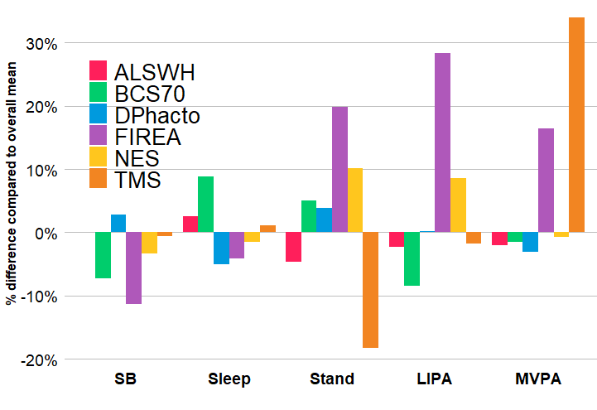
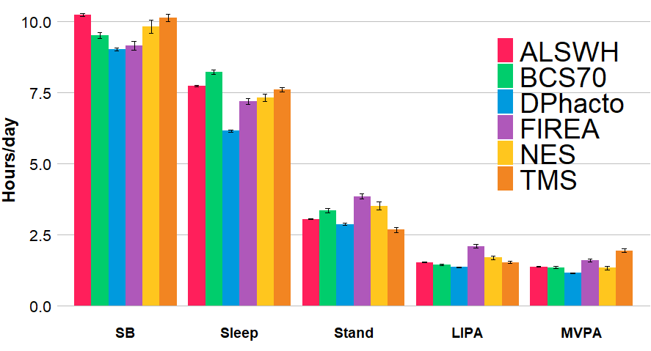
Supplemental Figure 1. Daily time spent in each behaviour by cohort presented as a) absolute time in hours and b) percent difference compared to overall mean of the sample (0%)
a
b

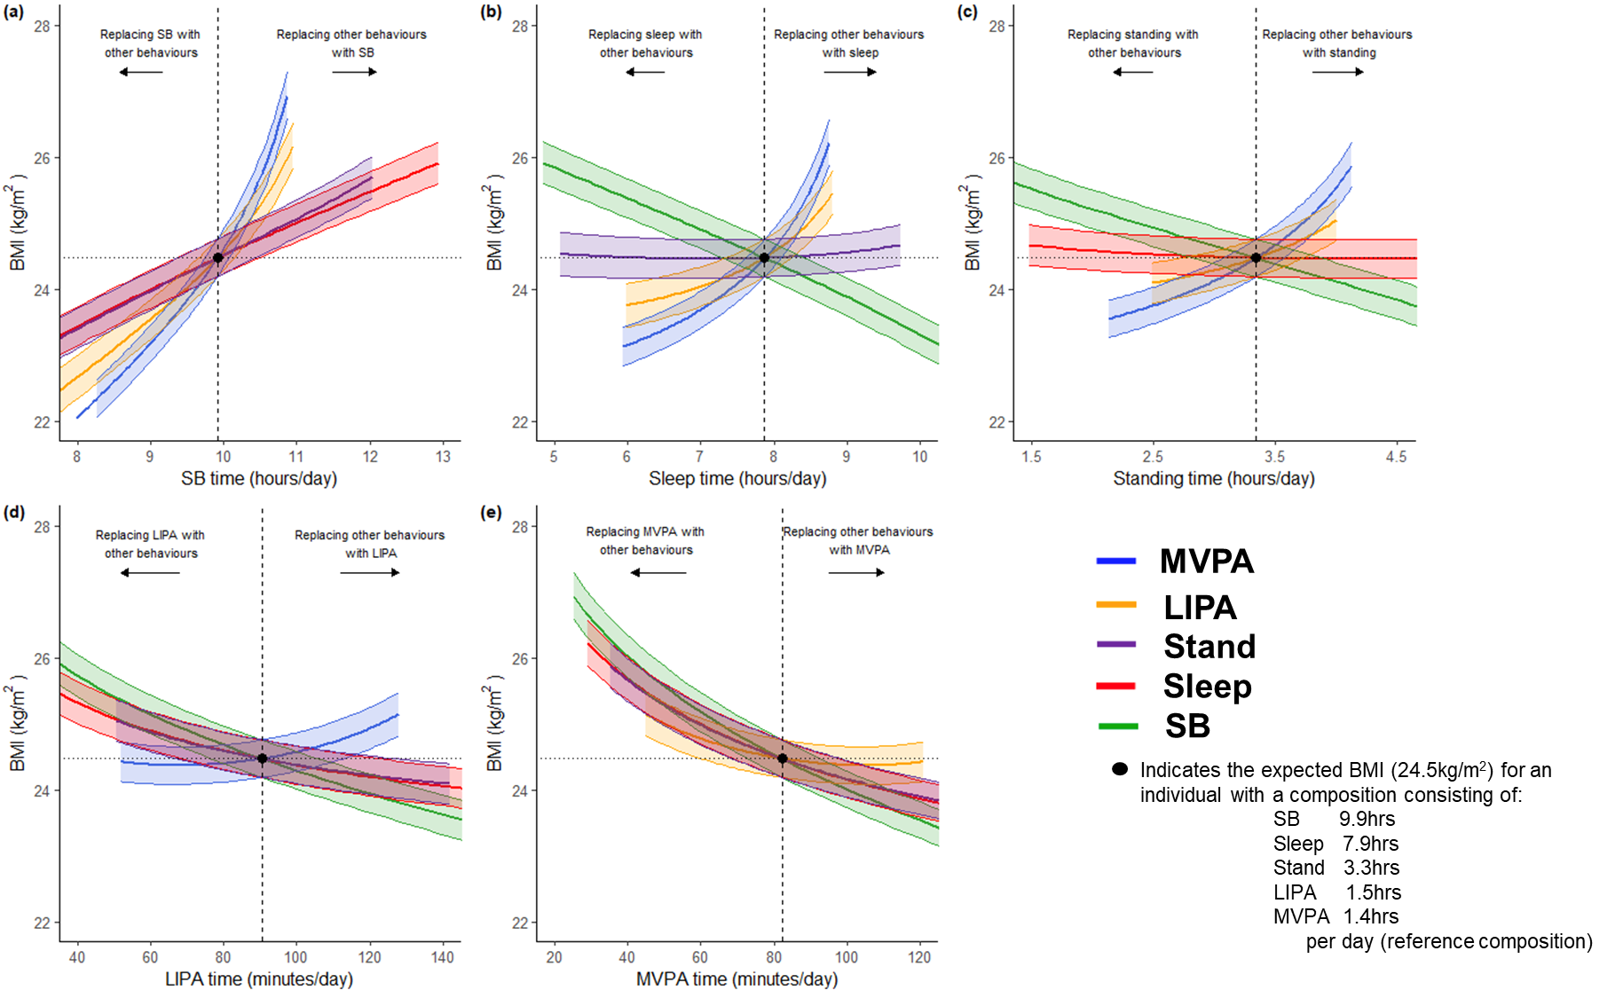

Supplemental Figure 2. Substitution models (n=8,300) for females for BMI for a) sedentary behaviour; b) sleep; c) Standing; d) Light Intensity Physical Activity (LIPA); e) Moderate-to-Vigorous Intensity Physical Activity (MVPA). Data to the left of the reference line indicates the predicted change in BMI if a given behaviour (e.g. SB in panel a) is replaced by each of the other four behaviours. Data to the right of the reference line indicates the predicted change in BMI if a given behaviour (e.g. SB in panel a) replaces each of the other four behaviours. Model adjusted for age (ref: 53.7 years; mean-centred) and cohort (ref: Maastricht Study).

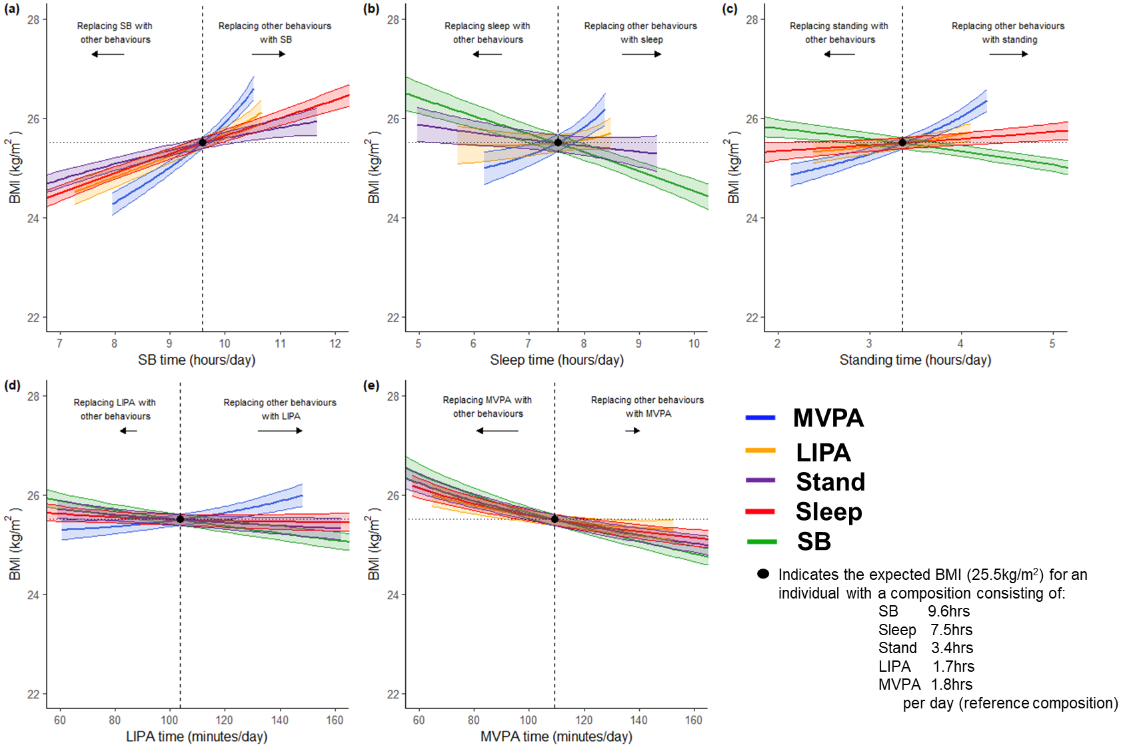
Supplemental Figure 3. Substitution models (n=6,900) for males for BMI for a) sedentary behaviour; b) sleep; c) Standing; d) Light Intensity Physical Activity (LIPA); e) Moderate-to-Vigorous Intensity Physical Activity (MVPA).

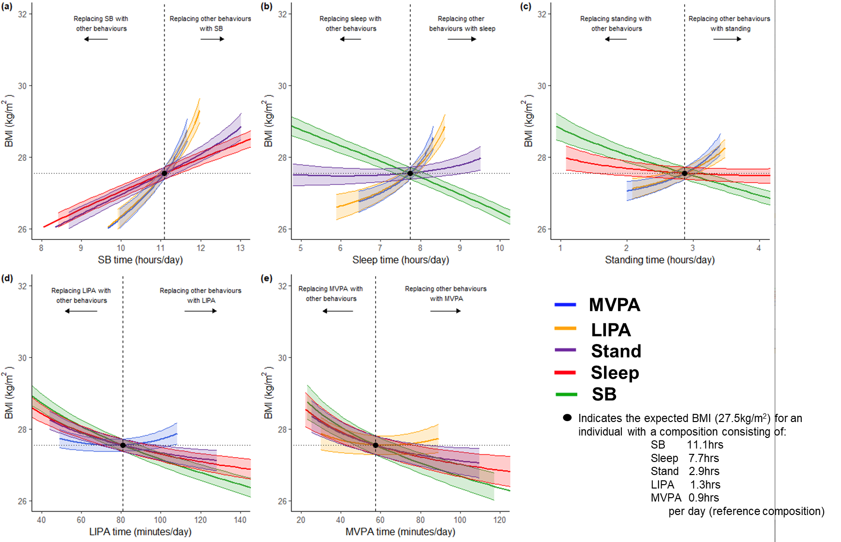Supplemental Figure 4. Substitution models (n=7,600) for those with low MVPA (<median: <76.2 min/day) for BMI for a) sedentary behaviour; b) sleep; c) Standing; d) Light Intensity Physical Activity (LIPA); e) Moderate-to-Vigorous Intensity Physical Activity (MVPA).

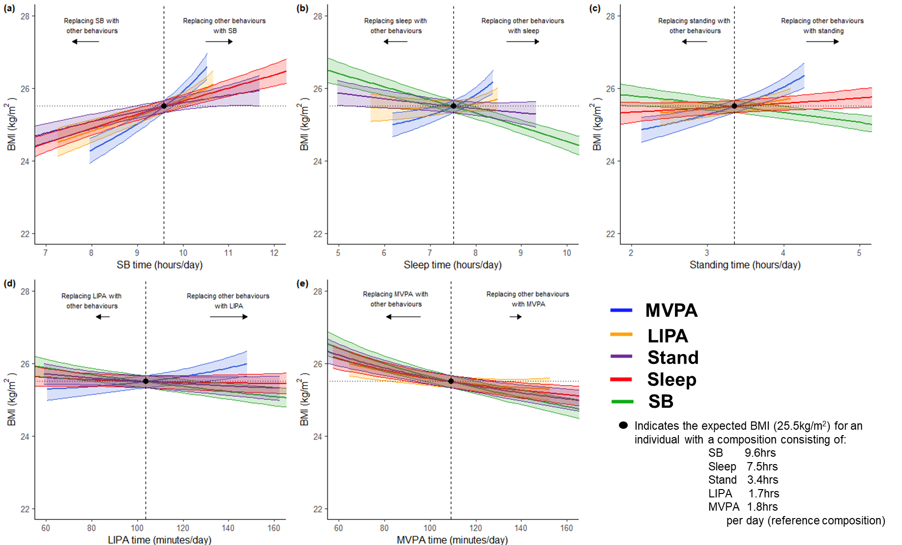Supplemental Figure 5. Substitution models (n=7,600) for those with high MVPA (median: (≥76.2min/day) for BMI for a) sedentary behaviour; b) sleep; c) Standing; d) Light Intensity Physical Activity (LIPA); e) Moderate-to-Vigorous Intensity Physical Activity (MVPA).

Supplemental Text 1. Details of individual cohort funding

The Maastricht Study was supported by the European Regional Development Fund via OP-Zuid, the Province of Limburg, the Dutch Ministry of Economic Affairs (grant 31O.041), Stichting De Weijerhorst (Maastricht, the Netherlands), the Pearl String Initiative Diabetes (Amsterdam, the Netherlands), the Cardiovascular Center (CVC, Maastricht, the Netherlands), CARIM School for Cardiovascular Diseases (Maastricht, the Netherlands), CAPHRI Care and Public Health Research Institute (Maastricht, the Netherlands), NUTRIM School for Nutrition and Translational Research in Metabolism (Maastricht, the Netherlands), Stichting Annadal (Maastricht, the Netherlands), Health Foundation Limburg (Maastricht, the Netherlands), and by unrestricted grants from Janssen-Cilag BV (Tilburg, the Netherlands), Novo Nordisk Farma BV (Alphen aan den Rijn, the Netherlands), and Sanofi-Aventis Netherlands BV (Gouda, the Netherlands).

The 1970 British Cohort Study is funded by the Economic and Social Research Council (ES/M001660/1). The age 46 sweep was also funded by the British Heart Foundation (grant SP/15/6/31397) and a joint award from the Economic and Social Research Council and the Medical Research Council (grant RES-579-47-0001). The ALSWH is funded by the Australian Government Department of Health and Aged Care and its substudy (Menarche-to-PreMenopause), from which accelerometry and clinical data were obtained, was funded by the National Health and Medical Research Council Project Grant (APP1129592). DPhacto is funded by The Danish Working Environment Research Fund. NES is supported by the Department of Physiology of the Radboud University Medical Center, the Dutch Heart Foundation (2020T063), and Siemens Healthcare Diagnostics (the Hague, Netherlands). FIREA is supported by the Academy of Finland (286294, 294154, 319246, 332030), Ministry of Education and Culture, Juho Vainio Foundation and Finnish State Grants for Clinical Research.

