Supplementary material: AIK ATDE (from O’Sullivan et al., 2023)

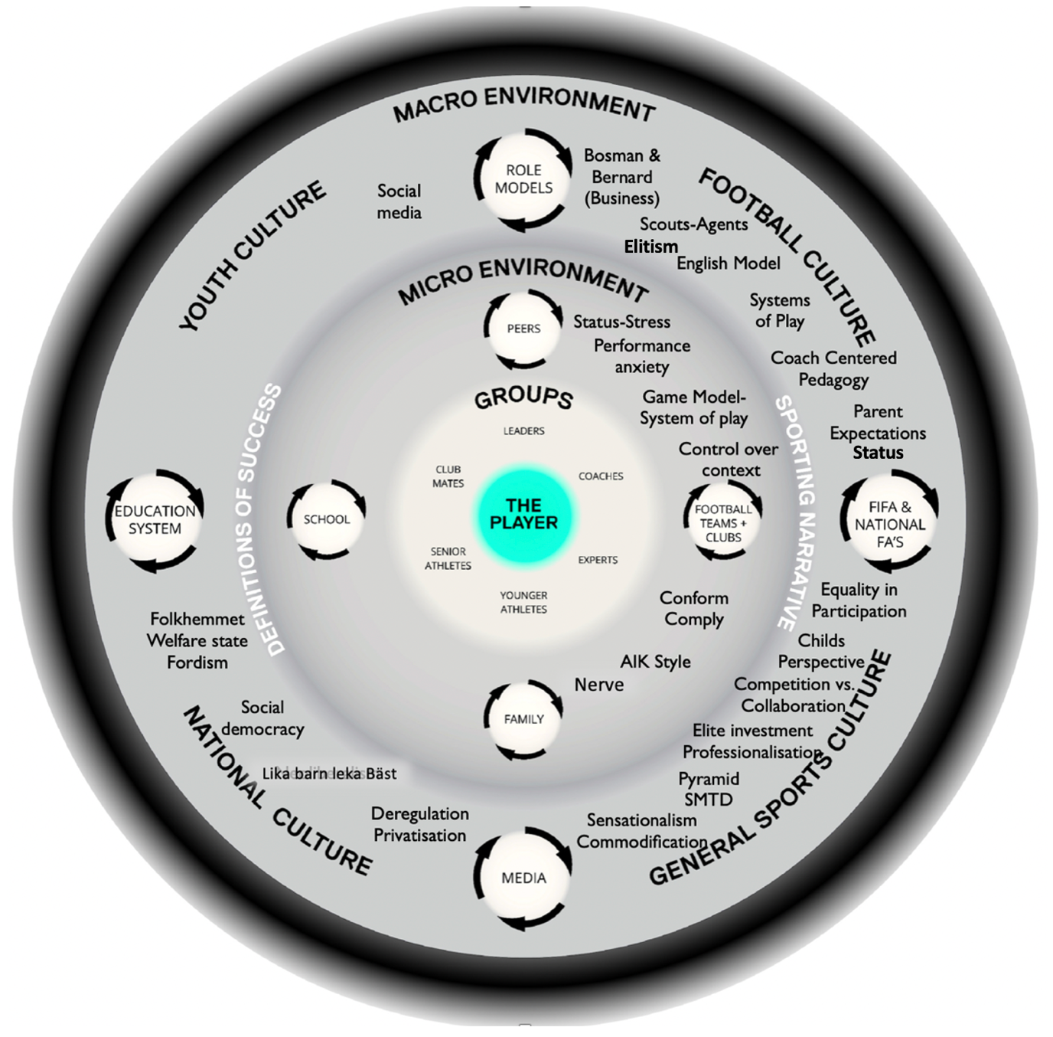
AIK ATDE used to organise and locate the data within a broader ecological context. Themes are embedded in relation to the environment/context (macro or micro) in which the data emerged and cohered.

