Supplementary material: Data analysis walk-through

The preliminary research question was: is there a connection between young players interactions with relevant fields of affordances and the intentions of coaches at AIK youth football, with the socio-cultural and historical context? To help unpack this question the Skilled Intentionality Framework (SIF), through a combination of ethnographic strategies (Contextual historical analysis, observation, interviews, field notes), was utilised to generate knowledge. Analysis began with data generation to help identify promising areas of research (Emerson et al, 2011; Lester & Anders, 2018). Initially, first-level descriptive codes (see table 1) were generated to capture the main ingredients of the data (e.g., who, what, when, where).

Table 1. Examples of raw data and initial first level descriptive codes.
17-08-2018 Skytteholms IP  Coach I began his session with his group of 11-year old’s with some adult warming up exercise, then static 1 on 1 passing drills. It is about 30 minutes before players face an opponent. (Field note: August 17th, 2018).  21-08-2018 Skytteholms IP pitch D  I am with my colleague Vincent (academy coach) watching the boys 2008 academy training at Skytteholmen. Parents are anxiously peaking over the closed off 7 a side pitch, while standing on seating area in the adjacent children’s playground. I have spent the last 15 minutes watching them from behind. Something happens, one parent looks up to the night sky, while the parent next to him stares at him and opens his arms, then drops his head and shakes it. The 2008’s are the last group to go through the early academy selection before AIK raised the academy age. With the end of the season approaching in two months, and an immanent selection, de-selection process approaching the intensity, or the ‘tempo’ is quite high. The game-based part of the sessions seems to be just constant transitions. According to Vincent, the early part of the session was a lot of repetitive passing drills followed by 1v1’s with no consequence (once the attacker lost the ball the 1v1 was over).  Vincent: This is more like a tennis match  Mark: The coach seems to be willing them on, Go! Go! Go!.  Vincent: This, I guess is what performance anxiety looks like coming up to the end of the academy season. They are competing against each other, even when in the same team, instead of collaborating to make each other better.  I was left thinking that this is some sort of interpersonal competition to maintain social status. They are competing against each other, even when in the same team, instead of collaborating to make each other better.  (Field note: Informal conversation, August 21st, 2018).  05-09-2018 Extra Training Skytteholms IP Looking at the sessions that take place after the ‘extra training’ with the older youth teams, there are a lot of predetermined passing patterns that are practiced in isolation of opponents and then put into a game. If the players don’t play out from the back the exact way the coach wants them to, then the play gets stopped. Tonight, I saw a very animated coach who, during an 8v8 practice was moving players around like chess pieces.  (Field note: September 5th, 2018).  I meet Coach G walking off the pitch.  Coach G: That coach (the animated coach) needs to get involved in extra training. I don’t think he will. He coaches one of the older academy teams and they see this as a step down.  (Field note: Informal conversation, September 5th, 2018).  COACH A  You see when I began it was …. there was a little nerve that influenced pedagogy. You were forced to have results even at 9, 10 years. This influenced your pedagogy a lot and what you do. There was a lot of ABC passing, if you have the ball here you pass there or perhaps there – you should be there when the ball is there, which game short-term results but influenced players over time. You lock their decision, you lock their creative solutions which means we don’t get player that are problem solving orientated, that can solve problems. It can look very good with a team of 10-year old’s because the opponents cannot solve the problem which means it looks good but it’s not really that good.  12-09-2018 Råsunda IP I head over to Råsunda IP after extra training to catch up with Coach J who is responsible for the 2008 groups, those that were not selected for the academy. The 2008’s are the last age group to go through an early selection process (8 years old).  Coach J: It is a slow start since the summer break. Although I have had a few parent meetings about rotating with the academy. Some parents are annoyed as the academy took in a player from outside the club just before summer.  Mark: I can understand that  Coach J: So, can I. But some of the parents that are moaning, there kids are not even here tonight.  (Field note: Informal conversation, September 9th, 2018).  The sessions look lethargic and pretty much isolated technical work for over 45 minutes. Coaches shouting focus, focus as kids wait in line and tempo, tempo, with speed (med fart!) as they dribble to a cone and back or work on a passing drill without opponents.(Field note: September 9th, 2018).  17-09-2018 Skytteholms IP Watching the sessions while in the adjacent pitch two of the older academy teams are training. As the season is due to start up after the summer break there seems to be a lot of “match planning” training going on. Coach A and H are working on how to press the opposition high up the pitch. As each of them have less than half a full-size pitch, this is quite challenging but then their teams only play 7 a side. I feel that there is too much focus on the pressing as opposed to helping the team playing out to “challenge” the press. A possible relic from “theme” based coach education?  On the nearby pitch the older academy teams are spending a lot of time on predetermined passing patterns. I notice this fascination with playing out from the back even when the high pressing team leave gaps to play through and beat the press. The coaches seem determined to get “their” way of playing across to the players. Is this the classic coach looking for their coaching points? Anyway, a lot of these type of sessions at the club have the same formula- build up on one side, move the opposition to that side and try and get the very fast wide player on the other side on the ball in a 1v1 with a quick switch. (Field note: September 17th, 2018).  13-02-2019 Training Boys/Girls 2011 Skytteholms IP  Met with all the coaches. Some of the coaches have experience as they have older children in the club. These coaches have adopted a more game centered approach. 2 of the other groups had too much queuing and passing drills where everything was decided by the drill (A to B to C to A). it is cold and too many kids are standing still. One coach even shouted ‘focus’ at a freezing kid who was jumping around. In general, most of the teams were playing matches (2 goals) or game like sessions.  Arne: I am trying to balance my role as a coach for all the kids in a group and as a parent for my son Charlie who plays in the team. Charlie sometimes feels frustrated with some of the other players who don’t have the same ambition as him. I have had a few parents ask me about ‘nivåindelning’ (splitting the kids into ability levels). His feeling was that “this is about winning games for their own child  (Field note: Informal conversation, February 13th, 2019).  There was a parent complaint about the extra training. I guess the inherent chaos of some of the game-based sessions is a challenge to parent expectations of what training should look like and how coaching is carried out. Looking across to the adjacent pitch where some of the older teams are training where there are neat passing patterns with a coach taking centre stage, I can see this being an ongoing discussion.  (Field note: September 9th, 2018)  06-11-2018 Solna School  Arion: I have been at extra training. My son enjoys it but I think that there are too many games. They can do that when they want. They don’t need a coach for that  Mark: What do you mean  Arion: Maybe more technique work. My son only uses his left foot. I think there should be some form of technique training so that he learns to use both feet.  Regarding AIK removing the early selection, a common conversation piece and point of view from parents was expressed by Mats  Mats: But we will lose the best players to other clubs that select early – if we don’t start selecting players early again.  (Field note: Informal conversation, November 11th, 2019).  03-02-2019 Skytteholmens IP  Coach E: The parents in my team have a different understanding, even from the C Diploma, what coaching is. They expect a dominant authority, very vocal and the Swedish word is “tydligt”-ordning och reda (order, clear, precise).  (Field note: Informal conversation, February 2nd, 2019).  14-02-2019 Huvudstafältet IP  Observing one of the 9-year-old groups; the kids are really enjoying the intensity of the game formats in the Swedish winter cold. Within this intensity are loud laughs and spectacular (sliding on their knees as far as they can) goal celebrations. The coach, a parent coach has been attending the extra training sessions that we run (AIK employed coaches and I run sessions once a week for kids who want to train extra) and has started to experiment with some of the designs in practice. Even in this weather, some parents are on the sideline, very engaged in watching every move their child makes. Mats a parent of one of the young players approaches me. At one of parent meetings organised by the club, he let his opinion known about AIK removing the early selection model. Mats expressed that the club would lose the best players to other clubs if we don’t select early (see field note 06-11-2018).  I turn to Mats and smile while suggesting that this is just what the young players need on such a cold winter evening like this. Almost on cue, Arion, Mats friend and parent of another player in the group turns up. They are at every training session together and they seem to be really “invested” in their son’s football. Sometimes they are so invested that they start to instruct their kids during training sessions.  Mats: They are just playing football; they can do this on their own, this is not serious training” Mark: What does serious football training look like at this age (9 years old)  Arion (interrupts): Well, the coach doesn’t seem to be interested, it doesn’t look like he is in control. It is like a ‘sandlåda’ (playground sandbox), its chaos, kids can do what they want when playing these games. He should be in there telling them what to do! Mats: We call this ‘saft and bulle’ (child’s soft drink and buns) training. Arion: Why are they doing the same session as Tuesday? We have seen this type of training at extra training as well. (Field note: Informal conversation, February 14h, 2019).  Coach H Through a lot of years in football. My feeling is that parents who don't have proper insight into development, they like the look of organisation. They like the look of control, which is easy to get because you can put them in a line and do a passing drill and for someone who doesn't have insight, it can look very, very good. You also get an effect from that very, very quickly and the players can look quite good, quite quickly for doing stuff like that.  Coach J  It was as if the trainer had the solution in the form of this folder [technique register]. You line up the kids, say pairs facing each other, throw a ball to each other, then you would pass the ball back with a volley. I would show the kids together with my trainer colleague how you should do it. So, there was a lot of focus on me [the coach] and my way was the right way. The players didn’t get to express themselves very much, I had shown then how to do it the correct way.  Coach G  The technique register, and its micromanagement, was absolutely seen in AIK, in the everyday practices  Coach B  Yes, even now when they say to players that we must work with switching the play [theme], players just pass the ball from side to side all the time because this is what the coach thinks that they must do and the players’ understanding is limited by the idea that they must switch the play, but they will do it so that it will look right for the coach.  11-11-2018 AIK head office  We had an “overlap” themed session. When we were finished, we were asked by the coach educators if we were happy with what we saw. We said relatively happy! Then we got criticized for a lack of successful overlaps. The coach educator assumed that the success of an overlap was when the overlapping player received the ball. The idea of a successful overlap is not about receiving the ball but also about distracting the defenders, pull them out of position and create other opportunities i.e., a gap to pass or dribble through as the defense is moved out of position by the overlap. We were also criticised for not clearly mentioning the theme of the session in the introduction.  (Field note: informal conversation Coach C AIK head office, November 11, 2018)  Coach D  When I came in as assistant trainer in our team 2 years ago it was quite a traditional approach/method where we drilled passes, 5 meters 10 meters, 1 touch, 2 touch. Steer and decide where the kids should be and how they should be positioned – quite detailed.  09-20-2018 Skytteholms IP  Coach C: I guess, afraid that he will make a mistake. The father wanted a guarantee that his son would play in the academy next year. He said that he has already been talking to other academy clubs. I think that Coach A had him when he was 9 years old.  (Informal conversation: September 20, 2018, Skytteholmens IP)  COACH A  He belonged to our academy from the first year at 9 and this was the start of the whole academy journey when we lowered the selection age [in 2011] and there, a lot of decisions were pre-decided decisions [in training and in games]. This set the pattern for him as in his first year at AIK academy, he didn’t own one of his decisions or test himself with regards to what worked or didn’t work for him. Doing these programmed patterns meant he developed a habit of doing what you are told. Which is a big reason why, despite being free, he decides to play centrally to another free player, who probably hasn’t the best situation to take the ball forward.  26/11/2018. AIK head office  Coach J: I have been on the new courses recently. Some of the material that SvFF have is very good, but the coach educators are not very engaged with the material.  Mark: In what way  Coach J: Well, I had this instructor on one course who said that the course is missing the technique register. Coaches should be using this with the youngest players so that they have a good ground.  Mark: I think I know who that is.  Coach J: Yes, he also runs the football coach education courses at our university (GIH).  (Field note: Informal conversation, November 11th, 2019).  09-01-2019 AIK head office  Coach H: Some coaches in the younger age groups hide behind parents to drive the team the way they want to.  Mark: In what way  Coach H: Parents have expectations about selection and training and some coaches who are “ambitious” want to just win to get recognition. If the club questions the coach, they just get the parents involved to argue for them.  (Field note: Informal conversation, November 11th, 2019).  Reflections February 2019  The impression of a learning environment that many parents have is one where there is an illusion of order and discipline, neatly laid out cones and kids running at “tempo”. Tempo is a commonly used word, it implies doing something very fast. This is what looks good from the outside. Of course, the coach must also be seen to be telling the players what they should do.  Coach D  There is a structural problem in Stockholm football that invites the possibilities for the development of an environment that is not child/player centered to develop in clubs. This also influences parents and coaches who in an effort to get results, select the best as early as possible, creating teams within a team.  16-10- 2019 AIK head office  Coach A: Years ago, the results were what I leaned on and if we won, we played well, if we lost, we were bad. When I was younger, I didn’t want to come in on Monday [to AIK] if we lost on Sunday. I was the one who selected the 8-year-olds to the academy.  (Field note: Informal conversation, October 16, 2019). | ADULT WARM UP  PASSING DRILL  ACADEMY  ANXIETY  MONOTORING  ANXIOUS BODY LANGUAGE  SELECTION  DE-SELECTION  INTENSITY-TEMPO  STRESS  REPETITIVE PASSING DRILLS  ONE DIRECTIONAL  CONSTANT TRANSITIONS  COACH VERBAL PUSHING  “WHAT PERFORMANCE ANXIETY LOOKS LIKE”  INTERNAL COMPETITION  COMPETITION  STATUS MAINTENANCE  NOT COLLABORATING  OLDER TEAMS  PREDETERMINED PASSING  ISOLATED DRILLS  PLAY THE COACHES WAY  STOPPED  EXPLICT INSTRUCTIONS  HIERARCHY  “NERVE”  RESULTS  PEDAGOGY  PREDETERMINED PASSING  EXPLICIT INSTRUCTIONS  “SHORT TERM RESULTS” PERSPECTIVE  LIMIT DECISION MAKING  SHORT TERM  “NOT REALLY GOOD”  SELECTION  POOR CLUB COMMUNICATION  NOT AT TRAINING  ISOLATED DRILLS  “FOCUS, FOCUS”  “TEMPO TEMPO”  MATCH PREPERATION  TACTICAL PRESSING  FOCUS ON THE THEME  PASSING -PATTERNS  COACH CONTROL  PLAY THE COACHES WAY  COACHING POINTS  FORMULAIC  PREDICTABLITY  GAME CENTERED  PASSING- PATTERNS  SHOUTING FOCUS!  GAME LIKE  PARENT COACH  FRUSTRATED SON  AMBITIOUS  BEST WITH THE BEST  RESULTS  PARENT COMPLAINT  EXPECTATIONS-  TASK DESIGN AND COACHING  PASSING PATTERNS  COACH CONTROL  EXTRA TRAINING  EXPECTATION  ASSUMPTIONS  ISLOATED TECHNIQUE  SELECTION  “LOSE THE BEST PLAYERS”  SELECTION  EXPECTATION  COACH CONTROL -“ORDNING OCH REDA”  INTENSITY  LAUGHING  CELEBRATIONS  TASK DESIGNS  ENGAGED PARENTS  MONOTORING  OPINION ON AIK DECISION  “LOSE BEST PLAYERS”  ARION  PARENTS  INVESTED  INSTRUCT FROM SIDELINE  PERCEPTION OF TRAINING  NOT SERIOUS  COACH NOT INTERESTED  “SANDLÅDA”-  NOT SERIOUS  EXPLICIT  SAFT OCH BULLE  PERCEPTION OF TRAINING  PARENT ASSUMPTIONS  ORDER  “THEY LIKE THE LOOK OF CONTROL”  STAND IN LINE  LOOKS GOOD  “IT WAS AS IF THE TRAINER HAD THE SOLUTION”  TECHNIQUE REGISTER  COACH CONTROL  CORRECT TECHNIQUE  TECHNIQUE REGISTER  COACH CONTROL  THEME  PREDEFINED OUTCOME  COACH CONTROL  PLAY THE COACHES WAY  THEMED SESSION  CRITICISED  ASSUMING  PREDEFINED OUTCOMES  CONTRASTING OPINIONS  CRITICISED  THEME  PREDEFINED PASSING DRILLS  EXPLICIT INSTRUCTIONS  ANXIETY  STATUS MAINTENANCE  ACADEMY  SELECTION  PREDEFINED OUTCOMES  “DIDN’T OWN ONE OF HIS DECISIONS”  COMPLY  NEW COACH EDUCATION  EDUCATOR ENGAGEMENT  TECHNIQUE REGISTER  COACH CONTROL  COACHES PARENTS  EXPECTATION-SELECTION  RESULTS  COACH CONTROL  TEMPO  EXPLICIT INSTRUCTIONS  STRUCTURAL PROBLEM  PARENT INFLUENCED  BEST WITH BEST  RESULTS  DEFINED  ANXIETY  SELECTION
The second cycle coding was used to interpret, organise and synthesise codes, moving beyond descriptive first level codes towards more “focused” coded themes that required interpretation and theoretical considerations (Tracy, 2018). Smaller first-level codes were grouped in a larger hierarchical (umbrella) category as exemplified in the table below.

Table 2. Examples of larger hierarchical umbrella codes.
Umbrella code | Code description | Examples
Coach pedagogy  PASSING- PATTERNS  ISOLATED DRILLS  “FOCUS”-ORDER  EXPLICIT INSTRUCTIONS  STRESS-ANXIETY  COACH CONTOL  GAMES BASED  PREDEFINED -OUTCOMES  PLAY COACHES WAY | Describes the various types of observed practices, pedagogical approaches and coach behaviour at AIK youth football. | there are a lot of predetermined passing patterns that are practiced in isolation of opponents and then put into a game. If the players don’t play out from the back the exact way the coach wants them to, then the play gets stopped. Tonight, I saw a very animated coach who, during an 8v8 practice was moving players around like chess pieces  The sessions look lethargic and pretty much isolated technical work for over 45 minutes. Coaches shouting focus, focus as kids wait in line and tempo, tempo, with speed (med fart!) as they dribble to a cone and back or work on a passing drill without opponents.  On the nearby pitch the older academy teams are spending a lot of time on predetermined passing patterns. I notice this fascination with playing out from the back even when the high pressing team leave gaps to play through and beat the press. The coaches seem determined to get “their” way of playing across to the players. Is this the classic coach looking for their coaching points?
Parents  MONOTORING  BEST WITH BEST  “LOSE BEST PLAYERS”  EXPECTATIONS  RESULTS  ANXIETY  STATUS MAINTENANCE | Describes parents behaviours, opinions and insights into practices at the club. | It doesn’t look like he is in control. It is like a ‘sandlåda’ (playground sandbox), its chaos, kids can do what they want when playing these games. He should be in there telling them what to do!  But we will lose the best players to other clubs that select early – if we don’t start selecting players early again  Parents are anxiously peaking over the closed off 7 a side pitch, while standing on seating area in the adjacent children’s playground. Something happens, one parent looks up to the night sky, while the parent next to him stares at him and opens his arms, then drops his head and shakes it.  The impression of a learning environment that many parents have is one where there is an illusion of order and discipline, neatly laid out cones and kids running at “tempo”. Tenpo is a commonly used word, it implies doing something very fast. This is what looks good from the outside. Of course, the coach must also be seen to be telling the players what they should do.
Coach insights  TECHNIQUE REGISTER  COACH CONTROL  EXPECTATIONS  PLAY THE COACHES WAY  PREDEFINED OUTCOMES  RESULTS  ANXIETY  STATUS MAINTENANCE | Describes coaches opinions and insights into club in general, on pitch practice | The technique register, and its micromanagement, was absolutely seen in AIK, in the everyday practices  He belonged to our academy from the first year at 9 and this was the start of the whole academy journey when we lowered the selection age [in 2011] and there, a lot of decisions were pre-decided decisions [in training and in games]. This set the pattern for him as in his first year at AIK academy, he didn’t own one of his decisions or test himself with regards to what worked or didn’t work for him.  Through a lot of years in football. My feeling is that parents who don't have proper insight into development, they like the look of organisation. They like the look of control, which is easy to get because you can put them in a line and do a passing drill and for someone who doesn't have insight, it can look very, very good.  Parents have expectations about selection and training and some coaches who are “ambitious” want to just win to get recognition.  The parents in my team have a different understanding, even from the C Diploma, what coaching is. They expect a dominant authority, very vocal and the Swedish word is “tydligt”, clear, precise, Ordning och reda?
Structure and impact of wider influences  “NERVE”  ANXIETY  STATUS MAINTENANCE  BEST WITH THE BEST  RESULTS  COACH CONTROL | Significant utterances and/or nonverbal actions or practices that resonate with and/or suggest wider influences | You see when I began it was …. there was a little nerve that influenced pedagogy. You were forced to have results even at 9, 10 years. This influenced your pedagogy a lot and what you do.  There is a structural problem in Stockholm football that invites the possibilities for the development of an environment that is not child/player cantered to develop in clubs. This also influences parents and coaches who in an effort to get results, select the best as early as possible, creating teams within a team.
Coach education  TEKNIQUE REGISTER  THEME  COACH CONTROL  PREDEFINED OUTCOMES  PLAY THE COACHES WAY | Significant utterances, experiences or references to both old (pre-2014) and new SvFF coach education courses | “It was as if the trainer had the solution in the form of this folder [technique register]. You line up the kids, say pairs facing each other, throw a ball to each other, then you would pass the ball back with a volley. I would show the kids together with my trainer colleague how you should do it. So, there was a lot of focus on me [the coach] and my way was the right way. The players didn’t get to express themselves very much, I had shown then how to do it the correct way.”  “ …we were stuck with the technique register, these big binders of exercises. We just got one exercise that we're told this is what you do. Well, almost like a word book on every type of isolated technique which should be used in football. We were doing sessions on the tackling. And we were standing in lines. The first in line ran towards the ball and kicked the ball, and we were told how to do that.”  “We had an “overlap” themed session. When we were finished, we were asked by the coach educators if we were happy with what we saw. We said relatively happy! Then we got criticized for a lack of successful overlaps. The coach educator assumed that the success of an overlap was when the overlapping player received the ball. The idea of a successful overlap is not about receiving the ball but also about distracting the defenders, pull them out of position and create other opportunities i.e., a gap to pass or dribble through as the defense is moved out of position by the overlap. We were also criticised for not clearly mentioning the theme of the session in the introduction.
Selection  LOSE BEST PLAYERS  STATUS MAINTENANCE  “PERFORMANCE ANXIETY IN ACTION”  RESULTS | Utterances or insights gained in the field in relation to AIK decision and selection and de-selection. | This, I guess is what performance anxiety looks like coming up to the end of the academy season. They are competing against each other, even when in the same team, instead of collaborating to make each other better.”  “I have had a few parents ask me about ‘nivåindelning’ (splitting the kids into ability levels- best with best). His feeling was that “this is about winning games for their own child.”  “Parents have expectations about selection and training and some coaches who are “ambitious” want to just win to get recognition (through results). If the club questions the coach, they just get the parents involved to argue for them.”

To delve further into the ‘how’, ‘why’, or ‘because’ during second-cycle coding activities, data emerging in the micro was compared with, analysed alongside, and synthesised with the data collected via document analysis that informed the historical contextual analysis (macro). This allowed for a triangulation of emerging codes using multiple sources of information, gaining varied perspectives on what is happening in the phenomena, helping form clear, conceptually interesting and contextually rich themes (Creswell, 2016). Embedded here is the appreciation that training sessions do not take place in a socio-cultural vacuum but are deeply entangled within meaningful contexts of a broader societal form of life (Juarrero, 2023; O’Sullivan et al., 2023). To better understand athlete development in and through sport, culture and context matter most (Araújo et al., 2019; Vaughan et al., 2022). Therefore, data from the micro system of practice synthesised with data from the historical contextual analysis can be understood as an important part of maintaining correspondence with the specific ecology of relations. Table 3 and table 4 shows data type and data sources that were synthesised during second-cycle coding.

Table 3. Data type and sources that were synthesised during second-cycle coding.
Analysis level | Data type | Data sources
Macro | Formal Texts | NGB guidelines and reports (e.g., Swedish Sports Council documents)  SvFF coach education material  Nordic Sports Forum Archive  Center for Sports Science (CIF) archive
 | Media sources and Supplementary texts | Newspapers (eg.., Dagens Nyheter, Expressen, Aftonbladet)  Online websites and blogs (e.g., Svenskafans, Norsk Fotballtrenerforening, SEF, idrottensaffär, SvFF, Swedish Sports Council, Fotbollskanalen, TV)
Micro | Observation, field notes  Interviews, informal conversations | Coaches, players, parents, club leaders, video footage

Table 4. Examples of raw data that informed the historical contextual analysis (macro) that was analysed alongside, and synthesised with the data emerging in the micro

With the aim to reduce performance anxiety (competing for social status) the club want to dampen the emphasis on child-youth football being about children being assessed and valued. It needs to be based on their interest. - We have looked in the mirror and thought. Why should we do it like the others? What is healthy children's and youth sports?  AIK has listened to the debate about healthy children's and youth sports, where early elite investment has been criticised from the perspective of children's rights with reference to the UN Convention on the Rights of the Child and guidelines from both the National Sports Confederation and the Swedish Football Association.  A misunderstanding is that AIK is closing its academy. No, but we will start it later. Before the age of 13, it should only be based on joy and interest. We want more people to play football longer and this is not a step back, on the contrary. We want as many of our own players in our A-teams as before, at least, but during the journey they we want them to feel good, says Leif Karlsson.  (Document analysis: Mitt i Solna article: AIK höjer åldern för start i akademilagen, June 2017. Translated from Swedish)  I'm confronting them. When they cross the line, I am very clear and say -You are not just out on thin ice, you have gone through the ice. Now you have to go back and do your job in a professional way ... If it does not suit you, just to leave the area. It is not a public right to look at the elite boys' camp. It has happened that we have closed national team camps because talent scouts, agents and relatives get involved and the young people have a hard time dealing with it, says Eriksson.  (Document analysis: Aftonbladet article: Agenter springer in på plan i jakt på talanger July10 2015. Translated from Swedish)  Youth football in Stockholm is the most stressful and unhealthy in the country. (Document analysis: Fogis, September 2017. Translated from Swedish).  There is currently a professionalisation of Swedish youth football with foreign big teams, child stars used as advertising planks and agents who shadow football pitches with money in their eyes. The ideals that Swedish youth football movement is based on has been split in two. On one side are international big clubs, elitist academies and money-hungry agents who have turned sports into a market and children into consumers and products. There is an evolving culture of status among parents that have a ‘high performing child’.  (Document analysis: Aftonbladet article: Blivit status att ha ett presterande barn, November 24, 2019. Translated from Swedish)  At the same time as the view of parenting is changing, there is also a change in attitudes towards children in the corresponding direction, where children are regarded more as independent individuals who participate in and influence their surroundings. This in turn has meant increased individuality and freedom of choice for the entire family. With this in mind, it can be understood that parenting in general and sports parenting in particular have come under scrutiny since the beginning of the 2000s and have been extensively discussed both within Swedish sports research and in the media. In this context, concepts such as "curling parent ” and “helicopter parents” have emerged and been lively debated. In short, it can be said that these parenting styles mean that the children's path forward in life is "swept" and "supervised" so that they avoid encountering resistance and problems.  (Document analysis: Centrum för idrottsförskning, 2015, p12. Translated from Swedish)  The serious game - who can't join?  https://www.expressen.se/sport/qs/den-allvarsamma-leken/  Selection and elite efforts have long been creeping down the ages in AIK, Hammarby, Brommapojkarna and Djurgården. They are accused of distorting a "system" and breaking rules about recruiting children - but they have started to pull in different directions.  But also a track that leads straight into Stockholm football, where four big clubs are accused of driving a problematic frenzy, but have started to pull in different directions. It will soon become clear that both cases essentially revolve around one issue more than any other: Selection.  Who is selected and who is eliminated?  Swedish football loses the most players aged 12-13. In the Swedish Football Association's latest survey from 2017, which Sport Expressen has gained access to, the number of football players dropped from 32,053 at the age of 12 to 23,604 for 13-year-olds.  Fallby: The commercialisation of football has played an important role, especially among boys. They (clubs) have developed an enormous fear of missing the next big star which will then mean glory and fame for the person who has "discovered" the player.  Football becomes very result-oriented at an early age. Especially in Stockholm. There is also money and agents driving this. This is a structural system where, for example, elite camps and youth national teams should be considered in the overall picture. And parents who have too little knowledge about what constitutes a healthy environment, he says.  The argument you most often encounter when you are out in clubs is that "the others do it". It shows what a low level the discussion is at. Fear drives the system. Unfortunately, I am getting signals that women's football is following in the footsteps of men's football. They have started to select more at younger ages there too, he says.  (Document analysis: Expressen article: Den akkvarsamma leken- vem är det som inte få vara med, October 2018. Translated from Swedish)  Selection for the Youth Academy must be completed in November, and then the coaching organisation must also be presented to players and parents. The players are selected in the Youth Academy one year at a time (p.41).  (Document analysis: AIK Verksamhetsplan, 2011. Translated from Swedish).  For sports associations, the market pressure is correspondingly rooted in perceived demands to run an increasingly professionalised and customer-oriented business. Costs (p.8).  (Document analysis: Idrottens pris: About the costs of sport and the importance of membership, 2015. Translated from Swedish)  Part of this has certainly been the professionalisation process we have been able to follow in sports since the early 1990s, that is, the dream of becoming a professional in one's sport is not only a child's, but also a parent's. Thus, the child's activities develop to also become interesting from the outside, what they can perform in the future (p.13)  (Document analysis: Idrottens pris: About the costs of sport and the importance of membership, 2015. Translated from Swedish)  There is no monster that controls access to elite programs. The problem is the football associations cowardice. (Document analysis: Dagens Nyheter article: Bodström står bakom elitgrupper för barn. December 12, 2007. Translated from Swedish).  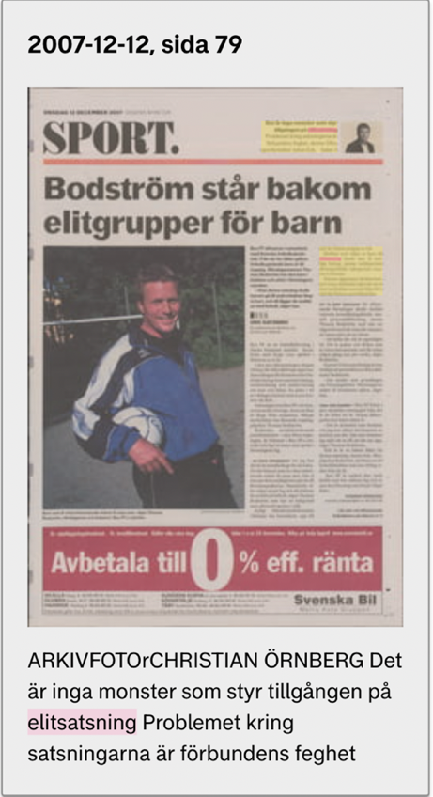  Thomas Bodström (Justice minister 2000-2006)- Bodström stands behind elite groups for children. Dagens Nyheter archive 12-12-2007  SvFF's talent developer Claes Eriksson detests teams that top - but is positive about ability grouping players.  - lika barn leka bäst, he says to Soccer Channel.  (Document analysis: Fotbollskanalen article: SvFF:s talangutvecklare om nivåindelning av ungdomar: "Lika barn leka bäst, December 17, 2016. Translated from Swedish)  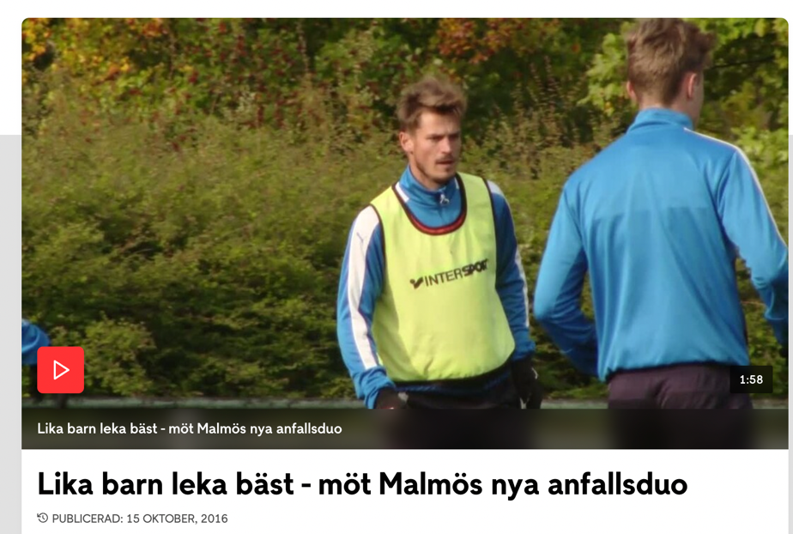  (Document analysis: TV4: Lika barn leka bäst -möt Malmös nya anfallsduon, October 15, 2016)  https://www.tv4.se/klipp/va/3572452/lika-barn-leka-bast-mot-malmos-nya-anfallsduo  From having been one obstacle, the money instead became an opportunity. While the state primarily promoted professionalization, the market supported commercialization. A specification of this is that state support has primarily had consequences for grassroots sports, while commercialization has primarily affected elite sports.  (Document analysis: Debate article: Idrottens professionaliserings och kommersialiseringsprocesser, 2005, Translated from Swedish).  Becoming a good player has nothing to do with talent, it’s just about training. Everything is possible to influence through training except its length. There is a more or less accepted belief in the so-called “10-year rule” which states tha to become an expert in an area requires a minimum of 10 years (10,000 hours) of training.  (Document analysis: Tips Elit article: Största talangen är att träna May 24 2011. Translated from Swedish)  Potential for football is seen, above all in the movement pattern of the child. And it can be seen early, already at the age of seven or eight. You see if he moves like a football player. There is something about balance and coordination.  (Document analysis: Renew Magazine. Tidig elitsatsning avgörande för fotbollstalanger. 2013. Translated from Swedish)  If one thinks that skills should be learned before a certain age and that a certain amount of training must occur early, this probably leads to clubs not taking in new children who have not started in time.  (Document analysis: Idrottsforskning article. Många vägar till landslaget October 2 2015. Translated from Swedish)  The debate took place in a period in Swedish society when neoliberalism emerged for the first time and became a serious ideological challenger to the social democratic welfare policy. The criticism of Roy and Bob was that they played robot football, factory football and it was rubbish football. The players who submitted to the system acted like robots without their own will. They could not express their own talents and they had to run exactly as they were told, like on a conveyor belt.  (Document analysis: Svenskafans: Bob and Roy, August 21, 2003. Translated from Swedish)  ..the pyramid, many individuals make their entry into organised sports. They develop knowledge and skills through a process where, in a form of Darwinian competition, they are emulated and compete with each other as they practice more extensive and increasingly advanced and specialised training (p66).  (Document analysis: Riksidrottsforbundet. Elitidrott rapport 2015. Translated from Swedish)  ….on the other hand, competitive spirit, selection and deselection increasingly further down the ages can be explained by the connection to the commercial elite sport.  (Document analysis: Debate article: Swedish Sports Science no. 2: Sport between the peoples movement and commercialism, 2003, Translated from Swedish)  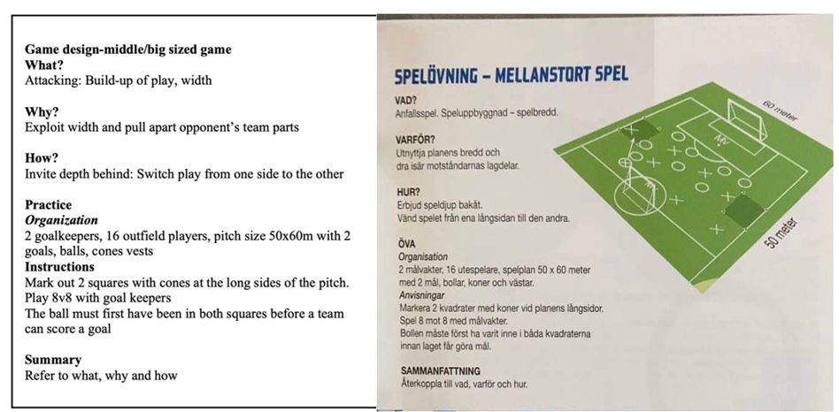  SvFF UEFA B session design (SvFF UEFA B Coach education, p. 43).  https://www.youtube.com/watch?v=U9UGWHQX9-c  SvFF Technique register video  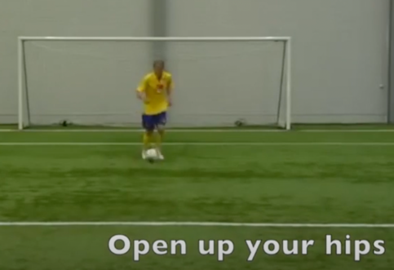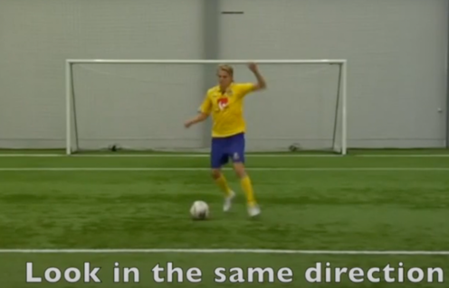  Instruction points  - Meet the ball at an angle to the pathway of the ball to create space for a deep pass forward  - B should turn if D presses in a bad way  - Back into the player before the ball is played from A  - Use 1 touch  - Use 2 touches to be aware of your own technique on receiving the ball  - Use 3 or more touches  - Receive the ball with foot furthest away from D  - Receive the ball with foot nearest D while half turned to D  - Take the ball quickly out of the area if D is beaten  (Estoril conference notes on Sven Göran Eriksson’s presentation from attendee Thomas Lyth 1983. English translation of direct instruction points from coaches to players promoting touch constraints and prescribed movement). | PERFORMANCE ANXIETY-STATUS  DAMPENING ASSESSMENT SELECTION  DEBATE  EARLY ELITE INVESTMENT  UNRC  MISUNDERSTANDING  JOY  RETENTION  CLUB AMBITION  WELLBEING  CONFRONTATION  GONE OVER THE LINE  “NOT A PUBLIC RIGHT”  STRESS AND ANXIERTY  WELLBEING OF PLAYERS  “STRESSFUL AND UNHEALTHY”  PROFFESIONALISATION  AGENTS/SCOUTS  BUSINESS  MOVEMENT DIVIDED  ELITE  MARKET  STATUS  “HIGH PERFORMING CHILD”  PARENTING  ATTITUDES  INDEPENDENT  INDIVIDUALITY  SPORTS PARENTING  UNDER THE MICROSCOPE  RESEARCH AND MEDIA  PARENTING STYLES  MONOTORING  AVOID -UNPREDICTABILITY  SERIOUSNESS  EARLY SELECTION  STOCKHOLM ACADEMIES  DISTORTED SYSTEM  EARLY RECRUITMENT/SCOUTING  DISTORTED SYSTEM  SELECTION  SELECTION/DESELECTION  RETENTION ISSUES  COMMERCIALISATION  FOMO  STATUS  RESULTS  BUSINESS  ELITE  PARENT EXPECTATIONS  ASSUMPTIONS  ARGUMENT  LOW LEVEL  FEAR DRIVES SYSTEM  EARLY SELECTION  SELECTION-DESELECTION  MARKET PRESSURE  “PROFESSIONALISED”  CUSTOMER (PARENTS)  PROFESSIONALISATION  DREAM  CHILD AND PARENT  EARLY ACTIVITY  FUTURE PERFORMANCE  EARLY ELITE BEST WITH THE BEST  SvFF COWARDS  JUSTICE MINISTER  ELITE CHILDREN  SvFF TALENT DEVELOPER  POSITIVE  BEST WITH THE BEST  BEST WITH THE BEST-SIMILAR WITH SIMILAR  STATE MONEY  PROFESSIONALISATION/ COMMERCIALISATION  ELITE  BECOMING GOOD  TRAINING VOLUME  BELIEF  10,000 HOURS RULE  IDENTIFICATION  EARLY  “SEVEN OR EIGHT”  GUT FEELING  BELIEF  TRAINING EARLY  EXCLUDING “LATE” STARTER  NEOLIBERLAISM  CHALLENGING  ENGLISH MODEL  ROBOT FOOTBALL  PLAY THE COACHES WAY  PREDEFINED OUTCOMES  COACH CONTROL  PYRAMID/TRIANGLE  SELECTION/DESELECTION  INTERNAL COMPETITION  SELECTION/DESELECTION  EARLY AND EARLIER  COMMERCILISATION ELITE  THEME  PREDEFINED OUTCOMES  COACH CONTROL  PLAY THE COACHES WAY  TECHNIQUE REGISTER  THEME  EXPLICIT INSTRUCTIONS  PREDEFINED PATTERN  PREDEFINED OUTCOME  COACH CONTROL  EXPLICIT INSTRUCTIONS  PREDEFINED PATTERN  COACH CONTROL

A feature of secondary-cycle coding, that served to focus the analysis-synthesis towards answering the first research question, was identifying which codes are most appropriate to probe (Tracy & Hinrichs, 2017). Returning to the data, these identified codes were then viewed in a more etic, deductive manner. The focus of research was then gradually narrowed to alter between emic or emergent readings of the data and etic use of existing models, explanations and theories. In particular, an understanding of theory and literature provided a foundation for interpreting and building theoretical explanations, as well as informing new lines of inquiry (see ‘study overview’ in the supplementary material). Exemplifying how the researcher remained ‘in touch’ with the phenomenon to offer a deeply contextualised and continuous analysis, a secondary research question emerged during the data analysis-synthesis: to what extent is the value-directedness (intentionality) that players experience on the football pitch related to the macrosystems, socio-cultural constraints, and forms of life that influence responsiveness to affordances?
To answer this question, the utilisation of interpretative creativity (analysis and synthesis) existing theories and models helped to deductively guide, organise, and locate the data within this broader ecological context as illustrated in the AIK ATDE (O’Sullivan et al., 2023) available as supplementary material. For example, the use of the broad macrosystem dimension, including a range of putative or generative influences (such as political, economic and socio-cultural) that developmentally instigate belief systems were captured as ethnographic themes and further interpreted as an interconnected system of ‘value directedness’ that cascaded through contexts. This is also captured in the analytical narrative presented later.
Key findings of the first research cycle
The findings from the first research cycle highlighted how multiple intertwined constraints were shaping the ecological niche at AIK youth football. This helped create a context that led to the emergence of context-dependent constraints (e.g., types of task designs, development pathways, expectations) that shaped the value-directedness experienced by players. Coaches, through a form of ‘control over context’ were over-constraining task designs so that players could only respond to specifically designed affordances. This indicated a need to dampen the influence of the pervasive organisational approaches that were acting as socio-cultural constraints, shaping intentions and attention of players and coaches. A list of related themes that constitute, arise from, and reinforce ‘control over context’ are presented in Table 5.

Table 5. Key themes arising from ethnographic data under the meta theme control over

Meta theme: Control over context
Themes directed towards: Control over context Related themes

Macro environment: Swedish national culture

- Lika barn leka bäst
- Neoliberalism

- Collaboration v Competition

Macro environment: Swedish sport

- SMTD
- Elite investment/professionalisation

Macro environment: Swedish football

- Coach centered pedagogy
- Elitism
- Parent expectations
- English model

- Systems of play
- Bernard/Business
- Scouts/Agents

Microenvironment: AIK football club

- Nerve

- Game model/Systems of play
- Technique register
- Status and performance anxiety
- Conform and comply

Control over context
The raw data provided information gathered to help explain the central phenomenon of the study captured in the meta theme ‘control over context’. The location of this theme aims to represent a coherence of data, not the sole location of data collected, or its realm of influence. This is expanded on in the following analytical narrative, where we highlight the extent to which the intentions of coaches and the value-directedness that players experience in training and in games, is related to the macrosystems, socio-cultural constraints, and forms of life that can influence responsiveness to affordances:
Throughout the data, there is an indication that the structure of development pathways and on-field pedagogies at AIK youth football were deeply interconnected, in the sense that development pathways and practice task designs were deeply ingrained in ideas and expectations of the notion of limiting unpredictability. This contributed toward the value-directedness that was shaping the intentions of coaches and players at the club, which was expressed in many ways. The description of a nerve that influenced pedagogy is indicative of an anxiety and expectation that cascaded through organisations and structures, amplifying ideas associated with early selection and de-selection. Within an evolving culture of status among parents this nerve emerged in parent behaviour. Here, ideas of coach control led to task designs and ‘nivåindelning’ (best with best) that aimed to achieve results, which accompanied an emerging parenting style ground in a form of monitoring to ensure exclusivity with their child not having to encounter too much resistance and problems in their development.
Coaches maintained their status through results and adopted deterministic methods in training and games. For example, using predetermined passing patterns to control future outcomes and limit unpredictability (predefined outcomes). Players maintained their status by playing the coaches way through compliance with explicit coach instructions. This approach provided the mirage of control (coach control) which appealed to the expectations of parents, which was associated with results. Another way to limit unpredictability regarding early results was to have an early selection of the best with the best which was becoming a pervasive practice within Swedish youth sport. These controlling tendencies resonated with those from the broader macro levels of the Swedish sports, football and national culture (professionalisation, commercialisation, early elite, market pressure), emerging economic interests (agents/scouts) even at the macro levels beyond Sweden, framing youth football as an economic interest (business)
This dynamic arguably amplified expectations as to what young players learning in development should ‘look like’. Indeed, a consequence of this was the reinforcement of the culturally resilient belief that greater stability and consistency in performance is related to practicing repeatable movement outcomes, evident in practice task designs that were limiting player engagement. This value-directedness towards limiting unpredictability aligned with a deeply rooted path-dependent coach education form of life. Practices prioritised in Swedish Football Association coach education until 2014 were underpinned by the use of themes that foregrounded predefined patterns/outcomes, optimal technique (technique register) under explicit instructions (play the coaches way). These practices highlighted a cultural-historical inheritance (1970’s English model) that embodied a coach control pedagogy, where the coach had the overall picture of how the game that players needed to comply with (play the coaches way). The coach control system trajectory was still evident in the new coach education courses. Theme driven game-based designs continued to be underpinned by the over constraining of tasks to limit unpredictability (predefined outcomes). Further, the coach educators socially and culturally constructed beliefs contributed to the maintenance of a traditional hierarchical model, the position of the (controlling) sports pedagogue (coach control) at the heart of the learning process.

Table 6. Key themes with examples of data relating to the meta theme control over context

Location | Theme | Codes | Examples
Micro-environment | Game model- systems of play | PREDEFINED OUTCOMES PASSING PATTERNS  COACH CONTROL  EXPLICIT INSTRUCTIONS  PLAY THE COACHES WAY | Looking at the sessions that take place after the ‘extra training’ with the older youth teams, there are a lot of predetermined passing patterns that are practiced in isolation of opponents and then put into a game. If the players don’t play out from the back the exact way the coach wants them to, then the play gets stopped.  A lot of decisions were pre-decided – very clear predetermined patterns which we also practiced very hard in training
 | Conform and comply | PLAY THE COACHES WAY  EXPLICIT INSTRUCTIONS  FOCUS  PASSING PATTERNS | There are many adult expectations placed on children. We seem to be looking to extract some sort of “inner adult”. We are expecting kids to behave like mini-(military) adults. Stand to attention, listen attentively, do what we tell them. If kids do this then the coach is a good. This is often the criteria from which parents judge a coach.  Yes, even now when they say to players that we must work with switching the play [theme], players just pass the ball from side to side all the time because this is what the coach thinks that they must do and the players’ understanding is limited by the idea that they must switch the play, but they will do it so that it will look right for the coach.”  Doing these programmed patterns meant he developed a habit of doing what you are told
 | Status and performance anxiety | NERVE  RESULTS  STATUS MAINTENANCE  COACH CONTROL  INTERNAL- COMPETITION  BEST WITH BEST | This, I guess is what performance anxiety looks like coming up to the end of the academy season. They are competing against each other, even when in the same team, instead of collaborating to make each other better.  I guess, afraid that he will make a mistake. The father wanted a guarantee that his son would play in the academy next year. He said that he has already been talking to other academy clubs.”  Years ago, the results were what I leaned on and if we won, we played well, if we lost, we were bad. When I was younger, I didn’t want to come in on Monday [to AIK] if we lost on Sunday. I was the one who selected the 8-year-olds to the academy.
 | Technique-register | COACH CONTROL  EXPLICIT INSTRUCTIONS  PASSING PATTERNS  ORDER | The technique register, and its micromanagement, was absolutely seen in AIK, in the everyday practices  There are a lot of predetermined passing patterns that are practiced in isolation of opponents and then put into a game  Do everything as fast as you can. From the ladder work to the isolated passing drills, to the games. I also keep hearing “snabba beslut”(quick decisions).  Coach C accompanies me to Huvudstafältet. I keep hearing the word focus – (come on boys, a little focus now). Children are doing various isolated dribbling exercises, followed by typical A to B to C passing drills.
Macro- environment Swedish football | English Model | COACH CONTROL  PLAY THE COACHES WAY  EXPLICIT INSTRUCTIONS | The criticism of Roy and Bob was that they played robot football, factory football and it was rubbish football. The players who submitted to the system acted like robots without their own will. They could not express their own talents and they had to run exactly as they were told, like on a conveyor belt.
 | Elitism | BEST WITH BEST  EARLY SELECTION  PROFESSIONALISM-  COMMERCIALISM  SCOUTS  AGENTS  ANXIETY | Selection and elite efforts have long been creeping down the ages in AIK, Hammarby, Brommapojkarna and Djurgården. They are accused of distorting a "system" and breaking rules about recruiting children.  It is not a public right to look at the elite boys' camp. It has happened that we have closed national team camps because talent scouts, agents and relatives get involved and the young people have a hard time dealing with it, says Eriksson.  The ideals that Swedish youth football movement is based on has been split in two. On one side are international big clubs, elitist academies and money-hungry agents who have turned sports into a market and children into consumers and products.  Potential for football is seen, above all in the movement pattern of the child. And it can be seen early, already at the age of seven or eight.
 | Parent expectations-status | MONOTORING  PREDEFINED OUTCOMES  COACH CONTROL  STATUS MAINTENANCE | There is an evolving culture of status among parents that have a ‘high performing child’.”  “At the same time as the view of parenting is changing, there is also a change in attitudes towards children in the corresponding direction, where children are regarded more as independent individuals who participate in and influence their surroundings. This in turn has meant increased individuality and freedom of choice for the entire family. With this in mind, it can be understood that parenting in general and sports parenting in particular have come under scrutiny since the beginning of the 2000s and have been extensively discussed both within Swedish sports research and in the media. In this context, concepts such as "curling parent ” and “helicopter parents” have emerged and been lively debated. In short, it can be said that these parenting styles mean that the children's path forward in life is "swept" and "supervised" so that they avoid encountering resistance and problems.”
 | Coach centered pedagogy | COACH CONTROL  TECHNIQUE REGISTER  THEME  EXPLICIT INSTRUCTIONS  PREDEFINED PATTERN  PREDEFINED OUTCOME  PLAY COACHES WAY | https://www.youtube.com/watch?v=U9UGWHQX9-c  Instruction points  - Meet the ball at an angle to the pathway of the ball to create space for a deep pass forward  - B should turn if D presses in a bad way  - Back into the player before the ball is played from A  - Use 1 touch  - Use 2 touches to be aware of your own technique on receiving the ball  - Use 3 or more touches  - Receive the ball with foot furthest away from D  - Receive the ball with foot nearest D while half turned to D  - Take the ball quickly out of the area if D is beaten
Macro environment Swedish sport | SMTD | SELECTION  DESLECTION  INTERNAL- COMPETITION  ANXIETY | …the pyramid, many individuals make their entry into organised sports. They develop knowledge and skills through a process where, in a form of Darwinian competition, they are emulated and compete with each other as they practice more extensive and increasingly advanced and specialised training.  ”They are accused of distorting a "system" and breaking rules about recruiting children - but they have started to pull in different directions.  But also a track that leads straight into Stockholm football, where four big clubs are accused of driving a problematic frenzy, but have started to pull in different directions. It will soon become clear that both cases essentially revolve around one issue more than any other: Selection.”
 | Elite  investment  professional-isation | PROFESSIONALISM-  COMMERCIALISM  MARKET PRESSURE  STATE MONEY  ELITE  STATUS | “From having been one obstacle, the money instead became an opportunity. While the state primarily promoted professionalisation, the market supported commercialisation.”  “There is no monster that controls access to elite programs. The problem is the football associations cowardice.” Bodström (justice minister) stands behind elite groups for children”  “Part of this has certainly been the professionalization process we have been able to follow in sports since the early 1990s, that is, the dream of becoming a professional in one's sport is not only a child's, but also a parent's.”  “….on the other hand, competitive spirit, selection and deselection increasingly further down the ages can be explained by the connection to the commercial elite sport.”
Macro environment Swedish culture | Neoliberalism | MARKET PRESSURE  PROFESSIONALISATION | The debate (English v Swedish model) took place in a period in Swedish society when neoliberalism emerged for the first time and became a serious ideological challenger to the social democratic welfare policy.  For sports associations, the market pressure is correspondingly rooted in perceived demands to run an increasingly professionalised and customer-oriented business.
 | Lika barn leka bäst | BEST WITH BEST  SELECTION | 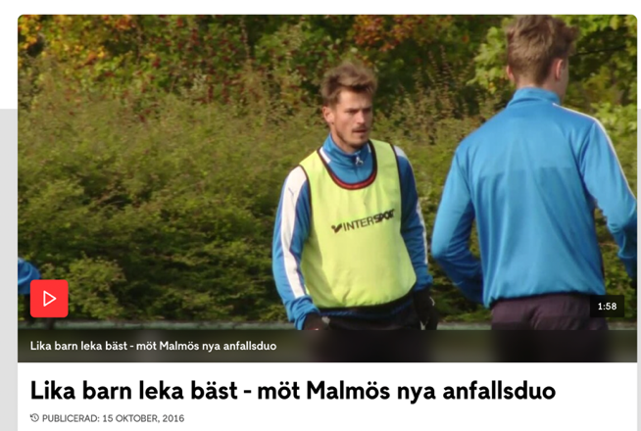  https://www.fotbollskanalen.se/video/3572452/lika-barn-leka-bast-mot-malmos-nya-anfallsduo/

First probe and second research cycle
The preliminary research question was devised to help orient the research in the field and navigate the research context. This was modified and morphed into the second research question during data analysis-synthesis. Findings from this initial research phase indicated a need to dampen the influence of the “control over context” approaches that were acting as socio-cultural constraints, shaping the intentions (in session design) and attention (during practice and performance) of players and coaches. To form a coherent foundation for the club’s practice design and education programs, the first probe, “AIK Base” framework (see O’Sullivan et al., 2023; Woods et al., 2020) was created to encourage the coordination of shared principles and language. As initial interventions to probe the system were being implemented, the next research cycle (utilising the SIF) sought to capture the evolving sociomaterial environment as it persisted and changed.

Table 7. Examples of raw data and initial first level descriptive codes
24-04-2019 Academy training Råsunda IP  Observed academy training with the Dutch FA. 3 teams on one pitch.  “What that coach is doing, I see a lot of that in Holland” (Filed note: Informal conversation : April 4th, 2019) – referring to a coach who kept stopping a session and goes in to show people where they should be positioned and what the player on the ball does  I checked with coach after the session, and he said that he is trying to get the players to work with the clubs game model -which I am a bit unsure what it is! (Filed note: April 4th, 2019).  27-11-2019  Coach H : My assistant coach thinks that the coach should have all the answers for the players. I am trying to work from the ‘Base’, but he is pushing a very explicit game model. Very SvFF!  He sometimes takes the start of training and delivers it in the form of a theme with very pre-determined goals for the players. Basically, his coaching points. He then steps in asap to correct as opposed to letting things flow for a while. (Filed note: Informal conversation : November 11th, 2019)  19-01-2020 Råsunda IP  Meeting with Ragnar (head of development for the boys academy). He showed me some session designs that the coaches have logged in to XPS. In general, the designs looked good but many of the sessions had detailed pre-determined coaching points. I wondered “how much insight these presentations of training sessions give into what actually happened in training. Are the coaching points a box ticking exercise?” (Field note: 19 January 2020).  Mark: Coaches are clearly spending a lot of time on planning, editing clips and administration work.  Ragnar: What is it we have discussed before? The illusion of professionalism?  Certification points means lots of administration for the coaches and money [for some it’s their salary] is connected to certification. Some of the administration might be of benefit but there is too much. (Field note: informal conversation, 19 January 2020)  02-04-2020 Råsunda IP  Coach B: There is more talk about organization of the players on the pitch, organisation of planning, organisation of administration, than actual football. This is how it has been at the academy for the last few years. (Field note: informal conversation, February 4, 2020)  03-02-2020 Råsunda IP  Adam: We have players filling all the channels [according to the Game Model] when we are in possession, but we still have problems securing control of the ball. We also have problems moving over in defense, we are slow to act. (Filed note: Informal conversation: Råsunda IP, February 3rd , 2020)  Bart the U19 head coach presents his training based on the Swedish Football Associations work plan model. I am intrigued to know why he uses this planning model.  Bart: We are not the best at preventing the opponent’s build-up of play in this club. We are in the right position so the players think that this will take care of itself. (Field note: February 3, 2020)  On a fika break I engage in conversation with Bart  Mark: I see that you are using the SvFF planning model  Bart: Yes, it works well for me  Mark: What do you mean by that?  Bart: Well, it gives structure to the training by having a clear plan to follow. It’s about sticking with the plan. (Field note: informal conversation, February 3, 2020)  12-05-2020 AIK head office  We don’t need to prepare the players for every situation. Problem is that [with the game model] the coach is almost trying to automatise everything. Coaches have a tendency of falling back on a more traditional way of coaching. (Field note: Department of Methodology meeting, March 12, 2020)  04-02-2020 Råsunda IP  Coach B: Players are in the right position [according to the Game Model], so some coaches and players think that everything will take care of itself. (Filed note: Informal conversation : February 4th, 2020)  11-03-2020 Skytteholmens IP  Coach H: The players (academy team) seemed to be used to being told what to do and where to stand. One player came to me and said - “Do you want me to not always pass it to our central midfield when we are building up play?”  Vincent: The game model or the “AIK” game model is attacking central  Coach H: Yes! And the coaches think that you ‘just’ attack central, if you want to attack central. So many of the sessions are based on this.  (Filed note: Informal conversation: March 11th, 2020).  16-09-2020 Skytteholmens IP  Some observations from the extra training that I would like to share with all the p2010/2009 leaders. Our focus is not to help children learn to play 7 a-side or 9 a-side (coach a model). We want them to learn to play football. This is quite challenging in 7 a-side as it is easy to cheat. I'm sure you have met teams that position a striker in an offside position near your goalkeeper and they will try to find that player as soon as possible. (Filed note: September 9th, 2020).  03-02-2021 Friends Arena  It will be a very exciting time for our youngest players (8-12). They will get to train at AIK senior team and Swedish national teams home pitch. Usually, the pitch is surrounded by electronic advertising boards. I recall a game that I attended here a few months back. There was some advertising for Uni-Coach which is a big sponsor of Swedish Elite Football (SEF) organisation that is responsible for academy certification and the 2 top leagues in Sweden. Betting companies cannot sponsor youth football events. To get around this Unibet use the name Unicoach! | DUTCH FA VISIT  OBSERVING  COACH CONTROL  EXPLICITLY INSTRUCTING  CORRECT POSITION  GAME MODEL  “COACH SHOULD HAVE ALL THE ANSWERS”  AIK BASE  EXPLICIT GAME MODEL  THEME  PREDEFINED COACHING POINTS  PLAY THE COACHES WAY  RAGNAR  LOG SESSION DESIGNS  PREDETERMINED COACHING POINTS  DESIGNTO TRAINING?  BOX TICKING  PLANNING/ADMINISTRATION  ADMINISTRATION  ”THE ILLUSION OF PROFESSIONALISM”  COACH ADMINISTRATION  CERTIFICATION  CONNECTED TO MONEY  ORGANISATION PLAYERS ORGANISATION PLANNING ADMINISTRATION  CORRECT POSITION  PROBLEMS KEEPING THE BALL  POSITIONING PROBLEMS  “WE ARE SLOW TO ACT”  BART  SvFF  PLANNING MODEL  PROBLEM  RIGHT POSITION  “TAKE CARE OF ITSELF”  PLANNING MODEL  WORKS FOR THE COACH  “GIVES STRUCTURE”  STICK WITH THE PLAN  PROBLEM  AUTOMATISE WITH GM  FALL BACK ON TRADITION  RIGHT POSITION  “TAKE CARE OF ITSELF”  PLAY THE COACHES WAY  “TOLD WHAT TO DO AND WHERE TO STAND”  GAME MODEL  ATTACKING CENTRALLY  JUST ATTACK CENTRAL  INFORMS DESIGNS  OBSERVATIONS  NOT LEARN TO PLAY MODEL  LEARN TO PLAY FOOTBALL  CHEAT  RESULTS  EXCITING  NATIONAL TEAM PITCH  ADVERTISING  SPONSOR ELITE FOOTBALL  ACADEMY CERTIFICATION  BETTING COMPAMY SPONSOR  UNICOACH

During the second-cycle coding activities, data emerging in the micro was compared with, analysed alongside, and synthesised with the data collected via document analysis that informed the historical contextual analysis (macro). Exemplifying how the researcher remains in touch with an ecology of relations, some of the emerging data in the second research cycle compelled the researcher to collect more data through further investigating (e.g., document analysis) the socio-cultural contexts in which phenomena historically unfold.
A third question emerged during the second research cycle: what are the ‘sticky’ socially and culturally constructed values, beliefs and attitudes contributing to a system inertia?

Table 8. Examples of raw data from further investigations of the socio-cultural and historical context that was analysed alongside, and synthesised with the data emerging in the micro, during the second research cycle.

In other words, they put the coach's role as educator clearly in focus – the coach had the overall picture of how the game should be organised and was solely responsible for teaching this to the players……  ….when the students/players must assimilate the systematised knowledge the teacher/coach possesses  (Document analysis: Idrotsforum article: English or Swedish? The battle for the pedagogical power over Swedish men's football at senior level 1974-82, August 19th, 2003 Translated from Swedish)  https://idrottsforum.org/articles/eliasson/eliasson.html  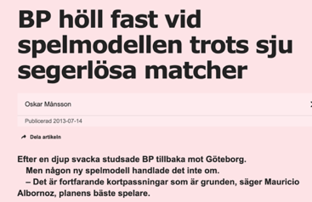  https://www.aftonbladet.se/sportbladet/fotboll/a/jPk9kb/bp-holl-fast-vid-spelmodellen-trots-sju-segerlosa-matcher  (Document analysis: Aftonbladet: BP stay with their game model despite seven winless games., July 14th, 2013, Translated from Swedish)  The idea of ​​a compact positional defense with straight lines, direct counterattacks and passing play had taken hold and the players were given clear roles to be carried out in their position and in a way made the game automated by linking all positions to a role and task. Very organisational, industrial and Swedish  Since the above reasoning is based more on a predetermined organisation (starting position and role are always the same from match to match), with few changes it becomes easy for the players to quickly understand the team's way of playing, which creates a sense of security and recognition and can be trained faster than a more dynamic variant. (Document analysis: Det gröna fältets schack: Should the coach adapt his idea to the players, or should the players adapt to the coach? May 15th, 2020, Translated from Swedish)  https://detgronafaltetsschack.com/2020/05/15/ska-tranaren-anpassa-sin-ide-efter-spelarna-eller-ska-spelarna-anpassa-sig-till-tranaren-ett-spelsystem-en-personlig-reflektion-del-2/  Return to 4-4-2 as soon as possible. It gives the players security and we don't have to have Mellberg as a game distributor!  (Document analysis: Folkbladet: Do not carry this game to South Africa, September 8th, 2008, Translated from Swedish)  https://folkbladet.se/sport/norrkoping/artikel/inte-bar-det-har-spelet-till-sydafrika/rkgedvvj  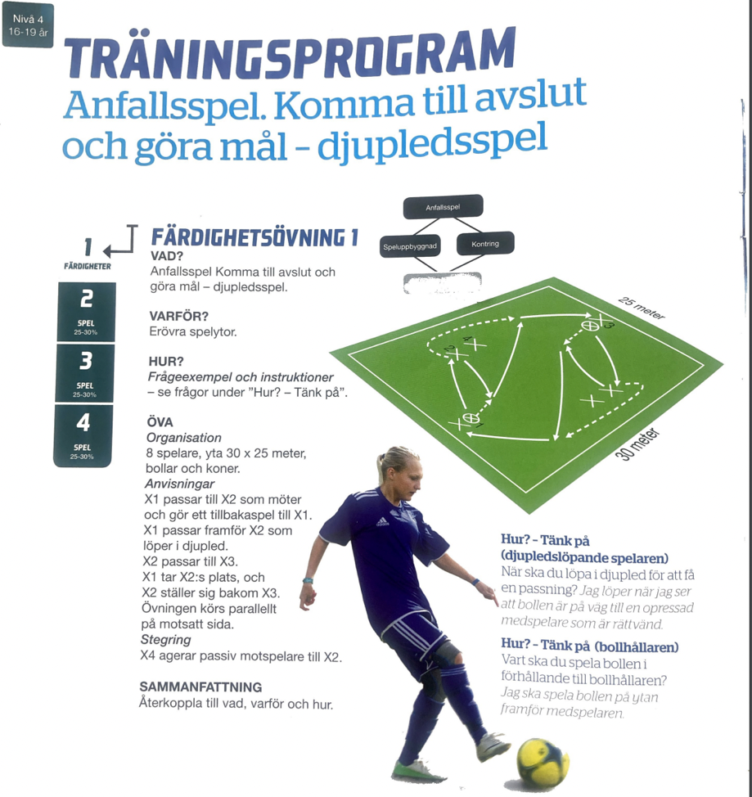  Swedish Football Associations Player Development Plan (SISU idrottsböcker och Svenska Fotbollförbundet, 2015, p. 120)  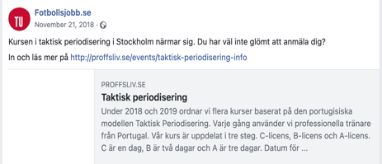  The road to a successful sports career is long and tough. Malin Träff, the National Sports Confederation's children and youth manager, compares the most extreme cases of early professionalization to trafficking.- Money, power and success are incredibly strong driving forces for many, including in and around sports, she tells Swedens Radio.  (Document analysis: Aftonbladet: Youth sport is compared with trafficking, May 2nd, 2022, Translated from Swedish)  https://www.aftonbladet.se/sportbladet/a/Rr0E7A/riksidrottsforbundet-malin-traff-jamfor-ungdomsidrott-med-trafficking  However, Stefan Lundin, sports director SEF (Swedish Elite Football Association) feels no worries. He is sure that they work-and have worked-in the right way in Swedish football’s talent development program. “We are at a completely different level than before. It is because the academies started the training at earlier ages.  (Document analysis: Aftonbladet: Gold the worst thing that could happen. July 11th, 2015, Translated from Swedish) | COACH IN FOCUS  ORGANISING THE GAME  TEACH THE PLAYERS  PLAY THE COACHES WAY  GAME MODEL  PLAY THE COACHES WAY  STICK WITH THE PLAN  STRAIGHT LINES  PLAYER COMPLIANCE  CLEAR ROLES  ORDER  INDUSTRIAL AND SWEDISH  PREDETERMINED ORDER  ALWAYS THE SAME  EASY TO UNDERSTAND  CAN BE TRAINED FASTER  RETURN TO 442 SYSTEM  “GIVES PLAYERS SECURITY”  COACH CONTROL  THEME  EXPLICIT INSTRUCTIONS  PASSING PATTERNS  PREDEFINED OUTCOMES  PROFESSIONALISM-  COMMERCIALISM  EARLY PROFESSIONALISM  MONEY  MARKET PRESSURE  “STRONG DRIVING FORCES”  SEF  NOT WORRIED  WORKING RIGHT WAY  DIFFERENT LEVL  ACADEMIES EARLIER AGES

Key findings of second research cycle and second probe
As a practical concept, AIK Base was introduced to guide coaches in designing affordances to support skilled intentionality. However, socio-cultural practices that were anchored to a dominant coaching form of life contributed to a system inertia, meaning that encultured approaches remained, at times, challenging to change and were very ‘sticky’. In this context, sticky refers to an ideological inertia, shielding traditionally inherited beliefs about how skill is understood and ‘acquired’ (Renshaw et al., 2022). This stickiness was revealed in the over-constraining of practice tasks through the application of the game model concept in the academy. A game model has been described as an overarching strategic approach considered important for team organisation to enhance player functionality (Ribeiro et al., 2019).

Table 9. Key themes arising from ethnographic data under the theme Game model

Meta theme: Control over context
Themes directed towards: Game model Related themes

Macro environment: Swedish national culture

- Lika barn leka bäst

Macro environment: Swedish sport

- Professionalisation

Macro environment: Swedish football

- Parent expectations
- English model

- Coach centered pedagogy
- Systems of play

Microenvironment: AIK football club

- Nerve
- Status

- Conform and comply

How a dominant coaching form of life, “control over context”/limiting unpredictability, was shaping how coaches were implementing a game model is exemplified in the following brief analytical narrative:
Adopting a form of “control over context”/limiting unpredictability, coaches were assuming that they could improve affordances by making them more prominent (explicit instructions, predefined outcomes) to players so that they only respond to specifically designed ones (play the coaches way). This was captured in the rigid nature (coach control, predefined outcomes, coaching points, predefined patterns/outcomes) of how a game model was being implemented which was limiting decision making and problem-solving opportunities, disregarded the interaction of individual, environmental and task constraints that shape skilled intentions from moment to moment. For example, players that were in the correct position according to the game model (knowledge about) were experiencing problems with positioning in relation to the fast-changing information (knowledge of).
The initial research cycle highlighted a form of game model, where young players were drilled to recall predefined passing patterns to control future outcomes and limit unpredictability (predefined outcomes) and be later regurgitated in competitive games. As previous coach interactions with the form of life placed a value on the utilisation of deterministic approaches (predefined passing/outcomes, technique register, play the coaches way) to limit unpredictability, these inherent tendencies shaped how coaches implemented a game model. This value-directedness towards limiting unpredictability aligned with a deeply rooted path-dependent coach education form of life and was having an over-constraining influence on player-environment interactions.
While data in the second research cycle highlighted how a game model was being implemented in the academy through amplifying player compliance (play the coaches way, correct position) according to the game model), it also suggested that coaches were complying (status maintenance) with a contribution of practices associated with what was culturally understood as professionalism (illusion of professionalism). For example, coaches were prioritising the operational procedures of coaching (theme, planning model, stick with the plan) and emerging operational demands (administration), rather than to its actual practice, arguably leading to a system capture e.g., doing things the way we have always done them. These controlling tendencies resonated with those from the broader macro levels of the Swedish sports, football and national culture (professionalisation, illusion of professionalism, commercialisation, early elite, market pressure), evident at administrative levels where the validation of “quality “ was arguably making the work of coaches appear both invisible and controllable.

To combat these encultured ‘sticky’ approaches, a need to dampen the prioritisation of knowledge about (e.g., rigid global to local game model) the environment, while amplifying task designs and coach behaviours that promote the development of players knowledge of (local to global) the environment was identified. Building on the key ideas of AIK Base, the Contemporary Player Learning in Development Framework (Sullivan et al., 2021) was proposed to encourage the design of tasks which are more neutral in terms of outcomes. As part of this framework, the Foundations for Task Design Model (Figure 1) (Sullivan et al., 2021), supported by the relational concept of shaping skilled intentions (Figure 2) (Vaughan et al., 2021), was suggested to support the designing of tasks underpinned by neutral affordances (Withagen et al., 2012).

Table 10. Key themes with examples of data relating to the theme Game model

Location | Theme | Codes | Examples
Micro- environment | Conform and comply | PLAY THE COACHES WAY  PREDEFINED -COACHING POINTS  PLANNING MODEL  ADMINISTRATION  EXPLICIT INSTRUCTIONS  PASSING PATTERNS  PREDEFINED OUTCOMES  CORRECT POSITION-  POSITIONING  STATUS MAINTENANCE  ILLUSION OF -PROFESSIONALISM | We have players filling all the channels [according to the Game Model] when we are in possession, but we still have problems securing control of the ball. We also have problems moving over in defense, we are slow to act.  …a coach who kept stopping a session and goes in to show people where they should be positioned and what the player on the ball does  …more talk about organisation of the players on the pitch, organisation of planning, organisation of administration, than actual football
Macro environment Swedish football | Coach centered pedagogy | COACH CONTROL  THEME  PLANNING MODEL  EXPLICIT INSTRUCTIONS  PREDEFINED PATTERN  PREDEFINED OUTCOME  PLAY THE COACHES WAY | In other words, they put the coach's role as educator clearly in focus – the coach had the overall picture of how the game should be organised and was solely responsible for teaching this to the players.  https://idrottsforum.org/articles/eliasson/eliasson.html  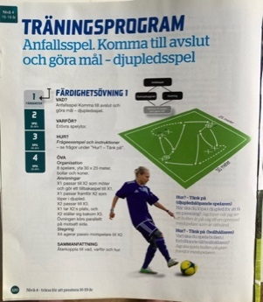  Training program  Attacking play. Get to an opportunity to score a goal- using depth  Example of predefined passing pattern with no opponents  Swedish Football Associations Player Development Plan (SISU idrottsböcker och Svenska Fotbollförbundet, 2015, p. 120)
 | Systems of play | PASSING PATTERNS  PREDEFINED OUTCOME  PLAY THE COACHES WAY  COACH CONTROL  EXPLICIT INSTRUCTIONS | BP stay with their game model despite seven winless games  https://www.aftonbladet.se/sportbladet/fotboll/a/jPk9kb/bp-holl-fast-vid-spelmodellen-trots-sju-segerlosa-matcher  The working method describes the team's priorities in the various stages of the game, for example marking or positional defense in the stage of preventing play build-up. The concept is introduced in the game form 7 against 7. Formation indicates the number of players per team. The team is in formation when the players have taken their starting positions. The concept is introduced in the game form 7 against 7. Roles are the tasks of the players in the different stages of the game, for example that a midfielder should be higher up the field than the others in the team's play structure.  https://utbildning.sisuforlag.se/fotboll/tranare/spelarutbildning/svffs-spelarutbildningsplan/spelet/lagets-spelsystem/
Macro environment Swedish Sport | Profession--alisation | (EARLY)-PROFESSIONALISATION-(ILLUSION OF)  ADMINISTRATION  COMMERCIALISM  MARKET PRESSURE  MONEY | Private company’s offering education courses on tactical periodisation. These ideas that were initially intended for senior professional sport are now being used to educate youth coaches.  The road to a successful sports career is long and tough. Malin Träff, the National Sports Confederation's children and youth manager, compares the most extreme cases of early professionalization to trafficking.  - Money, power and success are incredibly strong driving forces for many, including in and around sports, she tells Swedens Radio.  https://www.aftonbladet.se/sportbladet/a/Rr0E7A/riksidrottsforbundet-malin-traff-jamfor-ungdomsidrott-med-trafficking

