Supplemental Material

Supplemental Table 1

 | Women | N | Men | N | P-value
BV (ml) | 5095 ±594 | 21 | 7164 ± 1253 | 86 | <0.001
BV (ml·kg⁻¹ body mass) | 82.7 ±7.3 | 21 | 94.4 ± 8.1 | 86 | <0.001
BV (ml·kg⁻¹ LBM) | 107.0 ±7.4 | 9 | 111.5 ± 6.9 | 57 | 0.125
BV (ml·m⁻² BSA) | 2748 ± 241 | 18 | 3317 ± 353 | 82 | <0.001
RBCV (ml) | 2115 ± 273 | 21 | 3136 ± 521 | 86 | <0.001
RBCV (ml·kg⁻¹ body mass) | 34.3 ±3.7 | 21 | 41.4 ± 3.6 | 86 | <0.001
RBCV (ml·kg⁻¹ LBM) | 43.7 ±3.1 | 9 | 48.4 ± 3.4 | 57 | 0.002
RBCV (ml·m⁻² BSA) | 1147 ± 123 | 18 | 1451 ± 156 | 82 | <0.001
PV (ml) | 2981 ± 358 | 21 | 4028 ± 785 | 86 | <0.001
PV (ml·kg⁻¹ body mass) | 48.4 ± 4.5 | 21 | 53.1 ± 5.7 | 86 | <0.001
PV (ml·kg⁻¹ LBM) | 63.3 ± 5.0 | 9 | 63.1 ± 5.6 | 57 | 0.890
PV (ml·m⁻² BSA) | 1601 ± 145 | 18 | 1866 ± 235 | 82 | <0.001
Hb_{mass} (g) | 706 ± 90 | 21 | 1048 ± 162 | 86 | <0.001
Hb_{mass} (g·kg⁻¹ body mass) | 11.4 ± 1.1 | 21 | 13.8 ± 1.1 | 86 | <0.001
Hb_{mass} (g·kg⁻¹ LBM) | 14.9 ± 0.8 | 9 | 16.2 ± 1.1 | 57 | 0.001
Hb_{mass} (g·m⁻² BSA) | 383 ± 36 | 18 | 485 ± 46 | 82 | <0.001
[Hb] (g·dl⁻¹) | 13.9 ± 0.6 | 21 | 15.1 ± 1.0 | 86 | <0.001
Hematocrit (%) | 41.5 ± 2.1 | 21 | 44.7 ± 2.5 | 86 | <0.001
Hematological characteristics of female and male adult athletes BSA: body surface area; BV: blood volume; [Hb]: hemoglobin concentration; Hb_{mass}: hemoglobin mass; LBM: lean body mass; PV: plasma volume; RBCV: red blood cell volume. Mean ± SD

Supplemental Tables 2A-D

Results of best subset multiple regression analyses
- Model 1: clinical prediction of blood volume
Predictor number | Predictors | R² | Adjusted R² | C(p) | AIC
1 | LBM | 0.715 | 0.714 | 8.39 | 6435
2 | LBM, age | 0.724 | 0.723 | -1.57 | 6393
3 | LBM, age, height | 0.730 | 0.728 | -7.89 | 6387
4 | LBM, age, height, weight | 0.730 | 0.728 | -6.20 | 6357
5 | LBM, age, height, weight, sex | 0.731 | 0.727 | -4.74 | 6359
6 | LBM, age, height, weight, sex, VO_{2max} | 0.721 | 0.714 | 7.00 | 4057

- Model 2: simple prediction of blood volume
Predictor number | Predictors | R² | Adjusted R² | C(p) | AIC
1 | Sex | 0.504 | 0.503 | 260.7 | 8466
2 | Sex, weight | 0.616 | 0.615 | 85.77 | 8302
3 | Sex, weight, height | 0.655 | 0.654 | 26.42 | 8248
4 | Sex, weight, height, age | 0.671 | 0.669 | 5.00 | 8195

- Model 3: clinical prediction of hemoglobin mass
Predictor number | Predictors | R² | Adjusted R² | C(p) | AIC
1 | LBM | 0.793 | 0.792 | 30.15 | 4823
2 | LBM, sex | 0.812 | 0.811 | -9.57 | 4784
3 | LBM, sex, height | 0.815 | 0.813 | -12.41 | 4781
4 | LBM, sex, height, age | 0.816 | 0.814 | -12.40 | 4757
5 | LBM, sex, height, age, weight | 0.816 | 0.814 | -10.66 | 4736
6 | LBM, sex, height, age, weight, VO_{2max} | 0.798 | 0.794 | 7.00 | 3028

- Model 4: simple prediction of hemoglobin mass
Predictor number | Predictors | R² | Adjusted R² | C(p) | AIC
1 | Sex | 0.659 | 0.658 | 253.3 | 6403
2 | Sex, weight | 0.738 | 0.737 | 76.5 | 6243
3 | Sex, weight, height | 0.771 | 0.769 | 3.75 | 6175
4 | Sex, weight, height, age | 0.771 | 0.770 | 5.00 | 6153

AIC: Akaike Information Criteria; C(p): Mallow’s Cp; LBM: lean body mass; VO_{2max}: maximal oxygen uptake
Supplemental Table 3
Reference | N | CO rebreathing |  |  | Body composition |  |  | VO_{2max}
 |  | 10 min manual | 10 min Detalo | 2 min | DEXA | BIA | Skin-fold
Dandanell et al., 2016[52] | 13 |  | x |  | x |  |  | x
Montero et al., 2017[48] | 9 |  | x |  | x |  |  | x
Diaz-Canestro et al., 2021[53] and 2022[54-56] | 73 | x |  |  | x |  |  | x
Siebenmann et al., 2015[57] | 9 | x |  |  | x |  |  | x
- Almquist et al., 2020[58] and 2021[59] | 23 |  | x |  | x |  |  | x
Cepeda-Lopez et al., 2019[9] | 62 |  |  | x | x
Robach et al., 2021[60] | 22 | x
Lundby & Robach, 2015[40] | 9 | x |  |  |  |  |  | x
Jelkmann & Lundby, 2011[44] | 29 | x |  |  |  |  |  | x
- Lundby et al., 2018[3] | 5 |  | x |  | x
- Treff et al., 2014[21] | 15 |  |  | x |  |  | x | x
- Lundgren et al., 2021[22] | 50 |  |  | x |  | X |  | x
- Unpublished (a) | 76 | x |  |  | x |  |  | x
- Sjurdarson et al., 2022[61] | 42 |  |  | x | x |  |  | x
- Unpublished (b) | 33 |  | x |  | x |  |  | x
- Unpublished (c) | 46 |  | x |  | x
- Unpublished (d) | 29 |  |  | x | x |  |  | x
- Unpublished (e) | 59 |  |  | x | x |  |  | x
Unpublished (f) | 7 |  | x |  | x |  |  | x
Breenfeldt-Andersen et al., 2023[62] | 45 |  |  | x | x |  |  | x
Bonne et al., 2022[63] | 33 |  |  | x | x |  |  | x

Overview of the included variables. auto: automated; Bio: bio-impedance; CO: carbon monoxide; DEXA: dual energy x-ray absorptiometry; VO_{2max}: maximal oxygen uptake.

Supplemental Table 4
 |  | Women (n=263) | Men (n=319) | Total (n=582)
Age, years | Mean (min-max) | 36.6 (9.7-93.0) | 38.9 (9.5-86.0) | 37.8 (9.5-93.0)
<20 | N (%) | 33 (12.5) | 40 (12.5) | 73 (12.5)
20-30 | N (%) | 122 (46.4) | 119 (37.3) | 241 (41.4)
30-40 | N (%) | 26 (9.9) | 40 (12.5) | 66 (11.3)
40-50 | N (%) | 18 (6.8) | 36 (11.3) | 54 (9.3)
50-60 | N (%) | 8 (3.0) | 6 (1.9) | 14 (2.4)
60-70 | N (%) | 21 (8.0) | 33 (10.3) | 54 (9.3)
>70 | N (%) | 34 (12.9) | 44 (13.8) | 78 (13.4)
Body mass (kg) | Mean (min-max) | 65.5 (29.8-113) | 76.4 (26.2-119) | 71.5 (26.2-119)
Height (m) | Mean (min-max) | 1.66 (1.38-1.87) | 1.78 (1.35-1.96) | 1.73 (1.35-1.96)
BMI (kg∙m⁻²) | Mean (min-max) | 23.7 (15.5-40.6) | 24.0 (14.3-38.5) | 23.8 (14.3-40.6)
<20 | N (%) | 42 (16.0) | 29 (9.1) | 71 (12.2)
20-25 | N (%) | 140 (53.2) | 185 (58.0) | 325 (55.8)
25-30 | N (%) | 52 (19.8) | 88 (27.6) | 140 (24.1)
>30 | N (%) | 27 (10.3) | 17 (5.3) | 44 (7.6)
Body surface area (m²) | Mean (min-max) | 1.86 (1.18-2.40) | 2.09 (1.10-2.62) | 1.99 (1.10-2.62)
Body fat (%) | Mean (min-max) | 31.7 (14.9-53.1) | 20.3 (8.1-43.7) | 25.7 (8.1-53.1)
Lean body mass (kg) | Mean (min-max) | 41.3 (19.8-60.0) | 57.9 (20.0-82.9) | 50.0 (19.8-82.9)
VO_{2max} (ml/min/kg^{BM}) | Mean (min-max) | 39.1 (18.0-59.6) | 45.9 (18.9-69.9) | 43.2 (18.0-69.9)

Characteristics of all the included, non-athletic individuals. BM: body mass; BMI: body mass index; VO_{2max}: maximal oxygen uptake (n_{Total}=402)

Supplemental figure captions
Supplemental Figure 1. Effect of carbon monoxide rebreathing method on hemoblogin mass per lean mass. In non-athletic individuals including children, one-way anova revealed an effect of methods on hemoglobin mass per lean mass. n=436. LBM: lean body mass

Supplemental Figure 2. Linear relationship between age and blood parameters. A) Blood volume, B) Red blood cell volume, C) Plasma volume, D) Hemoglobin mass. Each dot represents one individual: n=523.

Supplemental Figure 3. Linear relationship between age and [Hb] and hematocrit. A) [Hb], B) Hematocrit. Each dot represents one individual: n=523. [Hb]: hemoglobin concentration.

Supplemental Figure 4. Relationship between absolute VO₂max and blood parameters. A) Blood volume, B) Red blood cell volume, C) Plasma volume, D) Hemoglobin mass. Each dot represents one individual: n=499; including all children, healthy adult and athletes in whom VO₂max testing was performed.

Supplemental Figure 5. Relationship between relative (LBM) VO₂max and blood parameters. A) Blood volume, B) Red blood cell volume, C) Plasma volume, D) Hemoglobin mass. Each dot represents one individual: n=499; including all children, healthy adult and athletes in whom VO₂max testing was performed.

Supplemental Figure 6. Relationship between Body Mass Index (BMI) and blood parameters.
A) Blood volume, B) Red blood cell volume, C) Plasma volume, D) Hemoglobin mass. Each dot represents one individual: n=582; including all children and healthy adult. Women: BV and BMI: R2=0.20, p<0.0001; RBCV and BMI: R2=0.17, p<0.0001; PV and BMI: R2=0.19, p<0.0001; Hbmass and BMI: R2=0.22, p<0.0001. Men: BV and BMI: R2=0.20, p<0.0001; RBCV and BMI: R2=0.20, p<0.0001; PV and BMI: R2=0.15, p<0.0001; Hbmass and BMI: R2=0.21, p<0.0001.
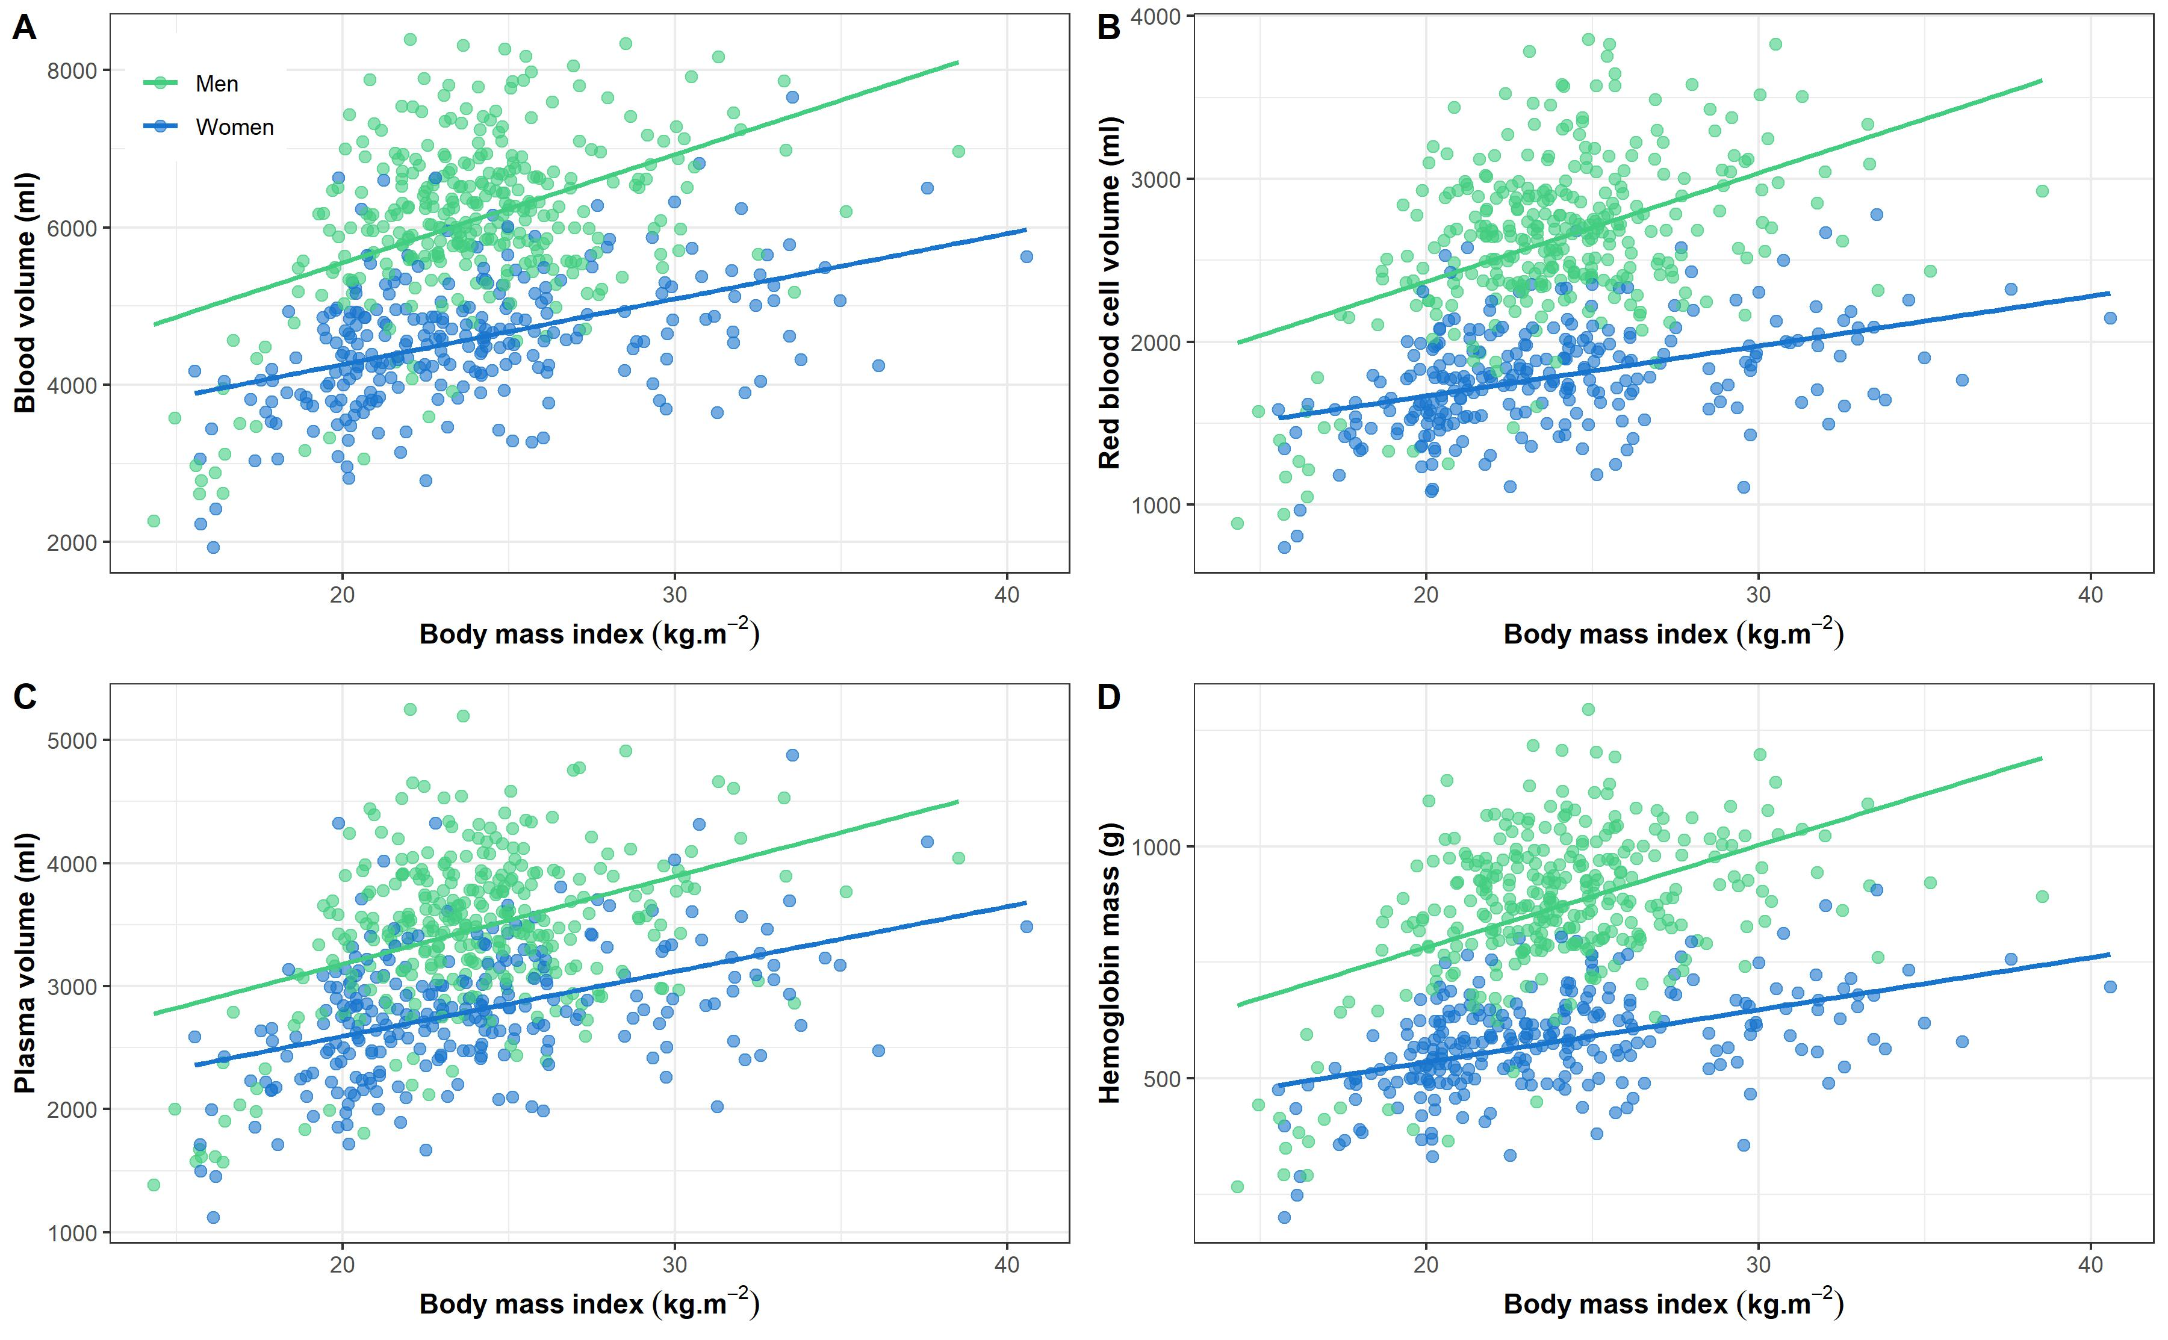

Supplemental Figure 7. Comparison of measured to predicted blood volumes in all non-athletic individuals (adults only) visualized by Bland-Altman plots. For all measured blood volumes in the present study, the predicted blood volume was calculated and subtracted from the measured (y-axis) and plotted against the mean of the measured and the predicted blood volume (x-axis). A) Prediction made by the Nadler formula (n_{Total}=582); B) Prediction made from age, body mass and height based on the current data (n_{Total}=582); C) Prediction made from age, height and lean mass based on the current data (n_{Total}=469). The black line indicates the mean difference between the measured and the predicted blood volume. The red, dashed lines indicate the 95% limits of agreement.

